Blindata Release Note 5.2.1 

24 December 2010

Bug Fixes and Enhancements

New Work and Customer Requests

2002. EDI Enquiry > EDI Import > JL EDI Import

A major change has been made to the ‘JL EDI Import’ routine, to incorporate a new file layout for a blind type.

The import file may contain orders with the existing JL layout and also with the new layout. We can now identify order details in the new layout because it will have the text ‘LAM GENERIC’ in it. We have incorporated this layout in the same import routine ie ‘JL EDI Import’.

2006. Quotations

It is now possible to confirm a quotation, be able to say if a survey is required and also be able to print out a survey sheet.

Administration > Parameters

There is a new parameter in Administration > Parameters called ‘Confirm Quotation Required’, which defaults to false.

If it is set to true, then there are two new buttons on the quotation enquiry form called ‘Confirm Quotation’ and ‘Quotation Failed’.

If ‘Confirm Quotation’ is selected, then the status of the quotation changes to ‘Quotation Confirmed’. Also, it is not possible to convert a quotation to an order until the quotation has been confirmed. It is also not possible to select ‘Quotation Confirmed’ if it has already failed or been converted.

Order Processing > Quotations

If ‘Quotation Failed’ is selected, then the status of the quotation changes to ‘Quotation Failed’. It is then not possible to select ‘Quotation Failed’ if it has already been confirmed or converted to an order.

There is also a new flag in the quotation entry form called ‘Survey Required’. This defaults to false. If a survey is required, then this enables a further button on the quotation enquiry form called ‘Survey Completed’. It is not possible to convert a quotation to an order unless it has a status of ‘Survey Completed’.

If ‘Confirm Quotation Required’ is true and ‘Survey Required’ is true, then ‘Survey Completed’ cannot be done until the quotation has a status of ‘Quotation Confirmed’.

2007. Stock Items > Unit Of Sale

We have several customers that sell components as well as manufacturing blinds. This is why we have the ‘Component’ button in the order detail form. At the moment when a component line is sold, we just enter the quantity, but we have make it a bit cleverer.

Customers will often sell a product that is in a pack or bundle. Let’s take an example of tube for roller blinds. Each tube may be 5 metres in length, and a bundle is 12 tubes. Therefore there is 60 metres in a bundle. At the moment, if we sell a bundle, it has to be entered as 60 metres. We want to be able to enter the quantity as a bundle or a length (or anything the customer decides).

Solution

There is a new table called ‘Unit Of Sale’. This contain ‘Description’ and ‘Quantity’ and is maintained in Administration > System Tables. For example:

Description Quantity

Bundle 60
Length 5
Unit 1

It is now possible to hold different units of sale against a stock item. There is a new tab for this in Stock Setup > Stock Items. There is a default record for ‘Unit’ and 1 entered. There is also a flag here to determine which is the default ‘Unit of Sale’ for that stock item.

When a component detail line form is opened, there is now a field for selecting the ‘Unit Of Sale’. The user is able to select this, and then enter the quantity. The existing quantity field has been changed to say ‘Unit Quantity’.

So if we use the example above and select ‘Bundle’, then enter a quantity of 5, the unit quantity will be 300.

We have also amended the following reports so they show ‘Unit Of Sale’, ‘Quantity’ and ‘Unit Quantity’ in the detail line.

Acknowledgement – Laser Print
Delivery Docket – Laser Print
Invoice – Laser Print

2008. SQL Express 2008 R2

We have checked to make sure Blindata works with with SQL Express 2008 R2.

Here is a useful link.

http://www.mssqltips.com/tip.asp?tip=2024

We have managed to install Blindata using SQL Express 2008 R2.

The following link was used to download the program.
http://www.microsoft.com/express/Database/default.aspx#Installation_Options

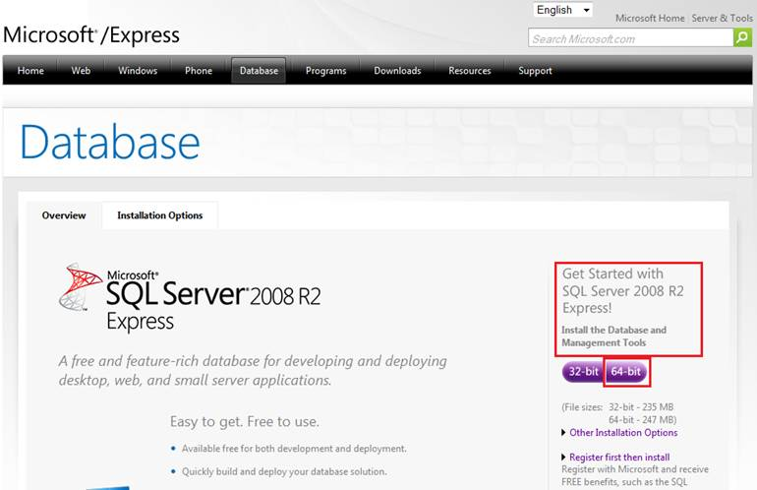

During installation we set not the Named Instance instead of the Default Instance and called it SQLEXPRESS2008.

This installation package contains all the required needed programs and tools.

Then we installed the server version of Blindata 5.2.0 on the SQLEXPRESS2008 and it successfully created all users, and attached the default database.

Blindata worked on this MS SQL server instance without any other additional adjustments:

We have checked full cycle of order creating starting from Sales Lead and finishing with Archiving.

We also checked the client PC connection: this works, but we had to set another TCP\IP port for the SQL Server connection, add exception for this port to the Windows firewall and add this port to the SQL Server connection line (example: localhost\SQLEXPRESS2008,49123). It is possible SQL Express 2008 R2 cannot work with standard 1433 port, but we will check this.

W95. Order Processing > Orders

When the first detail line of an order is entered, the fabric description was filled with the first available fabric. This is now left empty until the fabric is selected.

