Blindata Release Note 5.2.0 

16 December 2010

Bug Fixes and Enhancements

3231. Order Processing > Production Lists > Order Control by Rep

When ‘Order Control By Rep’ is chosen, it now allows you to choose by rep and print by rep. Previously it was being done by department.

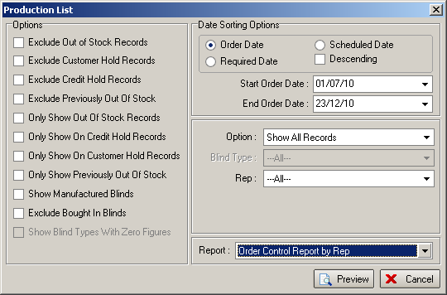

3232. Order Processing

We made a change to remove the vertical scroll bar from the option selection (when right clicking) but this has caused a problem if there were too many options. There is now a parameter to define the maximum number of options that can be shown. This is held in Administration > Parameters > Defaults.

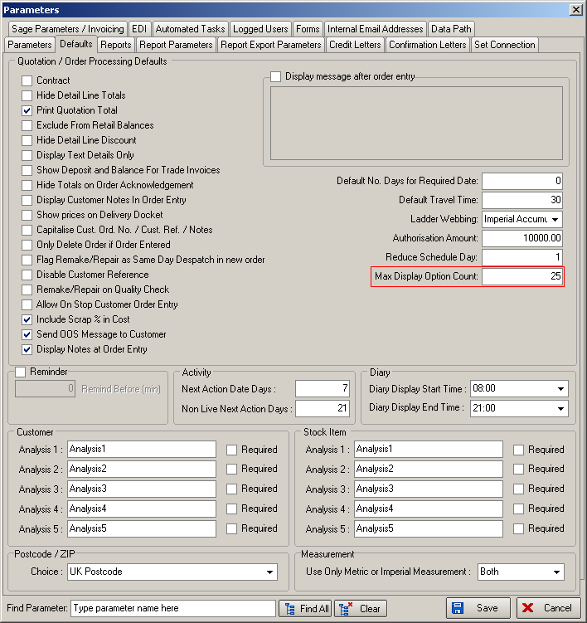

New Work and Customer Requests

1993. Pricing > Discounts

When displaying discount records, they are now displayed by drilling down to manufacturing location then to blind type (or whatever criteria is applied) and discounts.

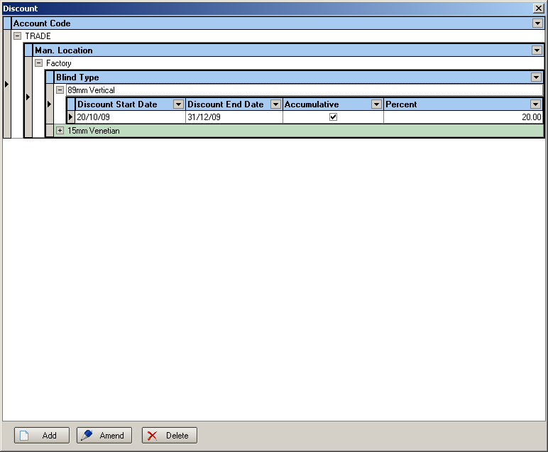

2000. Stock Items

It is now possible to calculate stock usage in feet and yards as well as the existing metres and quantity. Feet and yards are required because North American customers may hold and purchase stock like this.

12 inches = 1 foot, 3 feet = 1 yard. There are 25.4mm in an inch.

There is a new field in the stock record called ‘Measurement Unit’. This could be ‘Metres’, ‘Feet’, ‘Yards’, ‘Quantity’. All fabrics default to ‘Metres’. All records that do not have ‘Quantity’ as the calculator default to ‘Metres’. All records with calculator = ‘Quantity’ default to ‘Measurement Unit’ = ‘Quantity’.

Let’s take an example of a vertical blind (with a fabric that is set up with ‘Measurement Unit’ = ‘Yards’) that has 16 vanes, each fabric length being 45 3/8 inches. This means we need 16 * 45 3/8 = 726 inches = 60 feet 6 inches = 20 yards 6 inches = 60.5 feet = 20.166 yards.

We have adjusted the bill of materials calculation so it will take into account the ‘Measurement Unit’.

2001. Canadian Postcodes

The system can now handle Canadian postcodes. There is now a choice for ‘Canada’ in Administration > Parameters > Postcode / ZIP Choice.

http://en.wikipedia.org/wiki/Postal_codes_in_Canada

The Blindata link to Google Maps now recognizes Canadian postcodes as well.

2003. Administration > Import From Excel

When the ‘Fabrics’ spreadsheet is imported, we have included a field for ‘Measurement Unit’. This could be filled with ‘Metres’, ‘Feet’, ‘Yards’, ‘Quantity’, or be left blank.

2004. Supplier Multi Currency

It is now possible to enter foreign currency amounts for products when purchase invoices are being created from purchase orders.

Suppliers

‘Currency’ can now be held against the supplier record. This defaults to the default currency that is held in Administration > Parameters.

Regular Purchase Orders

When a unit price is entered against a purchase order detail line, there are now also fields for ‘Currency Rate’ and ‘Foreign Unit Price’. The user is able to amend these figures. Example:

Unit Price: 15.00 Currency Rate: 1.55 Foreign Unit Price 23.25

If the currency rate is changed to 1.50, then the foreign unit price will become 22.50.

If the foreign unit price is entered as 25.00 (and the currency rate is 1.55), the unit price will become 16.13.

The total VAT and total gross are then recalculated.

2005. Order Processing > Order Enquiry

If a ‘Blind Made Scan’ or ‘Blind Made’ is done in ‘Order Enquiry’ and all blinds have been manufactured, we have a customer who does not want the ‘Order Made’ form to appear, and they do not want to have to enter an employee.

There is a parameter called ‘Auto Set Man. Date in Scan’, which defaults to false. If it is set to true, then the ‘Order Made’ form is not shown and the order status should just change to ‘Order Manufactured’ when an order is scanned as made.

This parameter is now also applied to ‘Order Made’ and ‘Order Made Scan’ in ‘Order Enquiry’ and ‘Order Amend Enquiry’

2009. Administration > Maintenance > Repricing

There is going to be a change in VAT to 20% on 4 January 2011 in the UK. A minor change was required in the ‘Repricing’ function.

If a quotation is set to ‘proforma’ = true and it has been paid, then the VAT should remain at the current rate of 17.5%. This will also be true of orders that were created from quotations that were ‘Proforma’ = true, and then paid and turned into orders.

Therefore the ‘Repricing’ routine no longer changes the VAT amount for quotations that are proformas that have been paid and also orders that were converted from paid proformas.

W94. Order Processing > Orders

We now have the same functionality in the order detail line entry if ‘Enter Valance Size’ = true in the blind type record. This means we have added fields for ‘Valance Width’, ‘Return Length’ and ‘Return’.

We have also amended the XML file layout to handle these entries, and also changed the EDI Import routine.

W95. Order Processing > Orders

When the first detail line of an order is entered, previously the fabric description was filled with the first available fabric. This is now left empty until the fabric is selected.

