Blindata Release Note 5.1.9 

10 December 2010

Bug Fixes and Enhancements

3218. Works Order - Label 1

We have removed despatch method to the right of customer from the label.
On small label we have moved order number further left so it doesn’t overwrite ‘1 of n’.

3219. Form Displays

Sometimes forms did not display properly if they are left open and other forms are opened and closed.

For example, the ‘Pricing’ and ‘Option Price Enquiry’ forms sometimes lost date from fields – in these cases if the forms was left open, then you went in the ‘Blind Types’ form, closed it and redisplayed this form, the following was displayed. Fixed.

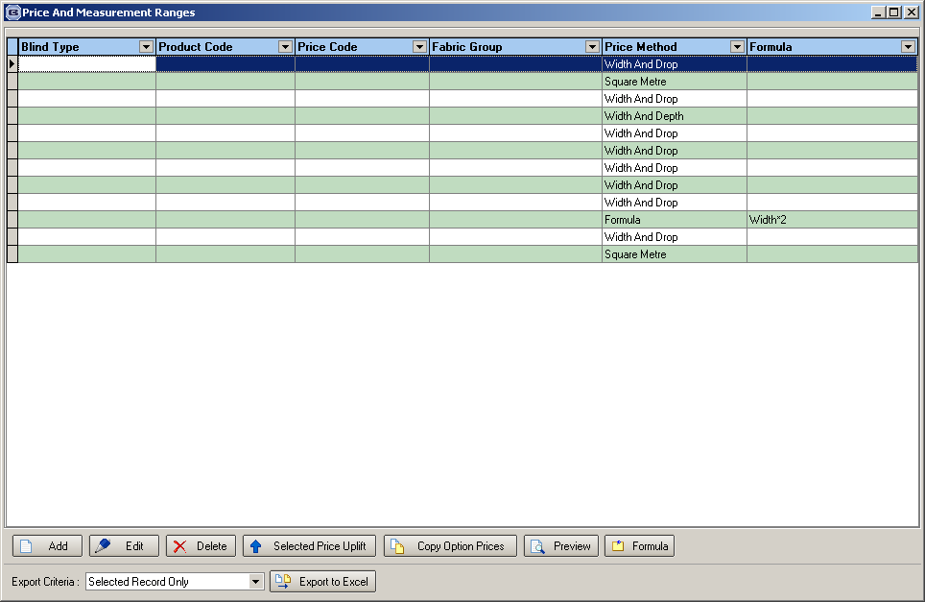

3224. Sales Files > Customers > Label Print (Customer Label – 4 x 2)

We made a change to this label (font and size). The font is fine but the size was too big. We have changed this to 12.

3226. Outstanding Retail Debtors Report

If an order has been generated from a proforma quotation, it is no longer shown on this report, even if the balance > 0.

3227. Acknowledgement – Laser Print (Letterhead)

- If the order only contains component lines, then ‘Width’ and ‘Drop’ is not printed.
- The description text now wraps around before quantity. Previously quantity was not being printed – it is now.
- The net total was not printing, even if ‘Hide Detail Line Totals’ was false. Fixed.

3228. Acknowledgement – Laser Print (Letterhead)

- If ‘Hide Detail Line Totals’ = true, then ‘Unit Price’, ‘Disc %’ and ‘Net Price’ no longer print.
- If ‘Hide Detail Line Discount’ = true, then ‘Unit Price’ and ‘Disc %’ no longer print.

3229. Financials > Post Invoices to Sage (Lakeview)

The following error appeared when trying to post invoices to Lakeview. The message now says ‘There is insufficient data to create Lakeview invoices: invoice number 999999’.

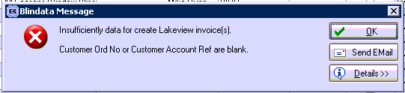

New Work and Customer Requests

1988. Stock Setup > Suppliers

When an alternative XML file is created, it uses the ‘Supplier Own Ref’ from the Supplier record. However we have one customer who is going to send XML files, but they need to have different ‘Buyer Party’ and ‘Ship to Party’ identifiers. The reason for this is that they have two different sales offices and two different accounts with the supplier.
Therefore we have created a new table that holds ‘department id’, ‘supplier id’ and ‘supplier own ref’. There is now a tab in the Department form so the user can add a record for supplier and Supplier Own Ref.

When the alternative XML file is created, it now looks to see if there is a record set up in this department form tab. If there is, then this ‘supplier own ref’ are used in the ‘Charge To Party’ identifier and the ‘supplier own ref’ and address are used in ‘Ship Party’.

For a normal XML file, if there is a record in department, then the ‘supplier acc ref’ is used as the account code and the address as the delivery address.

1989. Order Processing

If the global permission for ‘Allow Proforma Edit’ is false, it now only locks down the detail lines. If the user permission ‘Edit Proforma Order’ is switched on, the user is able to edit the order fully.

1990. Order Processing > Orders

If ‘Credit Hold at Order Entry’ is true and ‘On Hold’ is true in ‘Buttons Visibility’ for a user, then a user is able to put an order on hold at any point up to and including ‘Order Manufactured’.

1991. Order Processing > Global Search

- Search results now populate all the fields: customer name, contact name and customer order numbers are all blank.
- Customer order number search is no longer case sensitive. Also it is possible to enter a wildcard.
- Customer reference search is no longer case sensitive. Also it is possible to enter a wildcard.
- Customer name search is no longer case sensitive. Also it is possible to enter a wildcard.

There is also the following additional functionality.
There is now a context menu. This has choices for History, Copy to Clipboard and Column choices, Save Configuration, Default Configuration.
As well as the existing columns, there are now column choices for Despatch Date, Required Date Scheduled Date, EDI File Name, Original Quote Number, Order Source, Account Code, Must Go, On Customer Hold, On Credit Hold, Repair, Remake, Redespatch, Quality Required, Sample.

There is a Find for account code as well.

There are also buttons for adding and reading notes (similar to the order amend form), View Works Order and Delivery Notes.

It is also possible to view Archived Orders

1992. Order Processing > Out Of Stock Management

When the form is displayed, the fabric code and description are not shown until the BOM form has been updated. When displaying the BOM only one item can be flagged as OOS, which will then fill the fabric code form on the main form.

We have removed the ‘Stock Items’ and ‘Dimension Calculations’ button from the BOM form.

1994. Valance Length Modifications

Order Processing > Orders

1. On detail line entry, ‘Return’ now says ‘Return Length’.
2. ‘Valance Width’ and ‘Return Length’ are both integers.
3. ‘Valance Width’ and ‘Return Length’ now change to Imperial if Imp is set to true in the order detail line.

Administration > System Tables > Return Valance Add On

There is a new field in this table called ‘Number of Returns Description’, which is alphanumeric.

Works Order – Label 1

We have removed ‘Return Description’ from the works order and replaced it with ‘Number Of Returns Description’.

1995. Box Blinds Minimum Width

It is now possible to deduct/add slats depending on the drop and the width of the box blind, so we now hold the add/remove point in the ‘Box Blinds Minimum Width’ table. If there are figures (other than 0) held in here, then these are used instead of the existing fields in the ‘Box Blind Slat’ table.

This means that in the order entry program, we now look at the figures in the ‘Box Blind Minimum Width’ table.

1996. Pricing > Option Price Enquiry

It is now possible to enter a negative amount as a price in the option price form. Previously, if you tried to do that, it was saved as 0.

1997. Order Processing > Archive Enquiry

It is now possible to edit ‘Order Notes’ for orders that are in this form. There is a user advanced permission for this called ‘Edit Order Notes’.

1998. Order Processing > Orders

There is now a button for ‘Cust Notes’. This is view only.

1999. Stock Setup > Stock Items

There are now two buttons on the stock enquiry form called ‘Flag Item Kanban OOS’ and ‘Flag Item Kanban Bin’. These have button visibility permissions in Administration > Users. This allows the user to set to true/false the fields ‘Kanban OOS’ and ‘Kanban Item’ respectively.

‘Kanban OOS’ and ‘Kanban Edit’ now both appear as column choices in the stock enquiry form.

