Blindata Release Note 5.1.8 

3 December 2010

Bug Fixes and Enhancements

3211. Tabs

A couple of customers have commented about the tabs overlapping vertically. They have now been changed slightly so they do not overlap. This applies to all the forms that were changed.

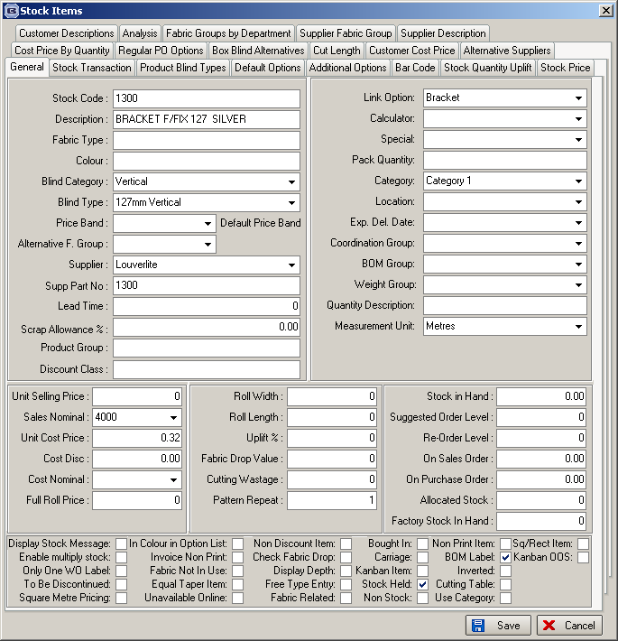

3212. Order Processing > Orders

When adding an order, if you entered a customer that is on stop, and then selected another customer, the carriage type field was not picked up from the customer record and put in the order. Fixed.

3214. Alternative XML File

The LineItemNum is now 10, 20, 30 etc, not 1, 2, 3 etc

3215. Alternative XML File

- The PONumber value is the ‘Supplier Own Ref’ from the supplier record concatenated with the PO number from the purchase order.
- There is only one space character between the first and last part of the postcode.
- There is only ever one order in a XML file.

3216. Works Order A4 Individual

‘Location’ has been moved a lot further left so it is just to the right of the drop value.

3217. Optimisation

There was a problem with optimisation if either the width or drop of a blind is bigger than the roll width.

In this example, roll width is 1900, calculator = ‘Width or Drop’, default code = A (add 300mm to drop).

Two blinds are entered

- Width 1200 x drop 2300
- Width 300 x drop 500

Scrap width add on = 20mm, scrap drop add on = 20mm.

Therefore the pieces of fabric required are 1220 x 2620 and 320 x 820.

The problem was that created two pieces of fabric for the first blind - now it only creates one.

New Work and Customer Requests

1982. Sales Analysis by Blind Type by Customer by Month (Quantity)

There is a new report that is similar to Sales Analysis by Blind Type by Customer by Month but shows blind quantity rather than value. We have applied the same rule about miscellaneous ie quantity of 1 per detail line rather than actual quantity. SA by Blind Type by Month (Quantity) has also been created.

1983. Order Processing > Orders

A new parameter has been created in Administration > Parameters called ‘Display Notes at Order Entry’. If this is set to true and there are notes held in Sales Files > Customers > Notes, then these notes will appear in a form immediately after the customer has been selected in the order entry program. The user then has to click OK to get the form to disappear.

1984. Reports > Sales Analysis > Sales Analysis by Blind Group Quantity

There is a new report called ‘Sales Analysis by Blind Group Quantity’. This has a similar layout to ‘Sales Analysis by Blind Type (Weekly) except blind quantities are shown instead of sales values, and the report is grouped by blind group and blind type instead of by blind identifier and then blind type. There is a total at the bottom of each day for the blind quantity and the sales value.

1985. Administration > Export Data > Blind Type Dataset

When data is exported by blind type, we also now export the ‘Link Options’ data from Blind Details > Blind Types > Link Options.

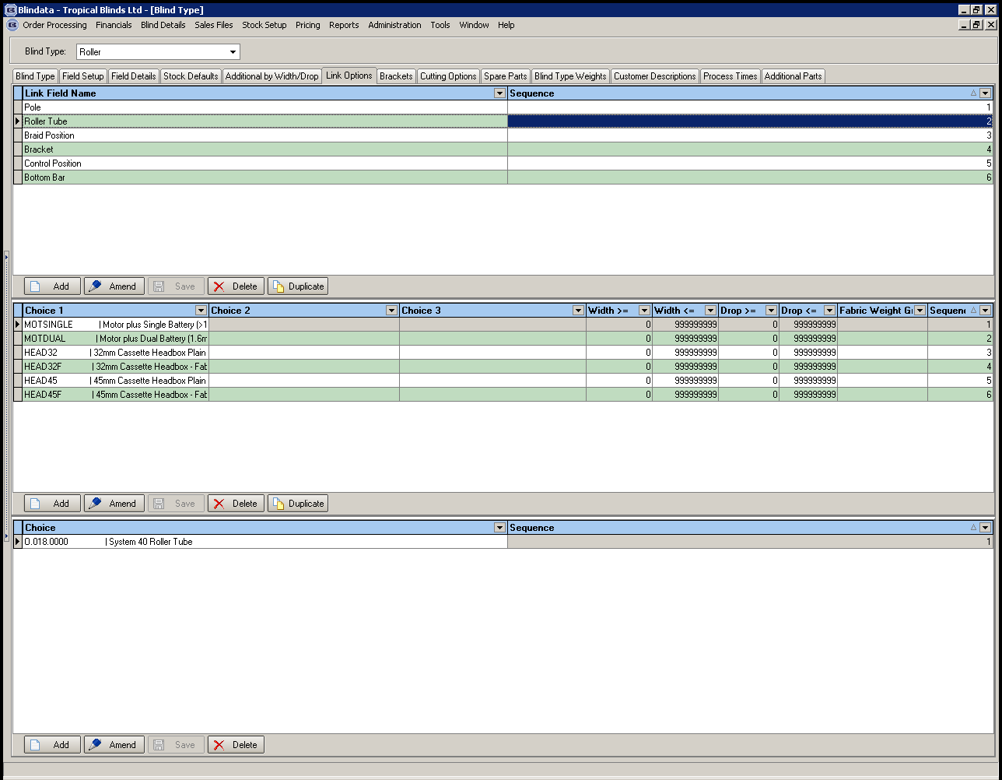

1986. Administration > Import From Excel > Blind Type Dataset

When the ‘Blind Type Dataset’ is imported, it also imports the ‘Link Option’ records that were exported (see dev 1985).

1987. Blind Details > Blind Types

We have made a few improvements to this form. ‘Field Setup’ now says ‘Option Setup’, and ‘Field Details’ now says ‘Option Selections’.

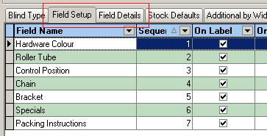

When a new record is created in Field Setup (Option Setup), it now sets flags to true in the same way it did in ‘Option Setup’ tab (when you open the blind type record).

The following tabs have been taken off this form and put on the main ‘Blind Types’ form, so there will be no tabs when this form is opened. (‘Stock Defaults’ and ‘Option Setup’ tabs were already on the ‘Blind Type’ form).

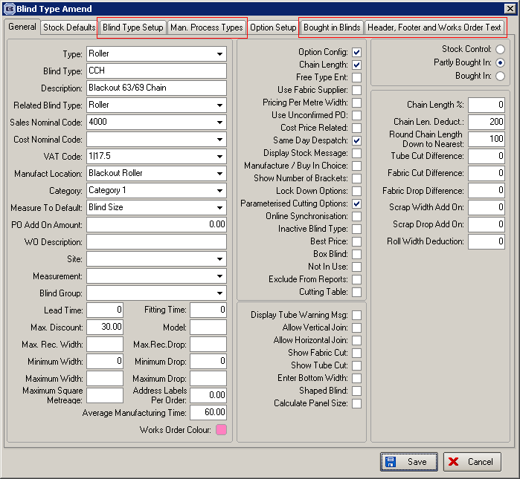

In the Blind Details > Field Details (Option Selections) tab, there is now a ‘Duplicate’ button. This button has the same functionality as the ‘Duplicate’ button in Stock Setup > Stock Items ie it will be possible to copy a stock record. Also, the ‘Product Code’ column is wider.

