Blindata Release Note 5.1.7 

26 November 2010

Bug Fixes and Enhancements

3201. Works Order – Bespoke 22

Fitting instruction (ready date) is now eing printed for misc orders as ‘Fitting Instructions’ can now be entered in the ‘Component’ entry form. The works order prints ‘Ready Date’ as it does for normal blind types.

Location now prints out for misc orders

The gap between ‘DELIVER TO’ and the address fields has been increased.

3202. Label – Bespoke 22

For miscellaneous items:

Description is being cut off

The fabric name and Qty/Mtr field are now printing.

3203. Vertical Vane Sheet

The grouping is now correct – occasionally it was printing more than one order on the same sheet.

If quantity > 1, then a separate barcode line is printed for each actual blind.

3204. Order Processing > Orders

When right clicking to view options, there is no longer a vertical scroll, as all options are displayed.

3205. Order Processing > Orders

After manufacturing, it is now possible to see free type in an option.

3208. Order Processing > Orders

The order detail line entry now changes the cost price properly for a bought in blind if you change the fabric, resulting in a different fabric group.

3209. Acknowledgement – Laser Print (Letterhead Logo)

This was sometimes printing an extra page when it shouldn’t. Fixed.

3210. Works Order – Bespoke 15

This report has been optimised.

New Work and Customer Requests

1976. Order Processing > Orders

It is now possible to choose to carry forward instructions to the next detail line. There is a new parameter called ‘Copy Spec Ins to Next Line’. If this is true, then when a second a subsequent detail line is added, it checks the previous detail line for special instructions. If the blind type is the same, then they are copied to the new line.

1977. Order Processing > Orders

There are now 20 characters in free type entry for an option.

1978. Sales Files > Customers

There is now a button for delivery address, so another form comes up for editing delivery addresses.

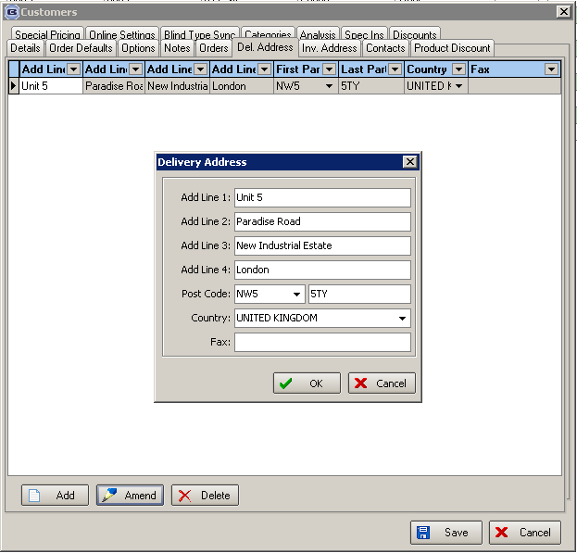
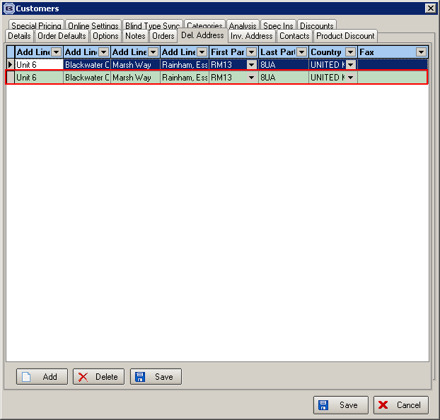

1979. Order Processing > Orders

On blind detail enquiry, the descriptions for totals now appear here. They are ‘Qty’, ‘Net’, ‘VAT’ (or Sales Tax), ‘Total’.

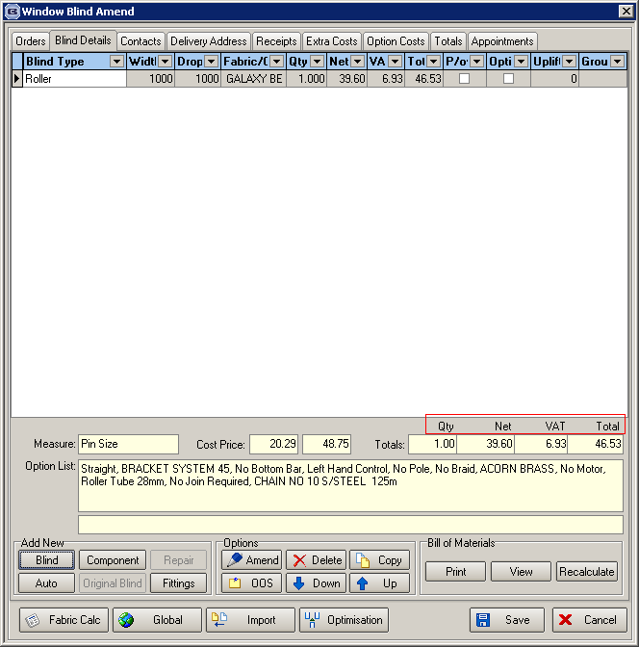

1980. Customer Label – 4” x 2”

The font for this label has been changed to Georgia font 16 point.

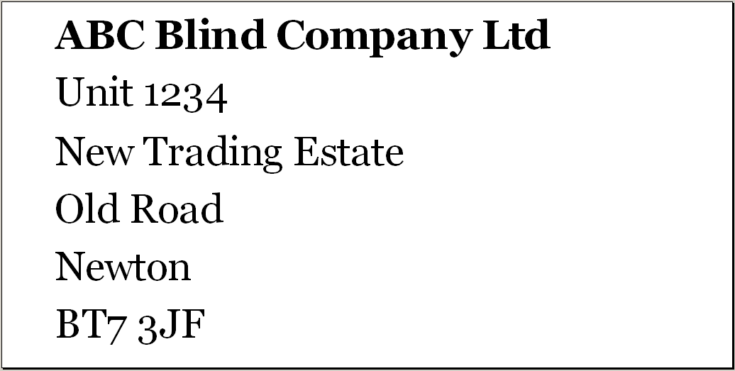

1981. Order Processing > Out Of Stock Management

It is now possible to view the bill of materials from this form (via a button) and flag the specific stock item that is out of stock.

