Blindata Release Note 5.1.6 

17 November 2010

Bug Fixes and Enhancements

3193. Order Processing > Orders

It was possible to change the entry for locked down options (Lock Down = true in Blind Type > Field Setup) by using the right click menu to edit them. It is no longer possible to do this.

3195. Order Processing > Quotations

When converting quotations to orders, sometimes record locking problems were being reported. This has been optimised.

3196. Works Order – Bespoke 31

The customer company name and the contact name are now printed on this report.

3197. Order Processing > Quotations

We recently added a parameter in Administration > Parameters called ‘Include Scrap % in Cost’. If the detail line was saved, then the bill of materials viewed, the cost price did not then display properly on the detail line (it showed the cost without the scrap % included). Fixed.

3198. Works Order – Label Blind Size

The number of vanes now prints if blind identifier = ‘Vertical’ or ‘Vanes Only’ or ‘Headrail Only’ or ‘Track’. In the previous version (only), it was not printing for ‘Headrail Only’.

3200. Out Of Stock Management

An error occured if ‘3 weeks OOS’ was set to true. Fixed.

3207. Works Order – Label 1

If ‘Box Blind’ = true and blind identifier = ‘Wood’ and ‘Enter Valance Size’ = true in the blind type record, then the Return information now prints out (same as if ‘Box Blind’ = false, which worked).

New Work and Customer Requests

1946. Works Order Label 1

If a return size is entered in imperial size and the works order is set up to print in metric, then the return size now prints in metric in ‘Works Order – Label 1’.
‘Return’ field choice also print here.

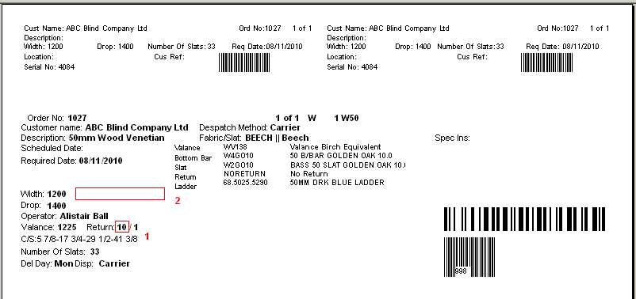
If a ‘Return Valance Size Add On’ record has orders for it, then it could be deleted. It is now possible to assign these to another existing ‘Return Valance Size Add On’ record.

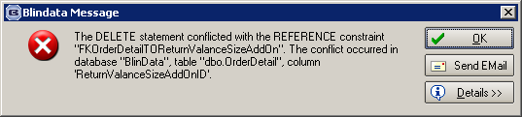

1956. Reports > System Reports > Customer Discount Report

There is now an option to print by rep.

1958. Production Lists

There is a new report for ‘Order Control Report by Rep. It is the same as ‘Order Control Report’ by split by rep, with a new page for different rep

1964. Sales Analysis by Blind Type (Weekly)

There is a new report based on the existing ‘Sales Analysis by Blind Type’, but it has Mon – Sun as 7 separate columns, then a total. We have removed cost, profit and contribution. Also the quantity for miscellaneous lines is 1 for each detail line. The report is in landscape.

1966. Out Of Stock / Back In Stock Emails

Previously, if an ‘Out of Stock’ or ‘Back in Stock’ email message was sent, it was sent to an internal email address. There is now also an option so that an email is sent to the customer. There is a new parameter in Administration > Parameters called ‘Send OOS Message to Customer’. If this is set to true, then the email is sent to the email address in the order, not to the internal email address. This parameter defaults to false.

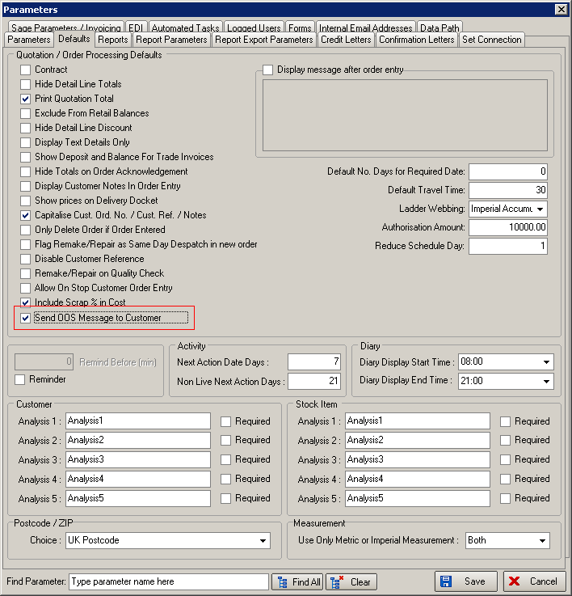

1967. Sales Analysis Reports (All)

This applies to all sales analysis reports that have a ‘Quantity’ column. Previously, if a report was printed out with records where blind identifier = ‘Miscellaneous’, the quantity is taken from the ‘Quantity’ field in the order detail line. The problem with this was that there may be a component line for many items and this distorted the figures completely. Therefore, we have changed the reports so that if the blind identifier = Miscellaneous in the order detail line, a quantity of 1 is used in the sales analysis reports. So if there is an order that has 5 detail lines, all for components, the quantity in the sales analysis would be 5.

1968. Auto EDI Email Acknowledgement

Previously it generated pop ups to inform if the email was successfully sent (I think this may be dependent on the version of Outlook that is running). This was no good if the EDI import is running automatically on a schedule, so the pop up has been removed. Also, the email address from the customer record is used for this and not the email address from the order. If it is not set to run automatically, then it is generated when it is checked manually.

1969. XML Files

It is now possible to store a XML folder location for EDI XML files. This can be set up in Administration > Parameters > EDI.

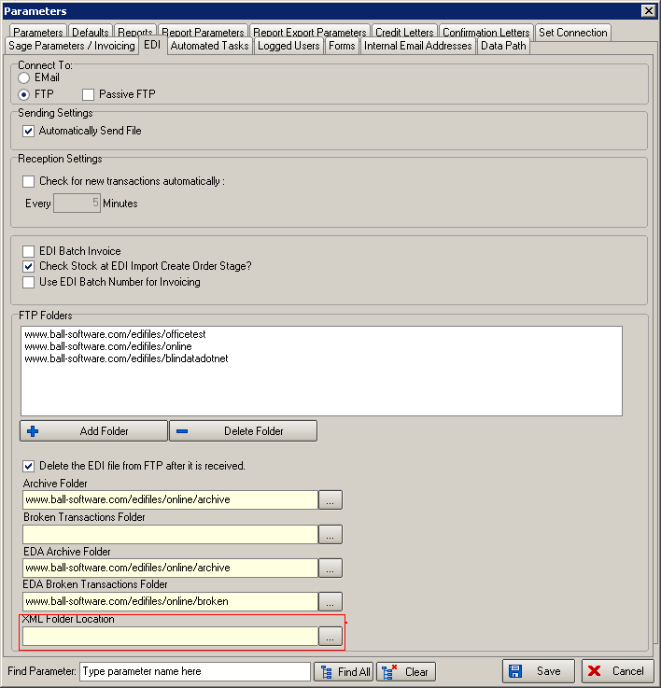

1971. Label Print – 3 ½ x 2 A

- Moved ‘Tube Cut Size’.
- Moved options up a bit and allowed for 12 to be printed.
- Removed the department
- Now print the barcode here (blind detail id barcode)

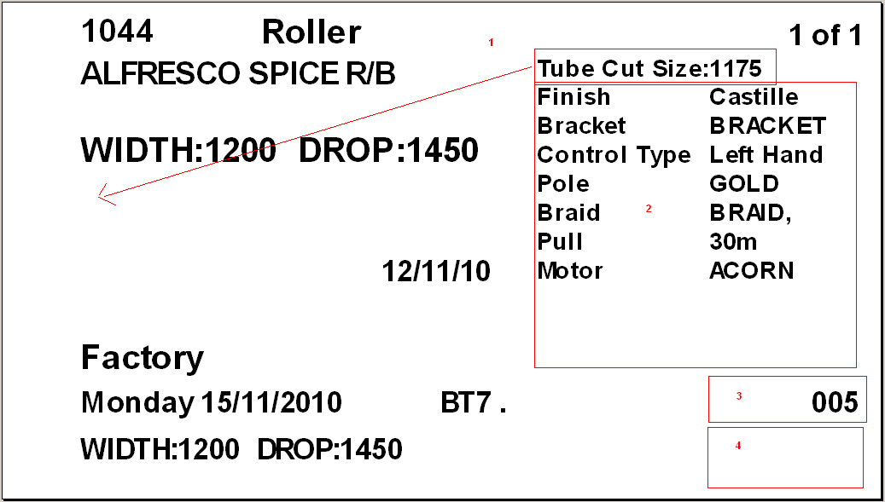

1972. Works Order – Label 1 (No Colour)

This is the same report as ‘Works Order – Label 1’ except that no colour strip is printed on the labels.

1973. Order Processing > Order Enquiry

It is now possible to see the ‘Purchasing Notes’ and ‘Sales Notes’ from the ‘Out Of Stock Management’ form here. There are buttons at the bottom of this form.

1975. Works Order – Label 1 (and Works Order – Label 1 (No Colour))

We now show the ‘Fabric Cut Drop’ for blind identifier = ‘Austrian/Roman’ in the same way it is shown for blind identifier = ‘Roller’. There is a new field called ‘Fabric Drop Difference’ in the blind type form for blind identifier = ‘Austrian/Roman’.

