Blindata Release Note 5.1.5 

5 November 2010

Bug Fixes and Enhancements

3183. EDI Import

Same Day orders for consolidated delivery day customers are now work properly. If a consolidated customer places a same day order online, it is imported to the relevant required date and not to the customers next delivery day.

3184. EDI Amendment Import

If an attempt is made to import an EDI amendment file, but it fails, the EDA XML file now, correctly, goes into the specified broken file folder.

3188. Sales Files > Customer > Email Order Report

This report now shows ‘Required Date’ instead of ‘Delivery Date’.

3190. Sales Files > Customer > Email Order Report

This report now only shows orders where status is before ‘Invoice Created’. It does not show cancelled orders.

New Work and Customer Requests

1923. Works Order – Label 1

There are now different colour codes for must go, etc. There is a colour strip that goes across all four labels.

Yellow = Must go and same day despatch
Blue = Remake/Repairs
Orange = Consolidated
White = Standard orders

1942. Order Processing

There is now functionality for SMS Order Acknowledgements. There is a new field in the Company Details form Email Text section for ‘SMS Acknowledgement Text’. There is also a new flag on the customer record called ‘SMS Acknowledgement’. If ‘Display Checked’ is set to true, the SMS are generated when an order is flagged as ‘checked’ and sent to the mobile number on the customers record. If an order is checked during the EDI import, then the SMS email is generated at this stage. If ‘Display Checked’ = false, then the SMS acknowledgement message is sent when the order is saved (and if ‘SMS Acknowledgement’ = true in the customer record).

1943. OOS Management Form.

A number of changes have been made to this form.

It is now possible to see text added on the OOS form from the order form (by right clicking and selecting ‘View Detail Lines’ on Order Amend Enquiry).
It is now possible to update order notes from the OOS form (there are advanced permissions for this).
There is a flag to highlight orders that will be OOS for more than 3 weeks (ie the ‘Exp. Del. Date’ for the OOS item is 3 weeks or more ahead of the order date.)
The Exp. Del. Date for the OOS item now appears as a view only column in the form.
The ‘Edit’ button at the bottom has been split into ‘Purchasing Notes’ and ‘Sales Notes’. There are user permissions for each.
When a Purchasing comment is added to an order, there is now an option to apply the same comments to all orders with the same OOS item.

1947. Invoice – Bespoke 31

Invoices and Proformas now print the size as the ‘Priced By’ size.

We have also amended the detail line layout so it prints the base price and options price separately before discount is applied.

1948. Quotation – Bespoke 31

Same as dev 1947, but for quotation.

1949. Sales Files > Customers

There is now a better history record of what has been changed in a customer record. For example, at the moment both history for ‘On Stop’ and ‘Off Stop’ says ‘On Stop’. As well as holding the field that was changed we now hold what it was changed from and what it was changed to.

1950. Delivery Note – Bespoke 31

Delivery notes now print 6 blinds per page.

Delivery company name now shows contact name instead of ‘Delivery Company’.

1952. Order Processing > Orders

Previously remakes/repairs were automatically flagged as ‘Quality Control’. This can now be de-activated.

There is a new parameter called ‘Remake/Repair on Quality Check’ in Administration > Parameters. If this is set to true, then remakes/repairs will go on quality control (this is what happens at the moment). If it is set to false, then ‘Quality Control’ will not be set to true on the order for a remake/repair. It defaults to true.

1953. Order Processing > Orders

There is now a way to temporarily override a customer being on stop, ie a customer is on stop but it is agreed to let them have one order. Previously you have to take the customer off stop then remember to put them back on stop.

There is a new parameter in Administration > Parameters called ‘Allow On Stop Customer Order Entry’.

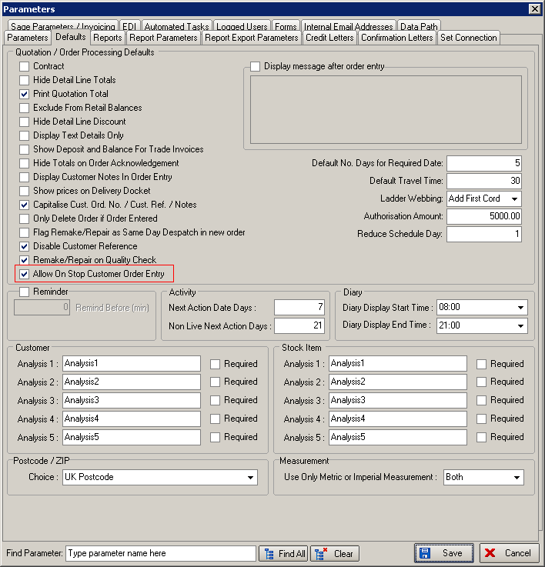

Now, if a customer is on stop, there is an option to override this, which is only usable by certain users. They will have to enter their username and password, and this will allow the order to be processed and a history record will be created showing who did this.

There is an advanced permission for a user to do this, called ‘Override Customer On Stop’.

If an operator tries to enter an order for a customer that is on stop, the following form will appear.

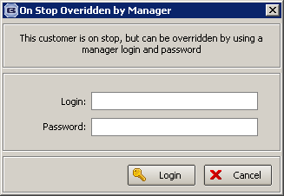

At this point a manager should enter their username and password, allowing the order to proceed. An order history record will be created when this is done.

1954. Administration > System Tables > Customer Default Options

It is now possible to select by Customer Account number when entering a new customer default option.

1955. Administration > Import From Excel

There is a new option to import ‘Customer Default Options’. The spreadsheet includes fields for customer, blind type, option name and stock item code.

1957. Sales Analysis by Blind Type by Customer

There is now a column for blind quantity.

1962. Order Processing > Order Enquiry > Carriage Report

There is a new report in Order Processing > Production Lists that shows: account code, company name, order no, delivery address (line 1 and postcode only), blind type, number of blinds. The report is by customer then order no then grouped by blind type. The criteria is by required date (default to next working day) only.
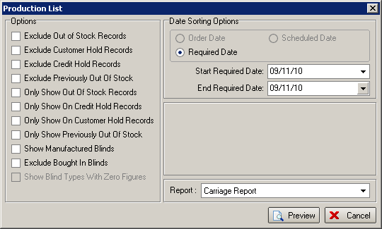

1963. Cord Spacing

There is now an ‘Extra Cord’ field in the ‘Cord Spacing’ record. This is required because we want to jump from 5 to 7 rout holes for one customer This is required because the blind looks better.

The ‘Extra Cord’ field defaults to 0.

At the moment, the cord spacing is worked out as follows:

First Cord = 150, max spacing = 500, max size = 2300, extra cord = 0

Blind width = 2200, so (2200 – 300) = 1900 / 500 = 3.75, which rounds to 4. 1900 / 4 = 375, so the cord spacing is 375.

Example 2

First Cord = 150, max spacing = 500, max size = 2300, extra cord = 1

Blind width = 2400, so (2400 – 300) = 2100 / 500 = 4.25, which rounds to 5. % + extra cord = 6. 2100 / 6 = 350, so the cord spacing is 350.

1965. Reports > System Reports > Orders by Operator

- The ‘Order Numbers’ column has been renamed ‘Order Quantity’.
- There is a new column for the quantity of blinds entered as well.

1970. Order Processing > Orders

There is a new parameter in Administration > Parameters called ‘Include Scrap % in Cost’. This defaults to false. If it is true, then the cost price is the total of the ‘Price Incl Scrap %’ in the bill of materials.

