Blindata Release Note 5.1.3 

22 October 2010

Bug Fixes and Enhancements

3171. Works Order – Label 1

The ‘Cust Ord No’ has been removed from this label.

3172. Purchase Order Enquiry > Generate Regular PO

When you generate a regular PO, the cost prices were sometimes not being picked up properly. Fixed.

New Work and Customer Requests

1907. Stock Setup > Stock Items

Previously you had to click on the right hand arrow to see all the tabs. All the tabs are now displayed in 2 or 3 lines. This has also been done in Administration > Parameters and Sales Files > Customers.

1913. Order Processing

We have removed the ability to flag an order OOS from the stock warning for certain users. Therefore there is an advanced parameter to do this. It is called ‘Allow Set As OOS’. If it is set to true, then when the OOS message appears in order entry, the user has permission to set OOS to true.

1922. Daily Outstanding Orders Report

There is a new report by customer that shows order number, customer order no, order date, delivery date, which is then emailed to the customer.

There is a new flag held against the customer record called ‘Email Order Report’. If it is set to true, then the system is able to email this report to the email address held in the customer record.

This can be done from a button in the customer enquiry form called ‘Email Order Report’.

The new flag ‘Email Order Report’ is also a column choice in the customer enquiry form.

1927. Order Processing > Orders

Previously if a fabric was flagged as ‘Discontinued’, it did not appear in the fabric lookup in the order detail entry. There is a new parameter called ‘Display Discontinued Fabric’ in Administration > Parameters. This defaults to false. If it is set to true, then the fabric is displayed in the fabric lookup, but when selected, a message appears saying ‘This fabric has been discontinued. Please contact the customer’ and does not allow you to continue, unless another fabric is selected.

1928. Stock Setup > Stock Items

It is now possible to enter a formula instead of a preset calculator. This can be created in Administration > System Tables > Dimension Calculations.

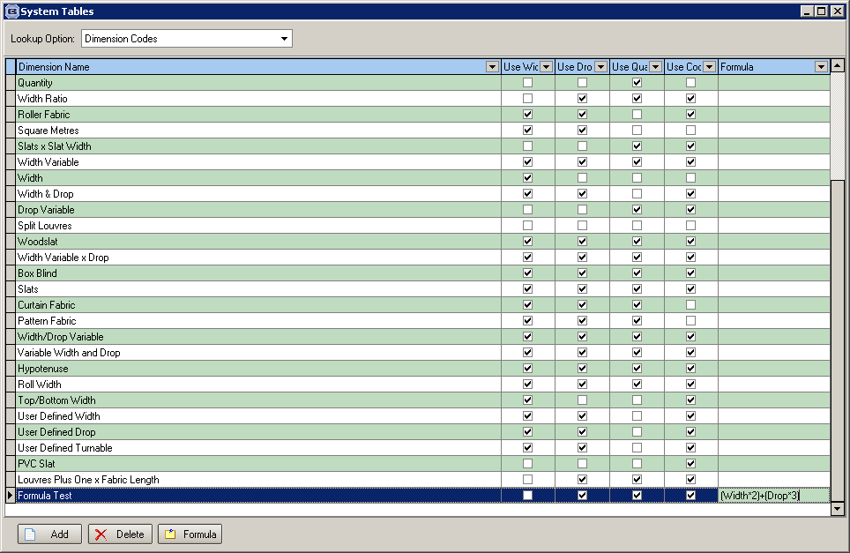

This formula record now becomes available as a calculator choice in Stock Items etc.

1929. Blind Types > Stock Defaults tab

There is now a Save button.

1930. Blind Details > Blind Types

There is now a default ‘Measurement’ for blind type, which will be either ‘Metric’ or ‘Imperial’. This overrides the ‘Metric/Imperial’ setting in the customer record. This is relevant for Perfect Fit as metric measurements are more accurate and so when a blind type is entered in an order, it can default to either metric or imperial..

1932. Financials > Post Invoices to Sage

When you filter records in this form, only the filtered records get posted (and only if they have been validated first if they are being posted to Sage).

