Blindata Release Note 5.1.2 

15 October 2010

Bug Fixes and Enhancements

3149. Invoice – Bespoke 30

Header and detail lines have been moved up by 3cm. Totals stay where they are.

If detail lines are in imperial sizes, they print as fractions, not decimals ie 45 3/8, not 45.375.

3159. Works Order – Bespoke 31

The repair description is now printing more lines on this works order.

3160. Financials > Post Invoice to Sage > Post Invoices (Lakeview Invoice Export)

The invoice number is now held in field reference_1 in the XML file.

3164. Order Processing > Orders

If you copied a detail line, and if there is free text amount entered against one of the options, it the free text did not get copied. It now does get copied.

3167. Order Processing > Orders

The fabric group has been moved lower so the fabric description can be extended to the same length as the blind type description.

3168. Quotation – Bespoke 31

The footer information is now correct.

3165. Order Processing > Orders

If a ‘Number of Vanes’ price was put in as a negative number in Pricing > Number Of Vanes Pricing, the option price remained as zero in the option price in detail line entry. It worked properly if a positive amount was entered. This has been fixed.

3169. Financials > Invoice Batch Print > Email Only

For ‘Invoice – Bespoke 31’, emails were being sent out with pdfs that could not be opened, in large email runs. Smaller runs of emails worked properly.

This has been fixed by adjusting how the logo was held in the pdf.

3170. Post Invoices (Lakeview)

If you created a XML file for an account with & in the account code, the account code in the XML file did not get created properly. This has been fixed.

New Work and Customer Requests

1900. Label 5161

Our American customer has asked for imperial sizes to print out in a different format. Instead of 45 1/8, 45 ¼, 45 3/8, 45 ½, 45 5/8, 45 ¾ and 45 7/8, it now prints 45.1, 45.2, 45.3, 45.4, 45.5, 45.6, 45.7. In other words, instead of 1/8s printing, it uses the first decimal place to identify the fraction.

This has only been done on this label.

1911. Blind Details > Blind Types

If blind identifier = Roller or Roman or Pleated, there is a new field called ‘Roll Width Deduction’. This is an integer. When an order is entered for a roller blind, the roll width of the fabric is checked to see if it can be made. The calculation has been changed so it checks (Roll Width – Roll Width Deduction) instead of just Roll Width.

This is also be applied to fabric optimisation. If the roll width is 2000mm and the ‘Roll Width Deduction’ is 30mm, then the fabric optimisation should be done on a roll width of 1970mm. It is also done for square metre pricing but not for the BOM Calculation.

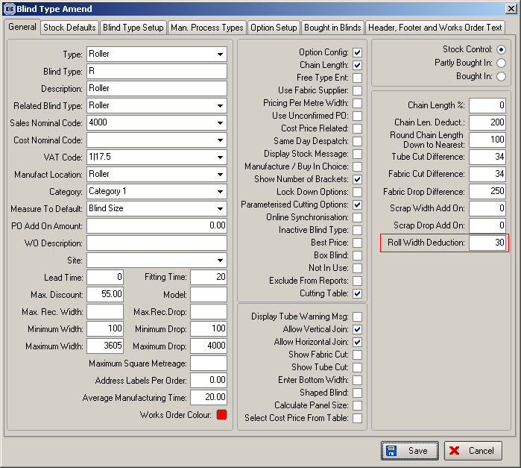

1914. Label Print – Bespoke 29

A new label print has been created, based on ‘Label Print – Bespoke 8’.

- Removed
- Allowed more options to print downwards – up to15.
- Moved detail bar code to middle of address label – moved ‘Location’, ‘Cust Ref’ and ‘Order No’ down.
- Removed
- Moved down to right of barcode.
- Removed.
- Removed.
- Removed.
- Moved to right by 20mm.

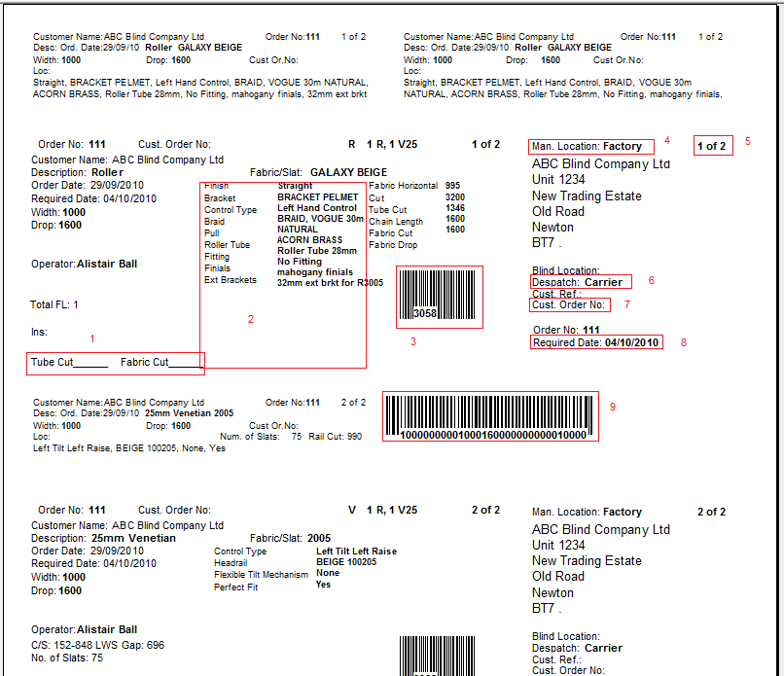

1919. Invoice Batch Print

A significant change has been made to the ‘Invoice Batch Print’ to take into account printing and emailing of invoices. There is now an option to select both ‘Print Only’ and ‘Email Only’ invoices, and to decide whether they are going to be changed to ‘Invoice Printed’ or not.

As an example, half of the invoices may be printed and half emailed, but if a print run of copy invoices is to be done first, then ‘Print All’ and ‘Update To Printed’ not true would be selected.

Once these invoices were printed, ‘Print Only’ and ‘Email Only’ runs would be done as before.

Please note that ‘Update To Printed’ is only enabled if ‘Print All’ has been selected.

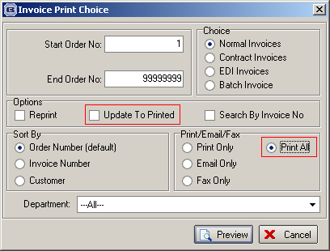

1921. Order Processing

There is a new parameter in the roller blind type form called ‘Display Tube Warning Message’. If this is set to true, a warning message to say that blind is over 2m and may need a heavier tube will appear.

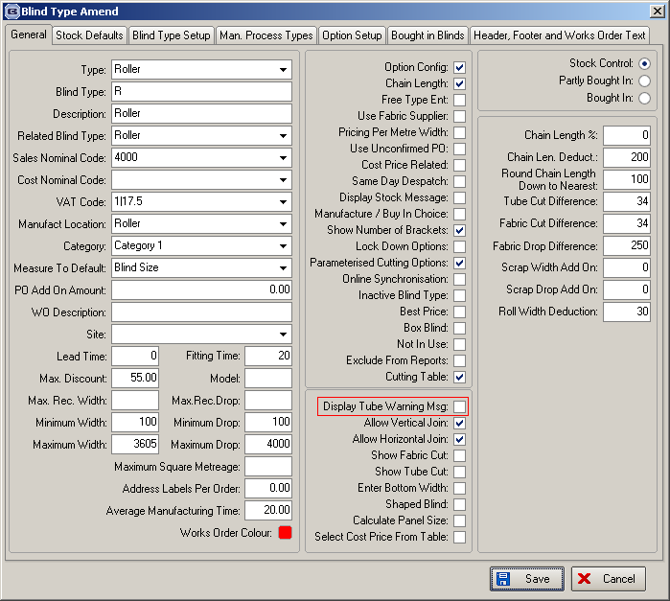

1924. Administration > Parameters

There is a new parameter to only update credit hold if order has a status ‘Order Entered’. This parameter is called ‘Credit Hold At Order Entry Only’. It defaults to false but if set to true, then an order can only go on ‘On Credit Hold’ if the order status of the order is ‘Order Entered’.

1925. Global Search

There is a new menu option in ‘Order Processing’ called ‘Global Search’. The purpose of this form is to look in Orders, Quotes, Archive orders: to look for fields order no, cust ord no, customer reference, customer name, order date range (start and end) and default end date to start. When the search is done, it displays all records that match the search and allows the user to view them (in the same way as view works in ‘Archive Enquiry’).

1926. Sales Files > Customers

There is a new column choice for ‘Email Invoice Only’.

