Blindata Release Note 5.1.1 

11 October 2010

Bug Fixes and Enhancements

3089. Order Processing > Orders / EDI Import

If an EDI order comes in after the evening cut off time then the scheduled date should not be the next day. It is now at least the following day. For example, if an order is accepted on 03/10/10 (Sunday) after the evening cut off time, then the order date will be 04/10/10 and the scheduled date will be at least 05/10/10 (previously it would schedule it in 04/10/10 if there was scheduled time available).

3143. Works Order – Bespoke 31

- The customer order no field is no longer being cut off.
- The fabric totals are now grouped by fabric.
- We have included ‘DEL NOTES’ in the header, as we did in ‘Delivery Docket – Bespoke 31’.

3144. Production Documentation

When we print ‘Works Order – Bespoke 31’ and ‘Label Print – Bespoke 33A’ from Production Documentation, it is now possible to print all non printed orders for each. Previously, if you printed one report, it would not print the other without setting the reprint flag to true.

3145. Works Order – Label 1

The bottom bar calculation for blind identifier = ‘Austrian/Roman’ was wrong. It was using the Drop but has been changed to use the Width.

3146. Order Processing > Orders

The maximum scheduling quantity is now taken into account for a ‘Same Day Despatch’ order. It is treated the same way as a normal order ie if the number of blinds in the order > large quantity, then the order is split across more than one day and ‘Same Day Despatch’ is switched off..

3147. Remake/Repair/Redespatch

It is possible to recreate an order for a customer who by copying an order from the archive using the ‘Repair/Remake’ functionality. It is no longer possible to do this for Repair/Remake if the customer is on stop, but Redespatch is ok. A message now appears saying ‘This customer is on stop’.

3148. Production Control Report

There is now a new page for each blind identifier, then within ‘Required Date’ the report is ordered by blind type ie for blind identifier ‘Vertical’ for a certain required date have all 127mm Vertical then all 89mm Vertical.

3150. Invoice Posting (Lakeview)

The ‘Customer Reference validation problem has been fixed.

3151. Production Documentation

If you printed works orders here, they go to the correct printer. If you then print labels, they go to the same printer (eg EPSON1) as the works orders, when they should go to EPSON2. If you printed the labels from ‘Order Amend Enquiry’, it goes to the correct printer. This has been resolved.

3152. Invoice Batch Print

If you print invoices with the ‘Print Only’ option, it now prints only invoices where the customer has ‘Email Invoice Only’ switched on.

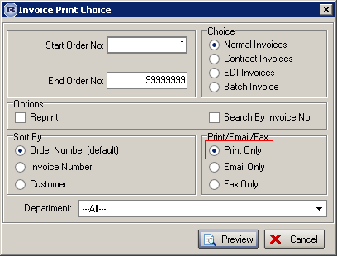

3154. Financials > Invoice Batch Print

If you select ‘Print Only’, it did not print invoices for ‘Email Invoice Only’, but it still changed the status of those orders to ‘Invoice Printed’. It now only changes the status of those orders that have been printed ie those orders where order status = ‘Invoice Created’ and customer field ‘Email Invoice Only’ = false.

3155. Financials > Invoice Batch Print

When you reprint invoices with ‘Email Only’ switched on, a number of things have been amended..

The message about delivery address emails being missing has been incorporated in the ‘Confirm’ form, so the user can select ‘No’, then go and enter the relevant email addresses.

3156. Order Processing > Orders

If you entered a blind detail line, then entered a carriage line, you could process the order with no problem. But if you entered a blind detail line, then saved the order and printed a works order, then go back and enter a carriage line, the order status changed back to ‘Order Entered’, but it was then not possible to print the works order – it says there are no lines to be processed. This has been fixed.

3157. Out Of Stock Management

This form now only includes orders that are out of stock. It does not look at quotes or cancelled orders or credit notes.

New Work and Customer Requests

1815. EDI Import

Once an order has been imported, there is now functionality to email an order acknowledgement immediately to the email address that is held in that order.

There is a new flag in the customer record called ‘Auto Email EDI Order Ack’. If this is set to true, then when an EDI order is imported, an order acknowledgement (using the pdf acknowledgement layout in Administration > Parameters > Report Export Parameters) is emailed to the customer.

1908. Sales Files > Customers

If invoices are going to be emailed to customers, then they should always be emailed as a pdf. Therefore we no longer need the choice of ‘Use Invoice Pdf Format’, because this will always be true if the invoice is being emailed. The field has been removed.

1909. Label Print – Bespoke 33A

If there are more 7 cutting sizes to print on the label, they now print in a second column.

1910. Delivery Docket – Bespoke 31

‘Contact Name’ and ‘Tel No’ now print on the delivery docket, above and below the address.

There is now a column heading for ‘Quantity’ and ‘Description’.

1912. Archive Enquiry

The field to link to the EDI file in the orders list is now in the archive enquiry.

1915. Delivery Docket – Bespoke 31

‘Delivery Date’ and ‘Account Code’ now print below ‘Order No’.

Account Code to also print below ‘Order No’.

If there is a separate customer fabric description, it now prints instead of the normal description

1916. Label Print – Bespoke 33A

- If there is a separate customer fabric description, it now prints instead of the normal description
- Fabric length now prints to 1 decimal place.
- For Impala, it now prints STD for single bunch and STD & REV for split
- Number of vanes and Impala fields now print for blind identifier = Headrail
- Total fabric length was printing 0 for pleated fabric – fixed.

1917. Works Order – Bespoke 31

- Removed ‘Customer Reference’, replace with ‘Despatch Method’
- Number of vanes and Impala fields now print for blind identifier = Headrail
- For Impala, it now prints STD for single bunch and STD & REV for split
- Cord spacing prints only if ‘Show Cord Spacing’ is switched on in blind type.
- If works order is for a repair, the text was being cut off on the report.
- Put barcode on works order for first detail line for component lines (ie blind identifier = Misc)
- Carriage text now prints below ‘Notes’

1918. Invoice – Bespoke 31

Replaced ‘Cust Ref’ with ‘Cust Ord No’ on the invoice header.

Blindata Online

W88. Order Processing

When entering a vanes only blind, it now works in the same way as the desktop order entry. If you enter the number of vanes, it should calculate the width.

In the desktop system, if ‘Calc Width From Vanes’ is set to true, then you can enter either the number of vanes or the width and it will then work out the other figure. In the online version you enter the width and it is now calculates the number of vanes.

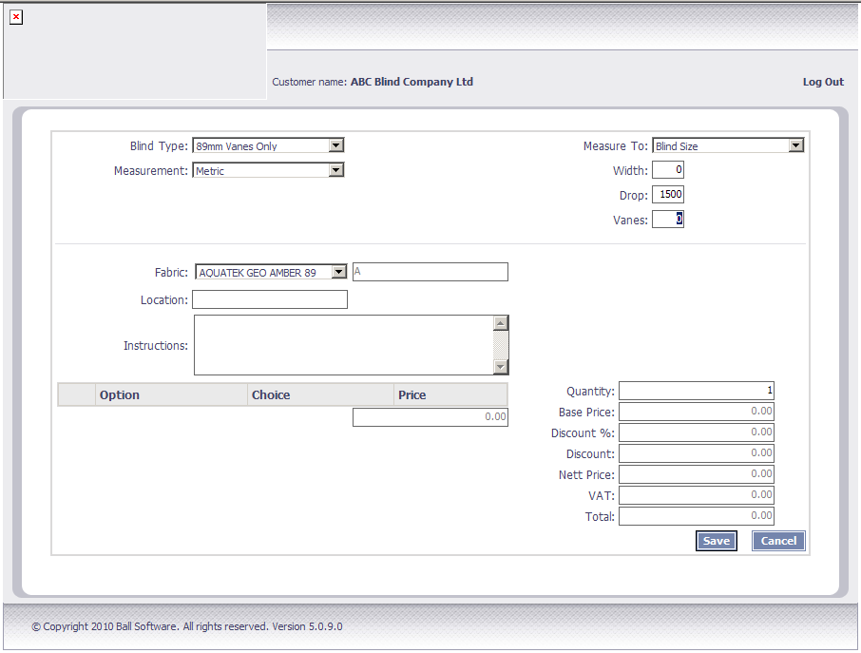

W90. Google Chrome / Firefox

If you save an order in Chrome or Firefox, then try to amend it immediately, a status code error sometimes appeared and then the record was blocked. Fixed.

W91. Order Processing

If you amend an order that is not on page 1, then after saving the order, the form goes back to page 1. It should stay at the page you are on.

W92. Order Acknowledgement Print

If a blind is entered that has blind identifier = ‘Vanes Only’, then the number of vanes now prints on the order ack.

