Blindata Release Note 5.0.9 

27 September 2010

Bug Fixes and Enhancements

3124. Label Print – Bespoke 33A

The label layout has been adjusted slightly.

3125. Blind Types > Blind Details

In dev 1887, we added the ‘Ladder Webbing’ field for blind types where the blind identifier = Wood and Pleated. Previously it had been done for blind identifier = Venetian, but this was removed. ‘Ladder Webbing’ now appears (and is calculated in order entry), if blind identifier = Venetian or Wood or Pleated.

3127. Label Print – Bespoke 33A

- If a control length is entered as imperial, but the labels and works orders are set to print in metric, then the control length now prints in metric.
- We have removed no of pleats or no of slats on label for pleated.
- Moved ‘Fabric/Slat’ down a line and put ‘Location’ to the right of ‘Customer Name’. Removed ‘Fabric/Slat’ label to make more room for fabric description
- The options are now lining up with choices.
- If blind identifier = Panel and ‘Calculate Panel Size’ is true, the panel size and no of panels now prints.
- No of brackets now prints on the big label (from Blind Types > Brackets) to the right of ‘Control’ if ‘Show Number of Brackets’ in the blind type record = true.

3129. Invoice – Bespoke 31

The following field names now appear in the box properly on the pdf invoice that is emailed out.

3130. Sales Files > Customers

When you set ‘Email Invoice Only’ = true, then it sets ‘Fax Email Only’ as true as well. It now only changes ‘Email Invoice Only’.

3132. Login

If you click on ‘Cancel’ in the Login form, an error appeared. Fixed.

New Work and Customer Requests

1862. Blind Details > Cord Spacing

If the Parameters > ‘Ladder Webbing’ is set to one of the Imperial settings, then it is now possible to enter the cord spacing values in imperial sizes. However the underlying data is still stored in metric, as it affects the cord spacing calculations.

1873. Delivery Docket (A4 Preprinted)
There is a flag in the customer record called ‘Print Cust Ord No Barcode on Delivery Docket’. This has been changed to ‘Print Cust Ref Barcode on Delivery Docket’ and the ‘Customer Reference’ is in the barcode.

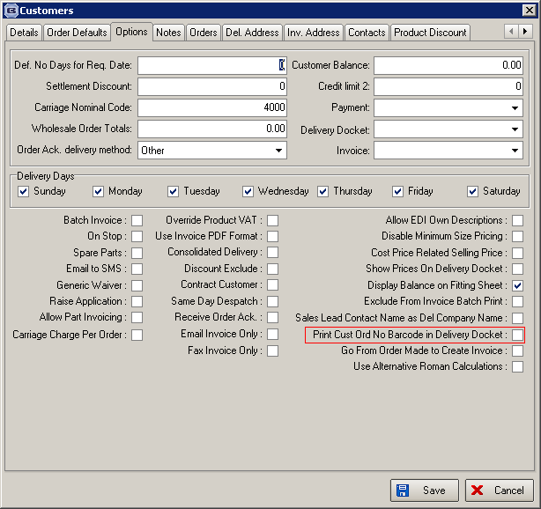

1880. Kanban OOS

There is a new flag in the stock record called ‘Kanban OOS’. Then in the order entry program, if any record in the BOM has ‘Kanban OOS’ = true, a message appears saying ‘Stock item …. Has been flagged as out of stock in the Kanban’.

1881. Blind Type Dataset

At the moment we have functionality to export records from Blindata using Administration > Export Data > Blind Type Dataset.

There is also a function to import the blind type dataset in Administration > Import From Excel > Blind Type Dataset.

The purpose of this functionality is to make it easier for our customers to use EDI. Here is an example. Company A and Company B are both users of Blindata. Company A is going to start buying blinds from Company B and want to do this using EDI. They need to set up their Blindata so they can enter orders and then transmit them to Company B. When Company B receives them, they will get imported via EDI. It is a lot easier if the blind type and stock codes being are the same and do not have to be mapped.

Therefore the reason for creating the ‘Blind Type Dataset’ was to allow Company B to send a file to Company A that can be easily imported. The following improvements have been made to this process.

Administration > Export Data > Blind Type Dataset

When this option is selected, it is now possible to select records by blind type or to select all.
The export file now also includes the blind type record: this has fields for blind identifier code, blind type code, blind type description. There is also a record for the bought in supplier. This contains blind type and supplier code. There are also options to use the Company Details account code as the supplier code and to default the sales nominal code to 4000.

Administration > Import From Excel > Blind Type Dataset

When the spreadsheet is imported, it will now import the blind type record (if the blind type code does not already exist) and also the bought in record (containing blind type and supplier code). Where fields do not exist (eg sales nominal, VAT etc, we should use defaults eg VAT code from Parameters, first sales nominal code in the nominal table).

So now it should be possible to export blind type(s) to a ‘Blind Type Dataset’ spreadsheet, and then import it to any other Blindata database. Once it is imported, the customer will be able to enter a sales order straight away for that blind type.

1889. Stock Setup > Fabric Group Setup

There is a new column and field choice at the bottom for ‘Default Code’.

1890. XML File Export

If ‘Transfer File 2’ is switched on in the supplier record, then a different XML file is generated (for Arena). Some minor changes have been made to the file.

- The nesting has been altered.
- The sizes are now in centimetres, not millimetres.
- The date format has been altered.

1891. Blind Details > Blind Types

For blind identifier = Vertical, there is now a flag called ‘Calc Width From Vanes’. If this is set to true, then when a detail line is entered for a vertical blind, the number of vanes is displayed and the user can enter an amount. The width is then calculated and the blind priced (just like ‘Vanes Only’).

1892. Administration > Parameters

There is a new parameter called ‘Disable Customer Reference’. If this is set to true, then the ‘Customer Reference’ field in the order entry is disabled.

1893. Delivery Docket – Bespoke 31

The ‘Delivery Notes’ (entered using the ‘Delivery Notes’ button in ‘Order Amend Enquiry’ now prints below the delivery address on this report. The text prints in bold.

1894. Blind Types > Cutting Options

In the ‘Formula’ form, it is now possible to select ‘Control Length’.

1895. Fabric Group Update

The ‘Pack Quantity’ field is now a column choice and update.

1896. Blind Types > Blind Details

It is now possible to print out labels by colour – different colour for different blind types. There is a colour setup in the blind type record (similar to the way we can choose a colour for an order status). This colour is then used on the label for the blind type and fabric description in ‘Label Print – Bespoke 33A’.

1898. EDI Enquiry > Receiving Data > JL EDI Import

We have made an amendment to allow for the importing of the latest John Lewis EDI files.

1893. Delivery Docket – Bespoke 31

The ‘Delivery Notes’ (entered using the ‘Delivery Notes’ button in ‘Order Amend Enquiry’ now prints below the delivery address on this report. The text prints in bold.

