Blindata Release Note 5.0.5 

20 August 2010

Bug Fixes and Enhancements

3108. Sales Files > Customers

In the ‘Copy’ button, the following changes have been made.

- ‘Go’ is now ‘Execute’.
- After copying a record, the record pointer points at the new record. This happens after adding a customer as well.

3109. Order Processing > Orders

Previously, if you clicked on the ‘Contract’ flag in the Totals tab, the contact name appeared in the ‘Contract Text’ box. The contact name is no longer placed there.

3110. Order Processing > Orders

In the component detail line entry, the tab order was slightly wrong. After ‘Nominal Category’ it now goes to ‘Qty/Mtr’. Previously you had to hit an extra tab.

3111. Works Order – Label 1

If blind identifier = Panel Blind, the ‘Panel Width’ and ‘Number of Panels’ now print on ‘Works Order – Label 1’. This had been working before we included ‘Headrail Cut’ and ‘Fabric Drop Cut’.

New Work and Customer Requests

1811. Order Processing > Orders > Status Field Button

There is now a flag on this form to allow the status of the detail lines to be changed as well as the order header.

This flag is called ‘Also Alter Detail Line Status’ and should default to true. If it is set to true and the order status is changed, then the status in the underlying detail line(s) are also changed.

1841. Vertical Vane Production Report

We made a change to this report so it is split by group number, and the group number is also printed after the order number, in the style 285 / 1. If there is no group entered in the order, then the report stays as it is.

1842. Order Processing > Orders

We have a customer that does not want to have the required date calculated at all and wants to enter it themselves before they enter any detail lines. Previously the following message appears after each detail line is entered.

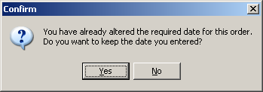

Therefore we have created a new parameter in Administration > Parameters called ‘Disable Required Date Calculation’. This defaults to false. If it is set to true, then the required date is not calculated at all (from parameters or customer or blind type) and the user enters a date. The ‘Customer Required Date’ flag is still set to true. If this parameter is switched on and a required date is not entered in the order, a message appears saying ‘Please enter a required date’.

1843. Label Print – Bespoke 22

1. The works order number and serial number now print at the start of this line (in very small print) and the works order text should be moved along a bit.

2. If a vertical blind has an Impala headrail, then the spacers are printed in brackets after the number of vanes (same as ‘Works Order – Label Blind Size’).

1844. Printer Setup

Previously the printers were only set up against reports in Parameters > Reports. It is now also possible to hold printers against users and reports. Therefore there is a new tab on the Users form that enable specific printers to be set for each report that is in Report Parameters.

1845. Panel Blind Calculator

A new calculation is required for fabric when used in a panel blind. Panel blinds are usually made with roller fabrics.

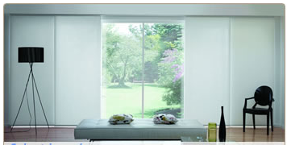

We would normally set up a blind type for a panel blind with ‘Related Blind Type’ = Roller, because they share the same fabrics.

However this causes a problem when the stock calculation is done for panel blinds, as we are not using the same amount of fabric as a roller blind.

Therefore we have made adjustments to calculators ‘Drop’, ‘Width’ and ‘Width or Drop’ to allow for the blind identifier. If the blind identifier = Roller, then these calculators remain the same. If the blind identifier = Panel Blind, then the fabric is calculated as follows:

There are 3 things needed to work out how much fabric to use for a panel blind.

- Panel width – the panel width is worked out either from the panel size in ‘Single Bunch Panel Blinds’ or ‘Split Bunch Panel Blinds’, or if ‘Calculate Panel Size’ = true in the blind type record, then it is calculated.
- Panel drop – this is the ‘Man Drop’ – ‘Fabric Drop Ded. Calc’ in the blind type record.
- Number of panels – this is the number of panels in the order detail line.

Therefore can calculate how much fabric we need ie the total of all the panel pieces. This logic is similar to a roller blind that has a join ie more than one piece of fabric is required.

It is then possible to optimise the fabric in the usual way.

1846. Order Processing > Orders > Out Of Stock

Previously it is only possible to flag a detail line as being out of stock in the ‘Order Enquiry’. We now have functionality to set this flag in the order entry program. This can be done in two different ways.

- There are two new buttons in the ‘Window Blind Amend’ form – one for ‘Out of Stock’ and another for ‘Back In Stock’. These both have advanced permissions. They have the same functionality as the OOS buttons in the ‘Order Enquiry’ form.
- If ‘Display Stock Message’ is switched on in the blind type record, and a message comes up saying there is not enough stock, another form appears that says ‘Do you want to flag this detail line as being out of stock?’. If yes, then the detail line is flagged as out of stock.

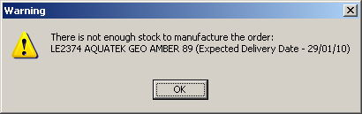

1847. Stock Items > Default Options tab

There is now a ‘Save’ button at the bottom of this form.

1848. Order Processing > Orders

We can see the file name of the XML file that has been imported to Blindata in the ‘EDI Enquiry’ form. It is now possible to see this file from the ‘Order Amend Enquiry’ form. It is also a column option.

