Blindata Release Note 5.0.6 

6 September 2010

Bug Fixes and Enhancements

3113. Blind Details > Blind Types

The description was being chopped off in ‘Field Details’ tab. Fixed.

New Work and Customer Requests

1787. Fabric Optimisation

We have made a minor change to the fabric optimisation for the optimising of individual orders. This will be followed soon by a more extensive modification.

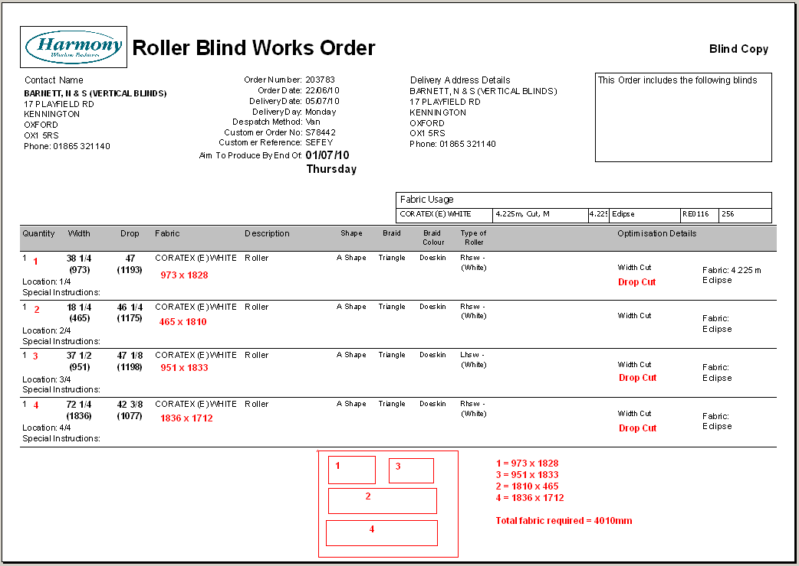

Blindata previously worked it out like this, but as you can see, there is a more effective way of optimising the cut.

There are a couple of things different.
- It should have turned piece 4 the other way round.
- Pieces 1 and 3 could have been cut more efficiently by turning them round.

Point 1 has been resolved but point 2 is difficult. We need to work out every possible combination and then select the most efficient one. This is only realistic in low numbers of pieces of fabric. The possible number of combinations can be described mathematically as 2ⁿ x n! where n is the number of fabric pieces.

At the moment we decide to turn the fabric based on some rules, and then we put the fabrics in descending order of width and then optimise. The problem in this example is that the decision on whether to turn (rotate) the fabric is dependent on the other fabric pieces.

So let’s look at this a different way. We do not put the fabrics in descending order, so we have (x = width, y = drop):

x1, y1
x2, y2
x3, y3
x4, y4
etc

We want an algorithm where we can pair (or triple fabric pieces together and cut them more efficiently). This will be made available in a later release.

1805. Order Processing > Splitting Orders

A situation can arise where not all of the blinds in an order get manufactured, and the order is therefore split. This means that the blinds that have not been manufactured are put into a new order, and removed from the existing order.

Therefore there is a new option on the context menu in ‘Order Amend Enquiry’ called ‘Split Order’. This has an advanced permission flag in Users > Advanced Permissions.

This then displays the detail lines in an order (similar to Remake/Repair/Redespatch) where the user can select which detail lines are to be split.

When an order is split, a new order is created with selected detail lines from the original order.

The order history for the relevant detail lines is moved to the new order, and a new history item ’Split Order Created’ is created in both the old and new orders. We also record the cross referenced order numbers in each order history record ie in the old one it says ’New Order Number 123456’ and in the new order it says ‘Created from order number 123456’.

There is a new flag in the ‘Orders’ table called ‘Split Order’. This will be set to true in the old order if it is split. This flag is a column choice option in ‘Order Amend Enquiry’.

When the new order is created, it keep the old ‘Order Date’ but the required date and scheduled date are calculated from the current date. The order status of the new order is ‘Order Entered’ and it is unchecked.

An order detail line can only be moved to a split order if it has a status of ‘Order Entered’, Order Printed’ or ‘Work In Progress’.

1834. Scanned Documents

We have a customer which scans all their incoming sales order documents. They are then stored on their server with unique names. We are able to identify documents by either order number or account code (which will be part of the file name). A filename may be called 123456.tif, where 123456 is the order number. There is now a button on the ‘Order Amend Enquiry’ form to view the relevant document, and there is also be a button on the ‘Archive Enquiry’ form to do the same thing. The buttons are called ‘Source Doc’.

Button Visibility has also been added in Administration > Users..

1849. Wood Sizes

We have a customer that manufactures wood blinds and so we have set up the stock records with W1 – W6 style codes.

W1 = 25mm slat
W2 = 50mm slat
W3 = 25mm bottom bar
W4 = 50mm bottom bar
W5 = 25mm valance
W6 = 50mm valance

The only problem is that they use the same valances for 25mm and 50mm blinds. At the moment if we enter W1xx As a fabric, it will select W1xxyy as the slat, W3xxyy as the valance and W5xxyy as the valance. If W2xx is entered, then it will find W2xxyy, W4xxyy and W6xxyy. This is hardcoded into the system at the moment.

We need to get W2xx to find W5xxyy instead of W6xxyy. Therefore we have created a new table in System Tables called ‘Wood Codes’. It has fields for blind type, slat code, bottom bar code, valance code. It could have entries like this:

25mm Wood, W1, W3, W5
50mm Wood, W2, W4, W5

When doing the ‘Woodslat’ calculator, if there is a record for the blind type in this table, it will select the W? codes. If there is no record there for the blind type, it will use the existing hardcoded choices.

1850. Sales Analysis by Option Choice (Partly)

A new sales analysis report has been created that will show options selected by blind type. The report is grouped by blind identifier then by blind type.

Example:

Roller Blind – total blinds = 25

Option: Finish
Qty Percentage
Straight 14 56
Castille 3 12
Shape A 8 32

Option: Pole

No Pole 22 88
Pine Pole 3 12

Etc

1851. Administration > Import From Excel

There is a new option to import product blind type records with fabric groups. It is called ‘Blind Type Fabric Groups’ and has fields for stock code, blind type code and fabric group.

1852. Cord Spacing Calculation

There is a new method for calculating cord spacing for venetians. It is based on metric accumulative, but the first measurement will be twice the ‘First Cord’, then revert to normal accumulative + first cord, and the last figure is the width of the blind (ie last measurement + first cord).

We have created a new ‘Ladder Webbing’ setting, which previously was only held in Parameters. It is also now held against the blind type record (if blind identifier = Venetian). If it is null, then the Parameter setting will be used.

There is a new ladder webbing description called ‘Add First Cord’. If a ‘Metric Accumulative’ is 150-450-750, the ‘Twice First Cord’ will be 300-450-900.

1853. Blind Details > Blind Types > Field Details

It is now possible to hold different defaults for options in different blind types, even though they are held against the same stock item.

1854. Option Price Enquiry

There is now an option for % uplift in ‘Option Price Table Enquiry’. Previously the ‘Uplift %’ was only held in Blind Details > Blind Types > Field Details.

Therefore there is a new ‘Price Method’ in Option Price Enquiry’ called ‘Uplift %’.

1855. Blind Types > Link Options

There is now a duplicate button in the top section

1856. Works Order – Bespoke 31

‘Works Order – Bespoke 31’ is now in portrait.

- Added ‘Customer Order No.
- Removed ‘Phase 1’ and box
- Removed fabric code
- Added ‘1L, 2V’ style
- Moved left in line with fabric description and move ‘Loc’ below fabric description

Removed cord spacing, no. of cords, slats.

1857. Delivery Docket – Bespoke 31

A new delivery docket report has been created called ‘Delivery Docket – Bespoke 31’. It has the same layout as ‘Works Order – Bespoke 31’ but is not split by blind identifier.

1858. Invoice – Bespoke 31

This invoice is now printed onto blank A4 paper, so we have added header info.

- Company name and address from Company Details.
- Address line 4 from Company Details
- Postcode from Company Details
- Logo 1 from Company Details
- Tel and fax number from Company Details
- Logo2 from Company Details

1859. Credit – Bespoke 31

This also has the header the same as in the invoice in dev 1858.

1863. Bespoke Works Order 8.5 x 11

If a valance, valance width and a return is entered on a detail line for a Wood blind, then they now appear on the works order.

