Blindata Release Note 5.0.3 

6 August 2010

Bug Fixes and Enhancements

3098. Order Processing > Orders (v5.0.1)

If you enter an order for a customer with a consolidated delivery day (ie not all delivery days are ticked), then if the first available day is not available, it now checks the delivery days and picks the next available one.

3099. Label Print – 3 ½ x 2A

If blind identifier = ‘Vanes Only’, then ‘Width’ is not printed on the label.

3100. Hardware Cutting Sheet

In dev 1803 we created a new column called ‘Profile Colour’. This is actually be called ‘Colour Profile’.

3101. Label – Bespoke 22

The flag to switch the option print on or off is now working for ‘On Label’ in Blind Types > Option Setup. Previously it was looking at ‘On Works Order’.

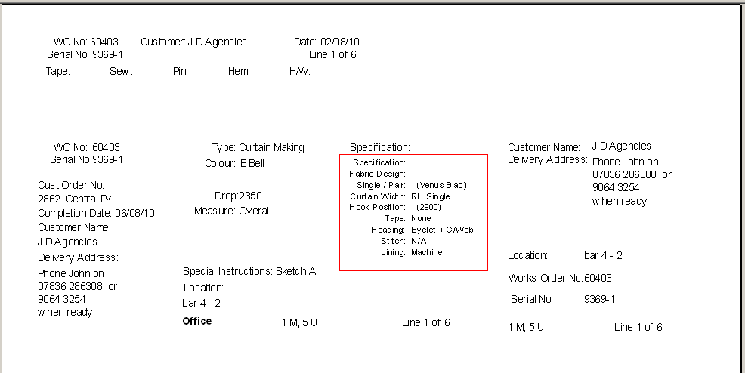

3103. Order Processing > Orders

For a curved track, the ‘Depth’ now displays below ‘Width’ and lines up vertically with it.

3104. Stock Setup > Fabric Group Setup

If you filtered the records by ‘Cost Price’ before doing an update, when you updated any thing, the following message appeared. Fixed.

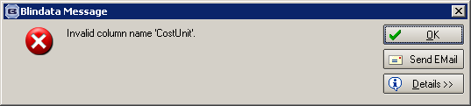

3105. Label Print Bespoke 8 (also see dev 1821)

- Cord spacing was overlapping the operator name.
- ‘No of slats’ is not required if blind identifier = ‘P’. We have put ‘Cord spacing’ here.
- The title of the label was incorrect in the ‘Print Preview’.
- We have moved ‘Special Instructions’ up a line?

New Work and Customer Requests

1824. Fitter Worksheet

There is a new parameter in Administration > Parameters > Report Parameters called ‘Only Print Balance on Fitter Worksheet’. If this is set to true then the fields marked below will not print.
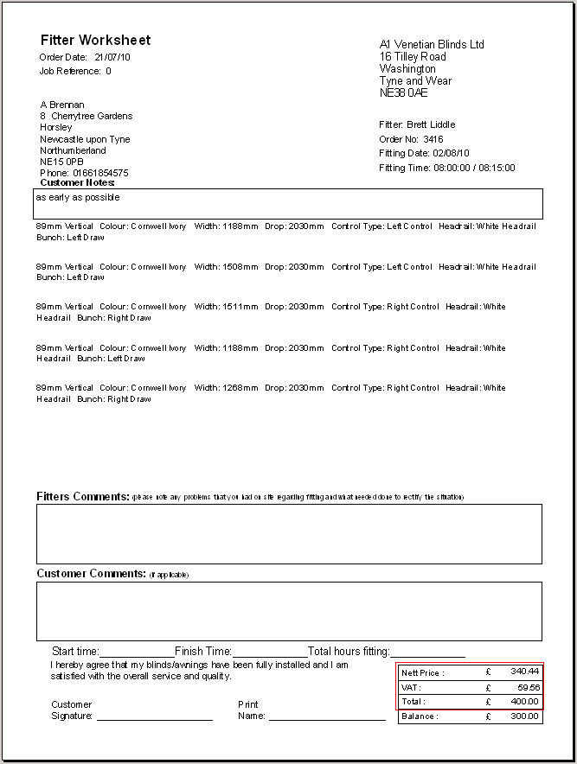

1825. Invoice – Bespoke 32

A new invoice print has been created called ‘Invoice – Bespoke 22’.

1826. Order Processing > Orders > Receipts

Previously it was not possible to post a credit payment to Sage. There is a new parameter to allow posting of credit receipts to Sage. This is held in Administration > Parameters > Sage Parameters / Invoicing and is called ‘Allow Credit Receipt Posting’.

If this new parameter is set to true, then it is now possible to post a credit receipt to Sage and for it to be allocated against the invoice that has already been posted to Sage.

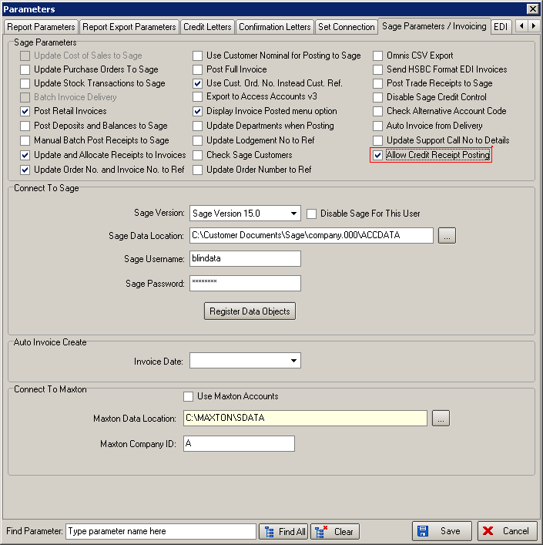

1827. Label Print – 3 ½ x 2 A

- If blind type has ‘Curved Track’ = true, ‘Depth’ now prints on this label.
- Tube cut size now appears on this label for blind identifier = roller.

1828. Order Processing > Orders

For Chain/control length, at the moment we can deduct an amount (by looking at Chain Length Deduct or Chain Length % in Blind Type). We still want to do this but then round down to nearest 100mm. Therefore we have created a new parameter in the blind type record to say ‘Round Chain Length Down to Nearest’. This is an integer, not a flag. So if the figure is set to 100 and the drop is 1925, and ‘Chain Length Deduct’ = 150, the chain length is calculated as 1700.

1829. Financials > Invoice Batch Print

We have amended the invoice batch print form to allow for faxing invoices as well as ‘Print Only’ and ‘Email Only’. There is a new choice for ‘Fax Only’.

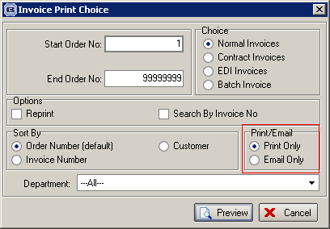

We also have a new flag in the customer record to indicate if invoices are to be faxed. This is called ‘Fax Invoice Only’.

1831. Sage 50 2011

Blindata now integrates with Sage 50 2011.

