Blindata Release Note 5.0.2 

30 July 2010

Bug Fixes and Enhancements

3095. Invoice – Bespoke 31

The bank account text now fit on the same line.

3096. Invoice – Bespoke 30

1. Moved header text down by 15mm.
2. Made detail line text smaller and put lines closer vertically.

3097. Rep/Fitters Top Sheet

- If there is more than one page of appointments for the rep/fitter, the name also prints on the other pages.
- There is now a page number, starting at 1 for each rep/fitter ie ‘Page 1 of 2’ style.

New Work and Customer Requests

1804. Pricing > Cost Price Table Calculation

When you change a fabric here, it now selects all the relevant option defaults (as it does in order entry).

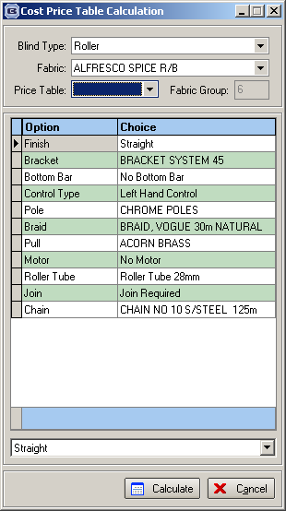

1807. Administration > Users

We have introduced a search facility in Administration > Parameters which has been very popular. We now have the same functionality in the Users form.

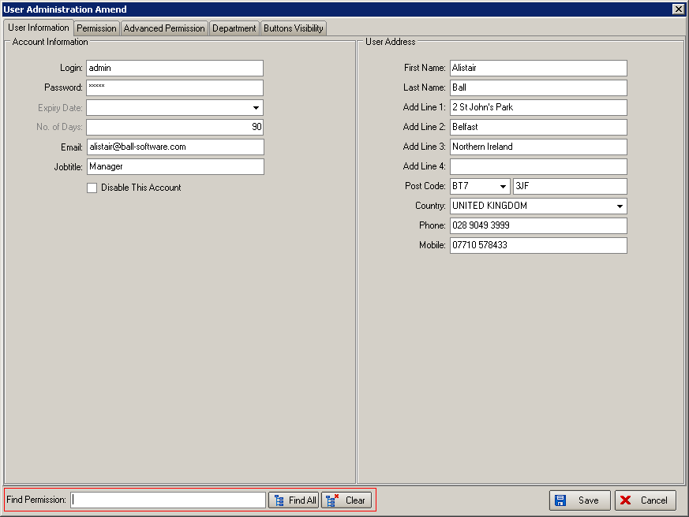

1808. Administration > Users

There is now a column in here for ‘Disable’ so we can see easily which users have been disabled.

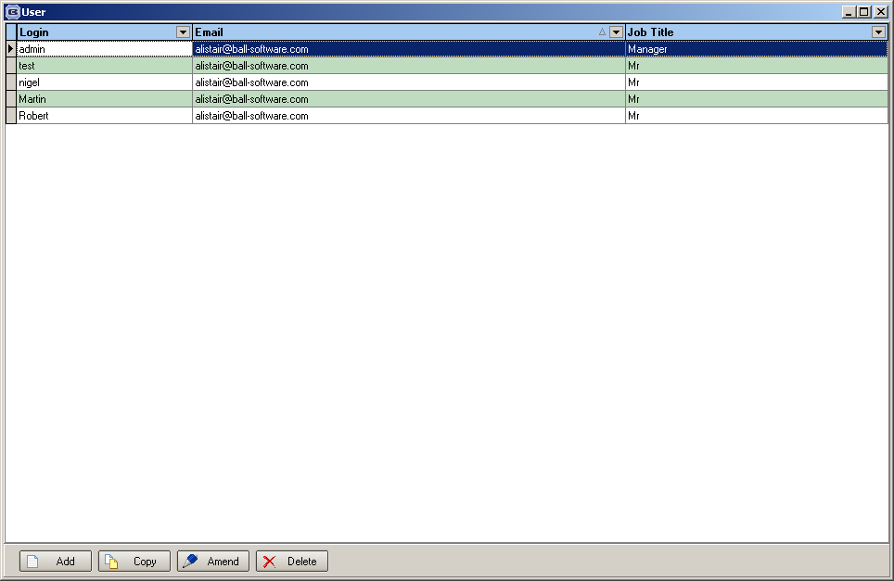

1809. EDI Enquiry > Receiving Data

The ‘Create Date’ field in this form should display Date and Time.

At the moment Create Time is not stored in the EDISenderInformation table at all. But the existing Create Date field is being used in many places. Thus we decided to add a new field called Create Time and display it as a separate column on the EDI Enquiry form.

1810. Part Manufactured Status

Some customers do not like the ‘Part Manufactured’ status. Therefore there is a new parameter called ‘Disable Part Manufactured Status’. If this is set to true, then if one blind in an order is manufactured, the status of the order does not change until all detail lines are manufactured, and then the status changes to ‘Order Manufactured’.

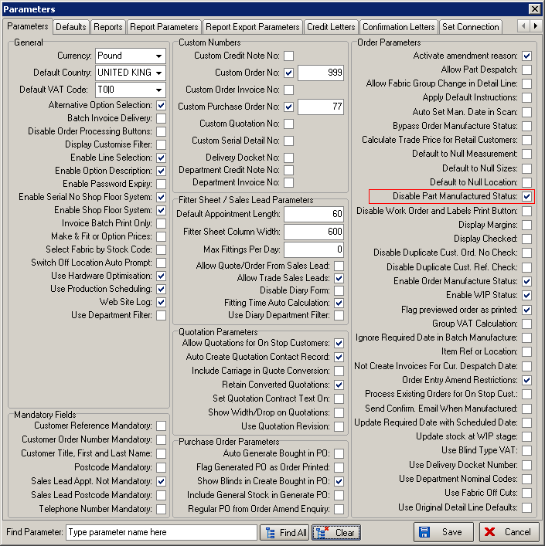

1812. Order Processing > Orders

If an order was previously converted from a proforma invoice, then it is no longer possible to change the value of the order. This means you are not able to amend the detail line prices or totals or the header totals.

1813. System Tables > BOM Group

There is a new flag on this form called ‘Additional’.

1814. EDI Import

Previously it was possible to import a detail line for a fabric that has been discontinued ie is flagged as ‘Not In Use’ = true. It should be possible to keep doing this, but a record should be written to the EDI log file to say a discontinued fabric order has been imported, and when the order is imported, it should be put on ‘customer hold’.

1817. Sales Files > Customers > Google Maps

It is now possible to view customer locations on Google Maps (in the same way as we have done in sales leads).

It is possible to filter the customer enquiry form, then click on a ‘Google Maps’ button and it will display all the customers on Google Maps (using the same method of lookup using postcodes and addresses).

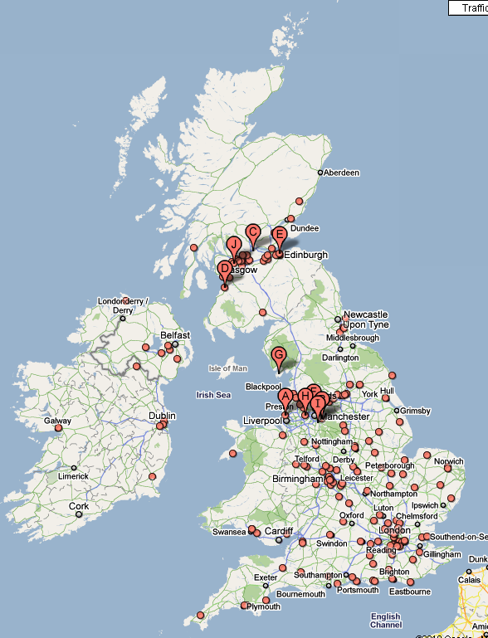

1818. Order Processing > Orders > Works Order

If ‘Print Modra Vertical Vane Report’ or ‘Print Roman Work Sheet’ is switched on, then these reports now print after the works order is printed from the ‘Order Amend Enquiry’ form.

1819. Works Order – Bespoke 22

The existing preprinted works order has been replaced by the new layout, which prints onto blank paper.

1820. Production Control Report

If blind identifier = verticals or vanes only, there is now a column for ‘Number of Vanes’, if blind identifier = Venetians, there is a column for ‘Number of Slats’ to print. There is also a column on the right hand side for maker to initial.

The report has also been changed to Landscape instead of Portrait.

1822. Financials > Invoice Batch Print

There is a new parameter in Administration > Parameters called ‘Invoice Batch Print Only’. If this is set to true, then when the Financials > Invoice Batch Print form is displayed, it goes straight to this form.

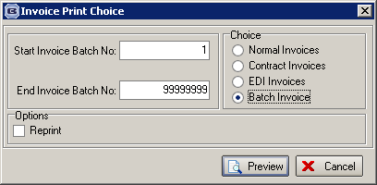

1823. Sales Lead Individual Tractor Feed

This should say ‘Recess/Blind Size’ instead of ‘Other’.

