Blindata Release Note 5.0.1 

26 July 2010

Bug Fixes and Enhancements

3048. Order Processing > Orders

If ‘Use Production Scheduling’ = true and a customer has a specific day set up for delivery days, the scheduled date for orders was not being created for the relevant delivery day.

For example, if the only delivery day set up is a Wednesday, and an order was entered on a Tuesday, but the scheduled date was calculated as the Thursday, then the required date should then be saved as the next Wednesday. The required date was not being calculated properly at the moment. Fixed.

3082. Order Processing > Orders

If ‘Enable Serial No Shop Floor System’ = true in Parameters and ‘Go From Order Made to Create Invoice’ = true in Customers, then when you did ‘Order Made’, an error occurred. Fixed.

3083. Order Processing

If a ‘Same Day Despatch’ order is entered, and the order is entered after the cut off time, then the scheduled date can still be calculated as the current date, if there is time available. In this case, the scheduled date calculation now starts from the next working day, not the current one.

3086. Order Processing > Orders > Scheduling

If you have an order that has detail lines with two different manufacturing locations, when you changed the scheduling date, it allowed you to select them all and then it alters the date according to the manufacturing location in the last detail line.

We’ve added the Manufacture Location column in the grid and disabled the possibility to include Scheduling records with different Man. Locations, because they have different available Scheduling Dates.

3087. Invoice Posting

In dev 1776 we made a change so that scheduling records should be removed. This functionality has been amended, and records are not removed when invoices are posted. There is only ‘Clear Posted Scheduling’ in Administration > Maintenance.

3088. Order Processing > Orders > Consignment Note Number

If you want to enter a consignment note number using this button, the ‘Risk Assessment’ flag had to be switched on in ‘Advanced Permissions’. It now looks at the ‘Consignment Note Number’ flag.

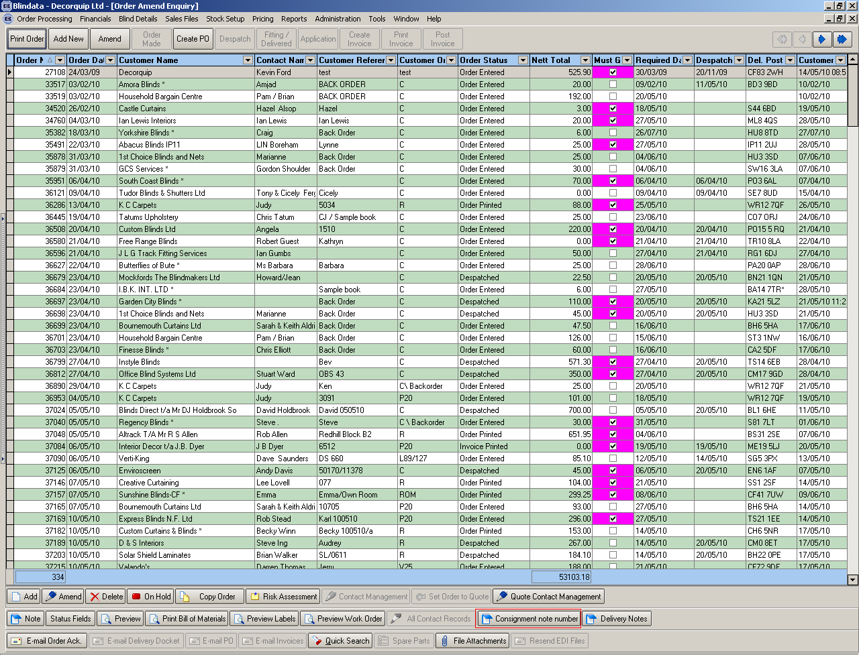

3093. Order Processing > Credits > Status Field

This form has been tidied up.

3094. Order Processing > Orders

An error occurred after you did the drop down for options in the detail line entry, but did not select an option and then just clicked elsewhere on the form. Fixed.

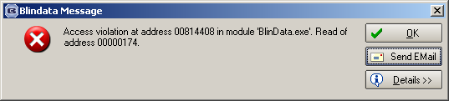

New Work and Customer Requests

1800. Invoice – Bespoke 31

A new invoice layout ‘Invoice – Bespoke 31’ has been created.

1801. Quotation – Bespoke 21

- 85,000 is now 100,000.
- 8,500 is now 10,000.

1802. Export Invoice

The text for bank payments has been moved up and in its place is ‘Order Text’.

There is a new system table for ‘Order Text’. This is similar to ‘Guarantee’, in that the user will be able to select ‘Order Text’ from the Totals tab in the order entry.

1803. Hardware Cutting Sheet

There is a new column for ‘Profile Colour’ (which is an option) on this report. It fits between ‘Mechanism Type’ and ‘Inner Chann’?

