Blindata Release Note 5.0.0 

21 July 2010

Bug Fixes and Enhancements

3069. Out Of Stock Scan

The ‘Out of Stock’ scan did not work correctly if a blind was scanned as out of stock and there were other blinds on the order in the same manufacture location that had already been manufactured. When scanned back into stock, the serial lines got a scheduled date, but the scheduled or required dates in the order were not updated. These dates are now updated.

3071. Works Order Label 1

For blind identifier = Austrian/Roman, the ‘Bottom Bar Cut Size’ is now the ‘Man Drop’ – ‘Bottom Bar Cut’, not ‘Man Width’ – ‘Bottom Bar Cut’.

3072. Sales Analysis Performance Report.

The target figure is now being calculated in this report.

3073. Order Processing > Orders > Scheduling

The ‘Scheduling’ date change duplicated order history records if there are more than one blind. It now only creates one record.

3075. Order Processing > Order Enquiry

Out Of Stock / Back In Stock scans did not work correctly with part manufactured orders. If you tried to scan a blind as ‘Out Of Stock’ when one of the other blinds was already manufactured, a message appears saying that the order has already been made. Fixed.

3076. Order Processing > Order Enquiry

The Order status change button now updates lines (temporary bug)

3079. Administration > Parameters

‘Appointment’ is now spelt properly.

New Work and Customer Requests

1466. Docuware Data Export

It is now possible send data from Blindata to a document management system. This consists of order records in a csv file. The fields required are:

Order Number
Customer Order Number
Customer Ref
Customer Name
Delivery Address 1
Delivery Address 2
Delivery Address 3
Delivery Address 4

These records are exported once a day so we have set up an automated process for this in Administration > Parameters > Automated Tasks. It is called ‘Export Docuware File’ and there is also a field for recording the time that this is done at.

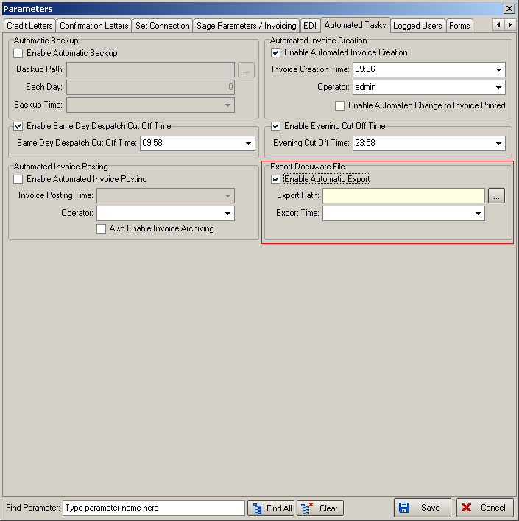

There should be a new field in the Order table called docu_exported and this should be set to true when the record is placed in the csv file. This means that when it is run for the first time, it will take all existing records (but not cancelled orders, not quotes, not credit notes).

1732. Australian Postcodes

Blindata will now look up Google Maps for Australian postcodes. Here is a description of how they work:

http://en.wikipedia.org/wiki/Postcodes_in_Australia

There is a new choice for parameter in Administration > Parameters for ‘Australia’.

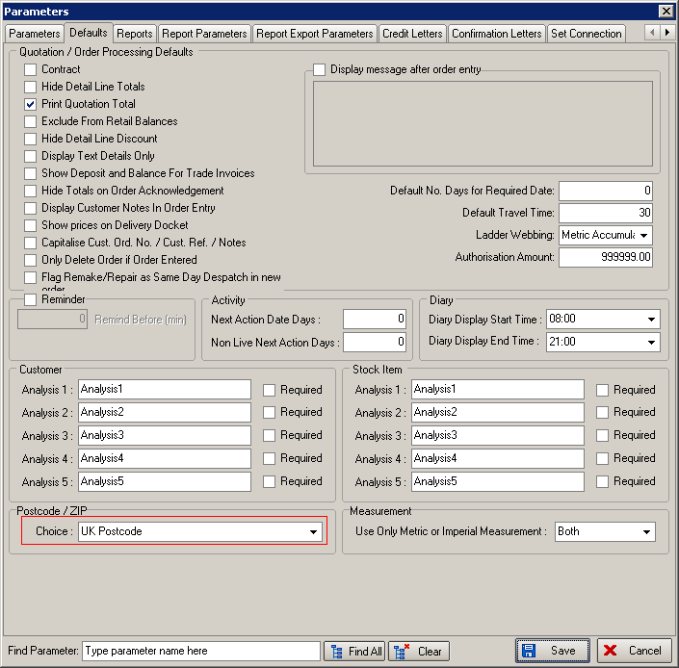

1739. Works Order A4 Individual

If an order is a ‘Remake’ or ‘Repair’ or ‘Redespatch’ this is now indicated on this works order.

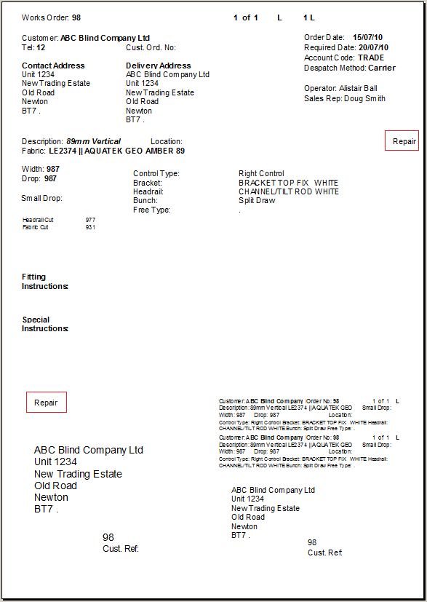

1742. Lakeview Integration

We have a customer that uses an accounting system which is provided by a company called Lakeview, therefore we have to be able to update customers and post invoices to the Lakeview system from Blindata.

W e have decided the best policy is to transfer XML files out to particular locations where they can then be picked up by the Lakeview system or by Blindata.

There is a new parameter in Administration > Parameters called ‘Use Lakeview Accounts’. If this is switched on and the folder locations are switched on, then Blindata polls the relevant folder for customer records to update. Once a customer record has been successfully updated in Blindata, the relevant XML file is moved to the ‘done’ folder.

This interface will only work correctly if all account codes are harmonised between both systems.

Customer Records
A file will be output regularly by Lakeview LM which will contain the current credit status of all customer records.

The file will use a reverse date/time filename so that items will sort into chronological order.

“customers_YYMMDD_HHmmSS.xml”

The file is formatted as follows:

<?xml version="1.0" encoding="ISO-8859-1"?>
<customers>
<customer>
<account_code />
<statement_code />
<balance />
<credit_limit />
<on_stop />
<company_name />
<address_1 />
<address_2 />
<address_3 />
<address_4 />
<address_5 />
<contact_name />
<phone />
<fax />
<email />
</customer>
.
.
</customers>

Sales Invoices (Received for import into Lakeview LM)
When Sales Invoices are produced in the Blindata software, an XML file will be output so that Lakeview LM can create the financial side.

The file will use a reverse date/time filename so that items will sort into chronological order.

“invoices_YYMMDD_HHmmSS.xml”

The file is formatted as follows:

<?xml version="1.0" encoding="ISO-8859-1"?>
<invoices>
<invoice>
<account_code />
<date />
<reference_1 />
<reference_2 />
<items>
<item>
<description />
<quantity />
<unit_price />
<vat_indicator />
<nominal_code />
</item>
.
.
</items>
</invoice>
.
.
</invoices>

These XML files should be sent to the relevant folder if ‘Use Lakeview Accounts’ is switched on and ‘post Invoices’ is selected in Financials > Post Invoices to Sage (or ‘Post’ in Financials > Invoice Print and Post’). However the order record should not be changed to ‘Invoice Posted’ until the following routine has been done. Blindata will need to look for confirmation of invoice records in the relevant folder.

Sales Invoices (Confirmation of invoice number sent by Lakeview LM)
When Sales Invoices produced in the Blindata software have been imported into Lakeview LM, an internal sales invoice number will have been produced. This message informs the Blindata software of the internal sales invoice number allocated to the imported invoice.

The file will use a reverse date/time filename so that items will sort into chronological order.

“invnumbers_YYMMDD_HHmmSS.xml”

The file is formatted as follows:

<?xml version="1.0" encoding="ISO-8859-1"?>
<invnumbers>
<invnumber>
<account_code />
<date />
<reference_1 />
<reference_2 />
<lakeview_invoice_number />
</invnumber>
.
.
</invnumbers>

File Formats and Paths

The file exchange will occur using two main folders:

“upload” Files sent from Lakeview LM
“download” Files sent to Lakeview LM

These folders will be subdivided further to allow additional messages to be added to the interface without the filenames getting into a muddle.

“X:\Data Exchange\download\invoices” XML files to process
“X:\Data Exchange\download\invoices\done” XML files processed OK
“X:\Data Exchange\download\invoices\errors” XML files processed with errors

“X:\Data Exchange\upload\invnumbers“ XML files to process
“X:\Data Exchange\upload\invnumbers\done” XML files processed OK
“X:\Data Exchange\upload\invnumbers\errors” XML files processes with errors

“X:\Data Exchange\upload\customers“ XML files to process
“X:\Data Exchange\upload\customers\done” XML files processed OK
“X:\Data Exchange\upload\customers\errors” XML files processed with errors

We hold these folder locations in Administration > Parameters, in a new tab called ‘Lakeview Data’.

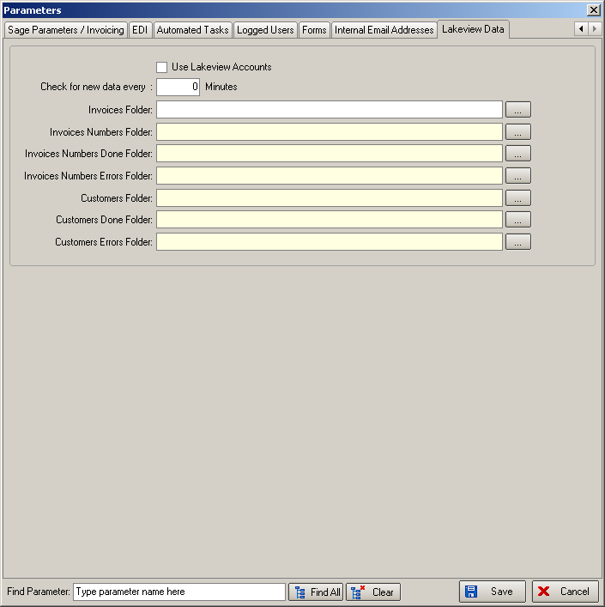

1776. Invoice Posting

It is now possible to remove old scheduling records. This can be done for orders with status ‘Invoice Posted’ in Administration > Maintenance > Clear Posted Scheduling.

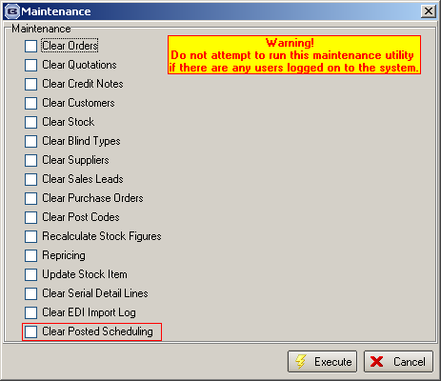

1777. Customise Filter

We have a few customers that do not like the ‘Customise’ filter option being displayed as a default. There is now a new parameter in Administration > Parameters to display the customise filter on certain forms, which is called ‘Display Customise Filter’. If this is switched on, then the following forms will display the filter: ‘Order Amend Enquiry’, ‘Archive Enquiry’, ‘Order Enquiry’, ‘Customers’, ‘Stock Items’, ‘Purchase Order Enquiry’.

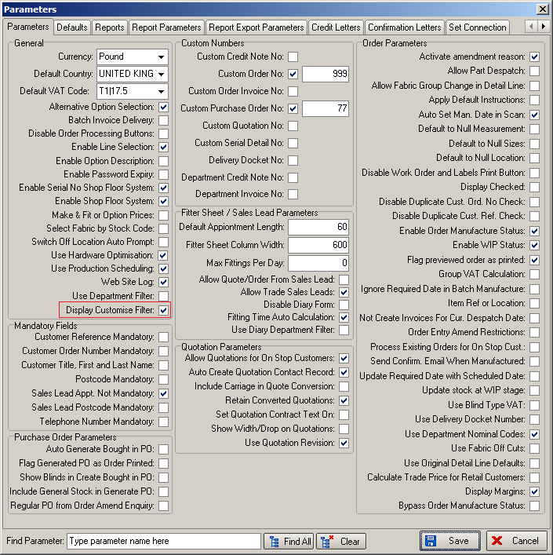

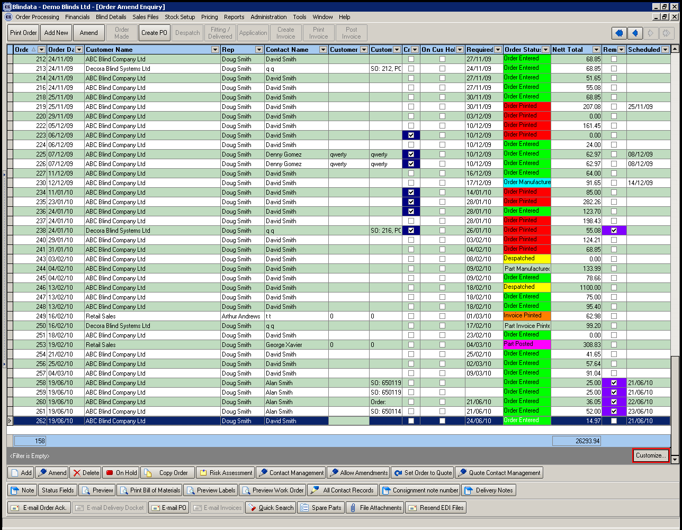

1778. Fitters Sheet / Sales Leads

There is now an option to limit for the number of fitting appointments in a day. There is a new parameter in Administration > Parameters called ‘Max Fittings Per Day’.

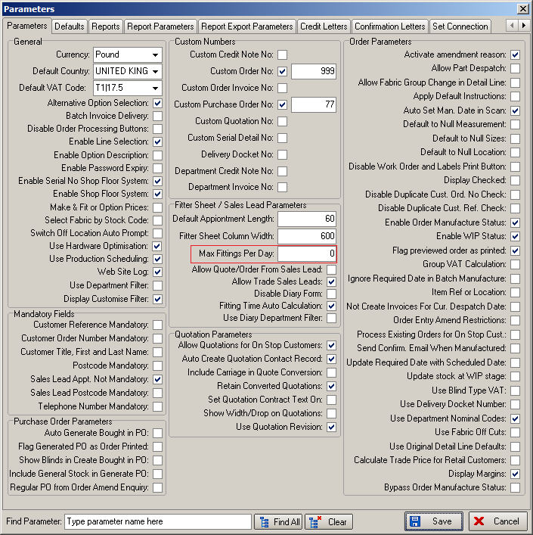

If an attempt is made to create a fitting appointment when the number of fittings is going to be exceeded, then the following message appears.

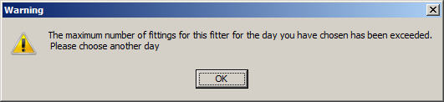

1779. Rep / Fitters Top Sheet 10

There is a new daily appointment summary report called ‘Rep/Fitters Top Sheet’.

1782. Remote Agent Appointments
This functionality has been developed for customers who have remote agents, and all sales calls for these agents are taken by a central call centre. The remote agents use blindata.net and the central call centre accesses the main Blindata application.

It is now possible to send these appointments to a specific Blindata.net database.

As an example, let’s say there is a remote agent called ‘Joe Bloggs Blinds’. As a result of advertising in his area, prospective customers will phone for an appointment. The call will be taken by the call centre and an appointment entered in the Blindata diary.

After the appointment is entered in Blindata, it is then sent to the relevant Blindata.net database and imported into the diary in Blindata.net. This means the remote agent will be able to see their new appointments.

This is why we created a ‘Remote Agent’ category in the Employees table in a previous version of Blindata.

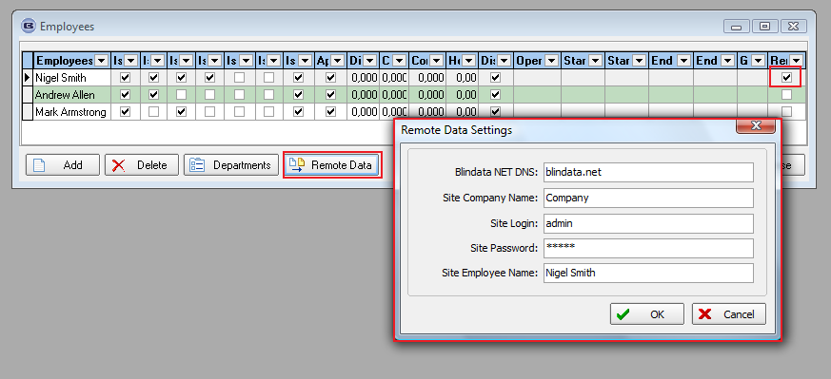

Blindata NET DNS: this is the Blindata.NET site address. You can enter it either with ‘http://’ or without that. So it will be blindata.net or http://blindata.net .
Site Company Name, Site Login and Site Password - it is authorization data for Blindata.NET:

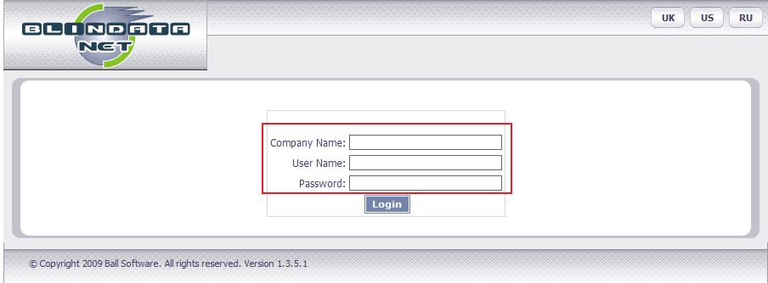

We have to authorize this because we need to find the corresponding Blindata.NET database, determined by Company, Operator etc.

Site Employee Name: the user should specify the employee in the Blindata.NET database. He may have different name, so first it should be checked in System Tables:

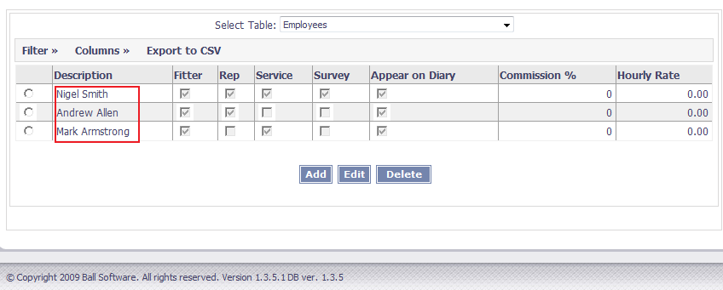

After we enter all Employee settings we can create sales lead appointment dragging over a sales lead task record. After we save it, following question is displayed:

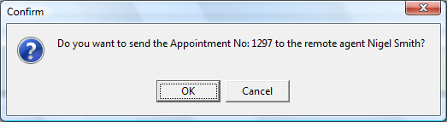

If everything fine, the appointment record will be created in the Blindata.NET database and the following message will appear:

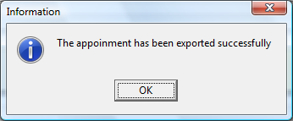

1788. Production List > Production Control Sheet

There is a new report in Order Processing > Production List called ‘Production Control Sheet’. This prints all blinds in orders for one day, grouped by blind identifier, then grouped by required date. The earliest required date records are printed first.

The columns printed are order number, item number, account code, customer company desc, customer reference, blind type description, fabric description, width, drop.

1789. Order Processing > Production List

This form now defaults to the current date for order date. There is now a default report option set up in Parameters > Reports.

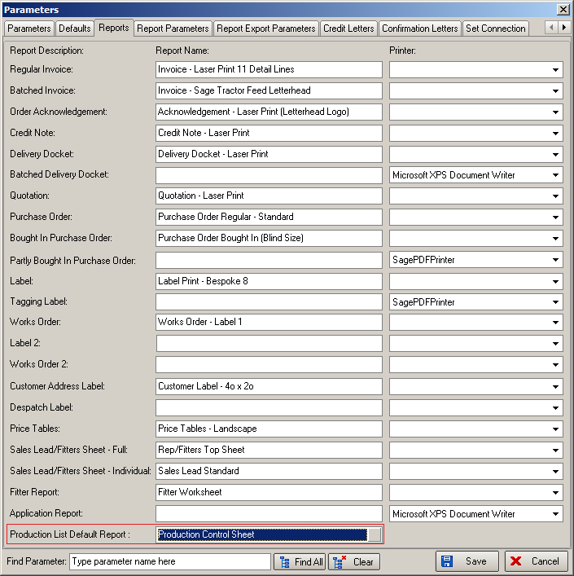

1790. Order Made

There is now an option to skip the ‘Order Made’ status. An order can go straight from ‘Work In Progress’ to ‘Despatched’, with the delivery docket printed.

A new parameter has been created, called ‘Bypass Order Manufacture Status’.

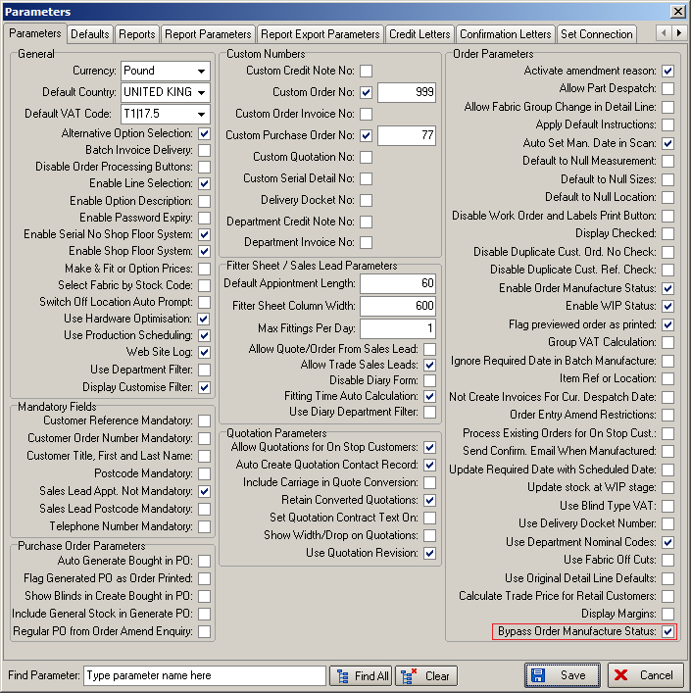

If ‘Order Made’ status is not used this means it will be possible to despatch an order if the order status = ‘Work In Progress’. It is possible to do this in the ‘Order Amend Enquiry’ form, the ‘Order Enquiry’ form and also in ‘Delivery Docket Batch Print’.

1791. Invoice – Bespoke 30

There is a new invoice layout called ‘Invoice – Bespoke 30’ which is for customers that do batch invoicing.

1792. Roman Creases

There is new functionality to print out two additional work sheet reports for Roman blinds. Either one or the other will be chosen.

In the reports, the last panel is always equal to 50% of the normal panel size. The first panel is always equal to normal panel size + headrail allowance. The number of panels is determined by the drop.

There is a new field in the blind type record (if blind identifier = Austrian/ Roman) called ‘Use Crease Lines Calc’. If this is set to true, then Roman Sheet 1 will be used.

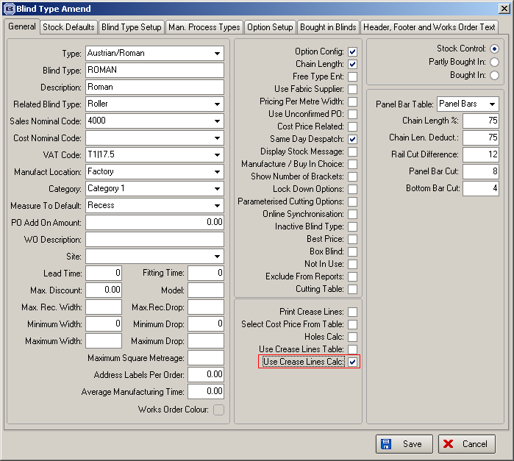

The difference between the work sheets is that the calculations in Roman Sheet 1 is the default for all customers but there is an alternative. Therefore we have a field in the customer record called ‘Use Alternative Roman Calculations’.

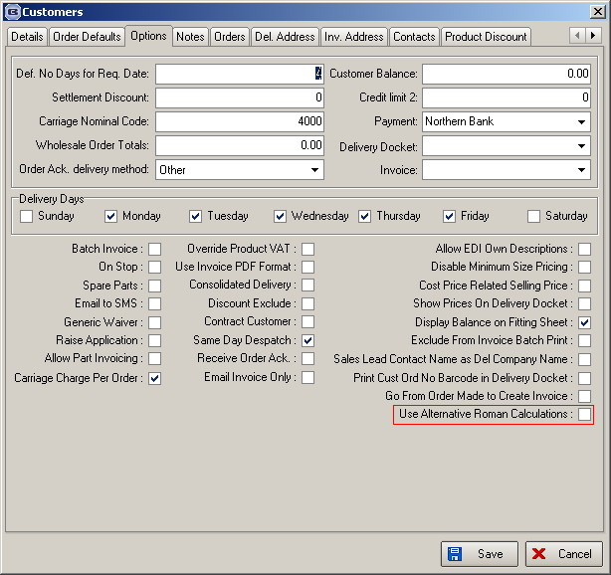

There is also a new ‘System Table’ called ‘Roman Crease Calc’. This contains ‘Panel Bar Table’, ‘Drop’, ‘Headrail Allowance’, ‘Adjustment’, ‘Panels’, ‘Gear Ratio’, ‘Lift Cords’.

There is also be a new parameter in ‘Report Parameters’ called ‘Print Roman Work Sheet’. This parameter works in the same way as ‘Print Modra Vertical Vane Report’ – if the order has a Roman blind type with ‘Use Crease Lines Calc’ in it, then one of the Roman reports is printed (Roman Sheet 1 or Roman Sheet 2) after the works orders are printed in ‘Production Documentation’. If ‘Use Alternative Roman Calculations’ = false, then ‘Roman Sheet 1’ should be used. If ‘Use Alternative Roman Calculations’ = true, then ‘Roman Sheet 2’ should be used.

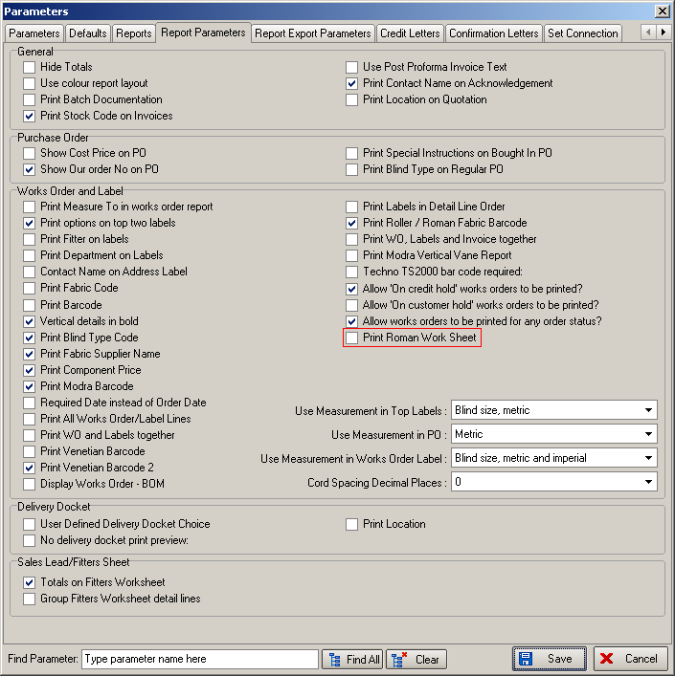

Roman Sheet 1 Calculations

      - Order number and batch number from detail line in format 123456/1
      - Customer company name
      - Customer reference
      - Fabric description
      - Man width
      - Man width
      - Man drop
      - Man drop + adjustment
      - Man drop + 5 (not sure about how we hold this). Should we just add 5mm to Man drop for the time being? Ok.
      - Lining colour – this is the ‘Lining’ option. Is this an option value from detail line where field name = ‘Lining’? Yes.
      - Number of panels
      - Calc from spreadsheet
      - Calc from spreadsheet
      - Headrail = Man width – rail cut difference (from blind type record)
Tiltshaft = Man width – panel bar cut (from blind type record)
Lathe bar = Man width – bottom bar cut (from blind type record)
Gear Ratio = from ‘Roman Crease Calc’ table.
Lift cord number = from ‘Roman Crease Calc’ table.
Sidewinder Control = Link option = ‘Control’ or ‘Control Type’
Chain loop = Chain Length.
      - Special instructions

Find number of panels from ‘Roman Crease Calc’ table
((Drop + adjustment (from table) + headrail allowance) / number of panels) + headrail allowance

((Drop + adjustment (from table) + headrail allowance) / number of panels)

((Drop + adjustment (from table) + headrail allowance) / number of panels) / 2

Roman Sheet 2

            - Customer company name
            - Customer reference
            - Fabric description
            - Lining option, order number and batch number from detail line
            - Man width
            - Man drop
            - Man drop + adjustment
            - Calc from spreadsheet. The same question as 13 item on ‘Roman Spreadsheet’
Cut Lining To = Man width – 5
Cut Headrail To = Man width – 7
Order headrail = from ‘Roman Crease Calc’ table
Let’s ignore the ‘Recess’ sizes here.
            - Number of panels
            - Calc from spreadsheet. If this calculation is different from the first one, please specify these differences. They are the same.
            - To be specified. Should we just display ‘3’ as hardcoded text for the time being? No, it is from ‘Roman Crease Calc’ table.
            - Control option. Is this an option value from detail line where field name = ‘Control’ (or maybe ‘Control Type’)
            - Chain length
            - Special instructions

1793. Works Order – Label Blind Size

If shaped blind is ticked, then the following fields are now printed on this works order.

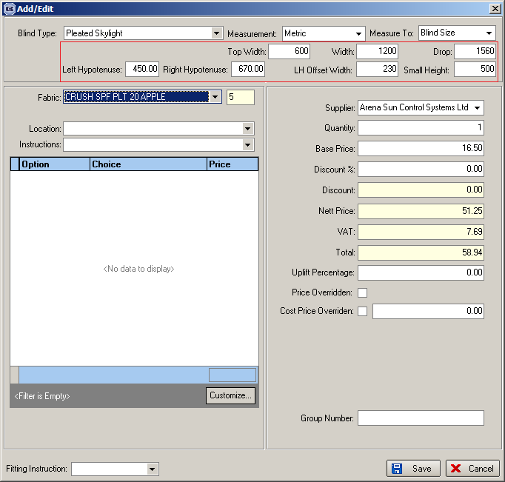

We only print 'Top Width', 'LH Offset Width' and 'Small Height' if 'Shaped Blind' = true, and only if they are > 0. These are printed to the right of width and drop.

1794. Works Order – Bespoke 31

A new works order has been created called ‘Works Order – Bespoke 31’. The page is 11” wide and 8” deep. Although it has ‘Delivery Note’ printed on it, it is actually a works order.

Pages are grouped by blind identifier.

1797. Order Processing > Orders

If an order is on authorisation hold, scheduled dates are no longer generated. When an order comes off authorisation hold, scheduled dates are generated.

1799. Order Processing > Orders

The required date on an order is now hidden if it is not scheduled as it is causing confusion. If there is no scheduled date, then the required date is hidden on the ‘Order Amend Enquiry’ form and the ‘Order Enquiry’ form.

