Blindata Release Note 4.9.8 

21 June 2010

Bug Fixes and Enhancements

3040. Label Print – Bespoke 22

The ‘Free Type’ field has been moved up and across to below location.

/1 (group number) now appears on the label (in the same way it does in ‘Works Order – Bespoke 22’.

On label chain length (control drop) now prints in metric if it has been entered in imperial.

Removed ‘Measure To’ from all blind identifiers except curtains.

Removed width and drop if blind identifier = Miscellaneous

When printing labels, now print in order by ‘Label Control’ then order no.

If Impala data has been stored, it prints on the label (in brackets after number of vanes).

3041. Works Order – Bespoke 22

- Moved Width and drop up 1mm.
- Moved Location down 1mm
- Now show imperial measurements as fractions, not decimals
- Removed width and drop if blind identifier = Miscellaneous
- Added ‘Qty/Mtr’ if blind identifier = Miscellaneous
- Added ‘Fabric Name’ if blind identifier = Miscellaneous

3042. Blind Types > Option Setup

When a user was making changes in this form, it seemed to slow the whole system down and caused timeouts on all the other PCs. We have optimised the form in this tab and also the whole ‘Blind Type’ form.

On further investigation it seemed to be caused when you try to save a record without an amount in ‘Default Margin’. Now when a new option name is being added here, the margindefaults to zero.

3043. Sales Analysis by Blind Type by Trade Type

This report is now grouped by blind identifier and also includes zero amounts if a blind type by either Trade or Retail trade type is zero ie print a line of zero sales (as was done in Sales Analysis by All Blind Types).

3044. Order Processing > Orders / Financials > Post Invoices to Sage

The following error appeared when you tried to post an invoice to Sage. Fixed – temporary bug.

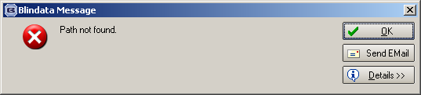

3055. Fitter Worksheet

- The postcode had too big a space in the middle of it.
- In certain cases the total was incorrect.

3056. Fabric Optimisation

There were still some problems with fabric optimisation.

The problems only occurred with fabrics that are turnable (ie calculator = ‘Width or Drop’) and where ‘Fabric Optimise One Direction = false.

We have the following possibilities, so the logic now cover the following for calculator = ‘Width or Drop’ and ‘Fabric Optimise One Direction’ = false. (Op piece = optimisation fabric piece)

Op piece width < fabric roll width
Op piece drop < fabric roll width
Op piece width < Op piece drop
Rotate

Op piece width < fabric roll width
Op piece drop < fabric roll width
Op piece width > Op piece drop
Do not rotate

Op piece width < fabric roll width
Op piece drop > fabric roll width
Op piece width > Op piece drop
Cannot happen

Op piece width < fabric roll width
Op piece drop > fabric roll width
Op piece width < Op piece drop
Cannot happen

Op piece width > fabric roll width
Op piece drop > fabric roll width
Op piece width > Op piece drop
Cannot happen

Op piece width > fabric roll width
Op piece drop > fabric roll width
Op piece width < Op piece drop
Cannot happen

Op piece width > fabric roll width
Op piece drop < fabric roll width
Op piece width < Op piece drop
Cannot happen

Op piece width > fabric roll width
Op piece drop < fabric roll width
Op piece width > Op piece drop
Rotate

Also if the calculator of the fabric is ‘Drop’ and there was a width add on of 100mm this was not being added to the optimisation piece. This has also been corrected.

3057. Works Order – Bespoke 22

Fitting Instructions now go below serial no on right hand side. If blank, they do not print. It prints ‘Ready Date’ instead of ‘Fitting Instructions’. (A date will be entered in fitting instructions).

3058. Invoice Posting

Maxton was being updated with order number, when it should update invoice number. Fixed.

3059. Label Print – Bespoke 22

Cloth Size should be ‘Man Width’ – ‘Fabric Cut Difference’. Previously it was deducting the ‘Fabric Cut Difference’ from the entered size.

3060. Invoice – Bespoke 22

We have removed the delivery company name from the first line of delivery address. It now only prints the delivery address lines.

3061. Label Print – Bespoke 22

The group number now appears after the order number in all parts of the label.

New Work and Customer Requests

1758. EDI Amendments Import

There is now a broken EDA file set up just like the EDI one and also in EDA archive.

1759. Order Processing

There is now an EDI amendments notes column on the order amend enquiry form.

1760. Reports > Sales Analysis

It is now possible to analyse remakes, repairs and redespatches in the sales analysis reports. Previously there was only an option to exclude these from the reports.

There is another flag here called ‘Show Only’. If this is selected, then the reports only shows whichever of Remakes, Repairs or Redespatches is ticked.

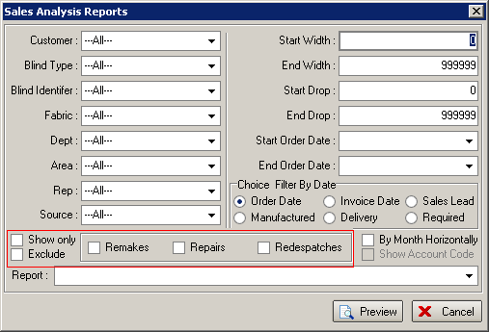

1770. Quotation – Laser Print (Letterhead)

We have added two logos to this report.

1771. Acknowledgement – Laser Print (Letterhead)

We have added two logos to this report.

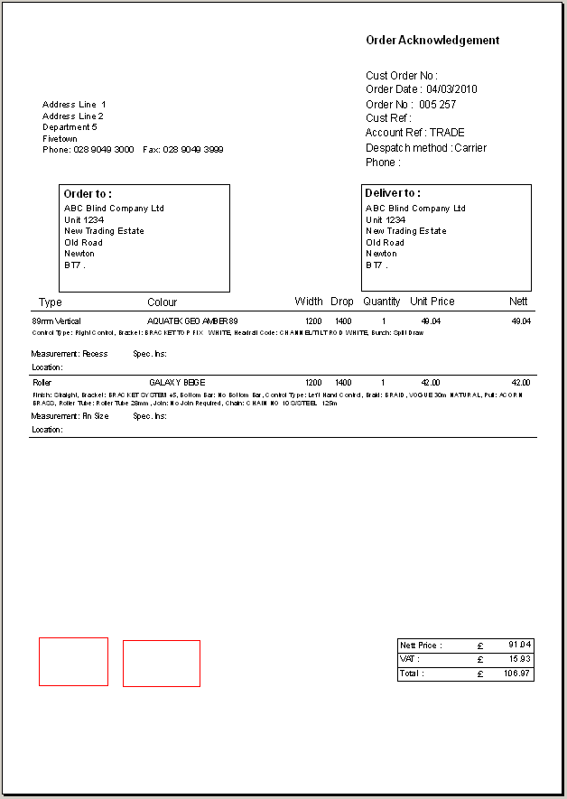

1772. Invoice – Laser Print (Letterhead)

We have added two logos to this report. We have also added ‘Invoice Text’ to the invoice.

