Blindata Release Note 4.9.7 

11 June 2010

Bug Fixes and Enhancements

3029. Optimisation

After a fabric had been optimised in an order, the cost prices printed incorrectly on ‘Print Bill of Materials’. Fixed.

As an example, enter an order for five roller blinds, all with the same fabric, then run fabric optimisation. The cost price was correct prior to the optimisation but wrong afterwards.

3030. Order Processing

This problem occurred if ‘Use Production Scheduling’ was switched on. If an order was entered and had a scheduled date assigned to it, and then the blind was manufactured before the scheduled date, then the scheduled time should have been removed from the scheduled date to make room to manufacture another blind. Fixed.

3031. Works Order – Label 1 (v4.9.5)

The ‘Scheduled Date’ has replaced the ‘Order Date’.

3032. Works Order – Bespoke 28

Width Cut and Drop Cut were being mixed up on the report. Fixed.

3033. Tagging Label 1

The customer name is now cut off after 7.5cm

3034. Label

Moved ‘1 of 12’ to where Location is, because sometimes the ‘1 of n’ was not being printed.

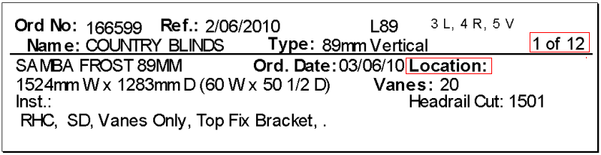

3036. Label Print – Bespoke 22

- This now print the ‘Free Type’ field from the Label Control record – in bold.
- ‘Location’ has been moved up to below ‘Special Instructions’.
- There is now a space between the option name and the option choice eg Control Drop : 1200
- If a component entry is done and the ‘Fabric Name’ is entered, it now prints instead of the fabric description from the fabric code entered.

3037. Works Order – Bespoke 22 (Ignored)

It should only print 4 lines of special instructions.

3038. Invoice – Bespoke 22

The text has been moved to the left so it lines up with where ‘Works Order No’ starts.

3039. Order Processing > Orders > Status Fields

If the invoice date is changed here, then it is also updated in the order detail line.

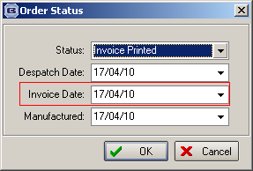

New Work and Customer Requests

1748. Fitters Sheet / Sales Leads > Converting to Order

We have a customer that uses to diary a lot, and creates fitting times when the sales lead is converted to an order. However if a fitting time is already taken, the following message appeared but the user did not know times that were available.

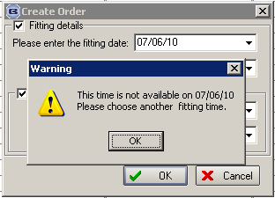

The message has been changed so it also says ‘Please choose another fitting time from the following times: 0900 – 1000, 1100-1130, 1430-1600’.

The times displayed are all free times for that fitter on that day.

1750. Sales Analysis by Blind Type by Trade Type

A new sales analysis report has been created called Sales Analysis by Blind Type by Trade Type that splits blind type sales into ‘Trade Type’ = Trade and ‘Retail’.

1751. Parameters > Report Export Parameters > Invoice – Bespoke 17

There is now a choice for ‘Invoice – Bespoke 17’ here.

1752. Parameters > Report Export Parameters > Quotation – Bespoke 17

There is now a choice for ‘Quotation – Bespoke 17’ here.

1753. Parameters > Report Export Parameters > Delivery Docket – Bespoke 17a

There is now a choice for ‘Delivery Docket – Bespoke 17a’ here.

1754. Parameters > Report Export Parameters > Delivery Docket – Bespoke 17b

There is now a choice for ‘Delivery Docket – Bespoke 17b’ here.

1755. Administration > System Tables > Departments

There are now fields for selecting which pdf layouts are used for invoices, quotations, order acknowledgements and delivery dockets.

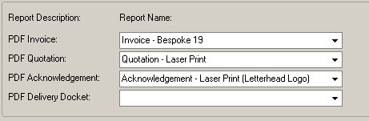

1756. Works Order – Delivery 8

This report now prints fabric metreage on the works order for vertical blinds and roller blinds.

1757. EDI Amendments Import

If an EDI amendment is imported, it now creates an order history record, with the text ‘EDI amendment – placed on customer hold’.

1761. Order Processing > Orders

It is now possible to create invoices as soon as ‘Order Made’ has been done in ‘Order Amend Enquiry’. There is a new flag in Sales Files > Customers called ‘Go From Order Made to Create Invoice’. If this is switched on, then once ‘Order Made’ is clicked, the ‘Create Invoice’ form will appear and the invoice can be created.

If ‘Order Made’ is done as a result of a bought in purchase order being delivered, this logic also takes effect.

1764. Label – Bespoke 22

In the blind type record (for any blind identifier) if ‘Chain Length’ = true, then the chain length now appears on the label, but it says ‘Control Drop’ instead of ‘Chain Length’.

Also, the report now only prints four lines of special instructions.

1765. Works Order – Bespoke 22

In the blind type record (for any blind identifier) if ‘Chain Length’ = true, then the chain length now appears on the works order, but it says ‘Control Drop’ instead of ‘Chain Length’.

Also, the report now only prints four lines of special instructions.

1766. Order Processing > Orders

- Component entry – Instructions field now allows for four lines entry without scrolling ie we have made the field larger vertically
- Qty/Mtr has been moved
- Miscellaneous entry – field for fabric name can now be entered – text entry

1767. Order Processing > Orders

When right clicking to display options, we have made the pop up bigger vertically to display up to 10 option choices without a vertical scroll appearing.

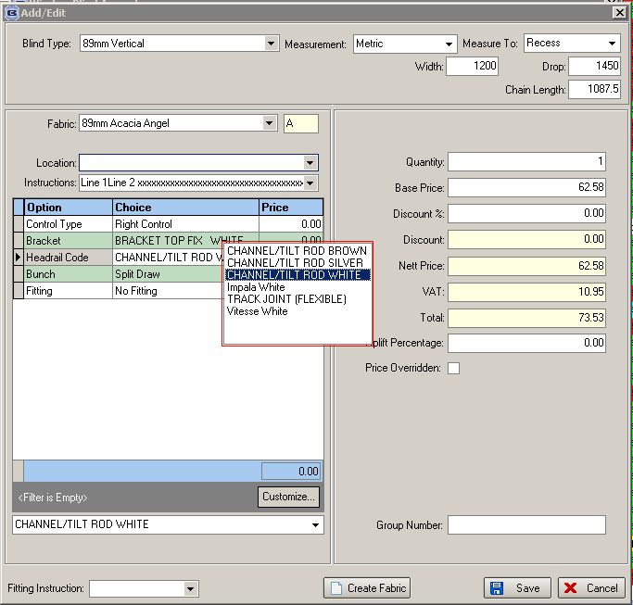

1768. Invoice – Bespoke 22

- Invoice number now prints in place of order number.
- Order number now prints to left of customer order no, with text ‘Works Order No:’ in front of it.

1769. Production Documentation

It is now possible to print out ‘Works Order – Label 1’ by scheduled date. This means we have a new criteria for scheduled date in here.

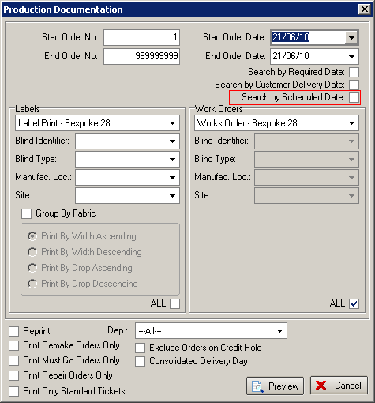

We therefore now hold a flag in the serial detail line to say if the line has been printed or not. When the print run is done by ‘scheduled date’, it flags this line to say it is printed and the order then has its status changed to ‘Order Printed’, even if only one of the serial detail lines has been printed.

We could have a situation where an order has records which have different scheduled dates in the serial detail lines.

We have also changed the program in two other places. If the order is set back to ‘Order Entered’, then the serial detail lines are all flagged as not printed. This could happen using the ‘Status Fields’ button in ‘Order Amend Enquiry’ or ‘Status Field’ in ‘Order Enquiry’ or ‘Enquiry Scan’ in ‘Order Enquiry’.

