Blindata Release Note 4.9.6 

4 June 2010

Bug Fixes and Enhancements

3025. EDA Import

If an EDA comes in at WIP stage it locked out the amend functionality and an error appeared. Fixed.

3026. EDA Import

When an EDA import comes in, the order is put on customer hold, and it is also set to Checked = false.

3027. Invoice – Laser Print

- If ‘Hide Detail Line Discount’ = true, then unit price and discount % no longer print.
- It was possible to have a rounding eror in the total. Fixed.

New Work and Customer Requests

1723. Gross Profit By Order Report

We have changed the existing Reports > Financial Reports > Gross Profit By Order report.

The report is now grouped by rep then by customer.
There is a column for ‘Customer Order No’ which prints before order date.
There are new columns for:

- Trade Nett Price - this is the price for the order if trade type = ‘Trade’ and Price Table = ‘Trade’. We have written a routine to find the trade prices for all the relevant orders.
- Retail Gross Profit - this is Sale (ex VAT) – Trade Nett Price.
- Retail Margin % - this is (Retail Gross Profit / Sale (ex VAT)) * 100
- Cost – this is the cost price
- Gross Profit – this is Trade Nett Price – Cost Price
- Trade Margin % – this is (Gross Profit / Trade Nett Price) * 100

These are all printed the right of Sale (ex VAT).

1730. Fabric Optimisation

There was a problem with fabric optimisation if the fabric calculator = ‘Width or Drop’. If you have a fabric that has calculator = ‘Width or Drop’, if blinds were entered in a particular order, the optimisation did not work properly.

A full review of the optimisation algorithm has been carried out and it seems to work properly now. The following rules apply. As you can see, it is extremely complicated.

Fabric has ‘Width’ calculator:
Optimisation pieces rotation is not allowed.
Optimisation is independent of ‘Fabric -> Fabric Optimise One Direction’ flag.
If ‘Order Detail -> Drop Man Size’ is greater than ‘Fabric -> Roll Width’ and ‘Fabric -> Allow Horizontal Join’ = FALSE then the detail will be excluded from the optimisation routine.
If ‘Order Detail -> Width Man’ more than ‘Fabric -> Roll Length’ then this detail will be excluded from Optimisation routine.
If ‘Order Detail -> Drop Man’ less or equal to ‘Fabric -> Roll Width’ then this detail will be located on the fabric roll as usual.
If ‘Order Detail -> Drop Man’ more than ‘Fabric -> Roll Width’ and ‘Fabric -> Allow Horisontal Join’ = TRUE then this detail will be split to the separate pieces and each piece will be optimised separately.
We sort items in descending width order; we locate the first piece to the top left corner on the fabric roll; we trying to fit the next piece to the right of the first piece; if it doesn’t fit – we locate it to the bottom of the first piece, in the next case – to the right of the first piece etc.

Fabric has ‘Drop’ calculator:
Optimisation pieces rotation is not allowed.
Optimisation is independent of ‘Fabric -> Fabric Optimise One Direction’ flag.
If ‘Order Detail -> Width Man’ is greater than ‘Fabric -> Roll Width’ and ‘Fabric -> Allow Vertical Join’ = FALSE then this detail will be excluded from Optimisation routine.
If ‘Order Detail -> Drop Man’ is greater than ‘Fabric -> Roll Length’ then this detail will be excluded from Optimisation routine.
If ‘Order Detail -> Width Man’ less or equal to ‘Fabric -> Roll Width’ then this detail will be located on the fabric roll as normal.
If ‘Order Detail -> Width Man’ more than ‘Fabric -> Roll Width’ and ‘Fabric -> Allow Vertical Join’ = TRUE then this detail will be split into separate pieces and each piece will be optimised separately.
We sort items in descending drop order; we locate the first piece to the top left corner on the fabric roll; we try to fit the next piece to the right of the first piece; if it doesn’t fit – we locate it to the bottom of the first piece, in the next case – to the right of the first piece etc.

Fabric has calculator ‘Width or Drop’:
Optimisation pieces rotation is allowed. Optimisation piece is turnable only if ‘Fabric -> Fabric Optimise One Direction’ = FALSE.
If both ‘Order Detail -> Width Man’ and ‘Order Detail -> Drop Man’ are greater than ‘Fabric -> Roll Width’ and both ‘Fabric -> Allow Vertical Join’ = FALSE and ‘Fabric -> Allow Horisontal Join’ = FALSE then this detail will be excluded from Optimisation routine.
If ‘Order Detail -> Drop Man’ is greater than ‘Fabric -> Roll Width’ and ‘Fabric -> Allow Horisontal Join’ = FALSE then this detail will be excluded from the Optimisation routine.
If ‘Order Detail -> Width Man’ is greater than ‘Fabric -> Roll Width’ and ‘Fabric -> Allow Vertical Join’ = FALSE then this detail will be excluded from the Optimisation routine.
If ‘Order Detail -> Width Man’ is greater than ‘Fabric -> Roll Width’ and ‘Fabric -> Allow Vertical Join’ = TRUE then this detail will be split into separate pieces and each piece will be optimised separately.
If ‘Order Detail -> Drop Man’ is greater than ‘Fabric -> Roll Width’ and ‘Fabric -> Allow Horisontal Join’ = TRUE then this detail will be split into separate pieces and each piece will be optimised separately.
In all other cases this detail will be located on the fabric roll as normal.
Optimisation is dependent on ‘Fabric -> Fabric Optimise One Direction’ flag. If ‘Fabric -> Fabric Optimise One Direction’ = TRUE:
We take all Optimisation details and perform optimisation by width without separate pieces rotation.
We store Width Optimisation result.
We rotate all Optimisation details and perform optimisation by drop without separate pieces rotation.
We store Drop Optimisation result.
We record the best Optimisation result only in the database.
Optimisation is dependent on ‘Fabric -> Fabric Optimise One Direction’ flag. If ‘Fabric -> Fabric Optimise One Direction’ = FALSE:
All details are turnable here as ‘Fabric -> Fabric Optimise One Direction’ = FALSE.
We take each detail and apply the following logic to it

if ((Optimisation Piece Drop < Fabric Roll Width) and (Optimisation Piece Width < Fabric Roll Width)) then
if (Optimisation Piece Drop > Optimisation Piece Width) then
we rotate this piece
else
we don’t rotate this piece
else
if ((Optimisation Piece Drop < Optimisation Piece Width) and (Optimisation Piece Width < Fabric Roll Width)) then we don’t rotate this piece
else
if ((Optimisation Piece Width < Optimisation Piece Drop) and (Optimisation Piece Drop < Fabric Roll Width)) then we don’t rotate this piece
else
if (Optimisation Piece Drop < Optimisation Piece Width) then
we rotate this piece
else
we don’t rotate this piece

We sort the items in descending width order; we locate the first piece to the top left corner on the fabric roll; we trying to fit the next piece to the right of the first piece; if it doesn’t fit – we locate it to the bottom of the first piece, in the next case – to the right of the first piece etc.

We have the following possibilities, so the logic covers the following.

Op piece width < fabric roll width
Op piece drop < fabric roll width
Op piece width < Op piece drop
Rotate

Op piece width < fabric roll width
Op piece drop < fabric roll width
Op piece width > Op piece drop
Do not rotate

Op piece width < fabric roll width
Op piece drop > fabric roll width
Op piece width > Op piece drop
Cannot happen

Op piece width < fabric roll width
Op piece drop > fabric roll width
Op piece width < Op piece drop
Cannot happen

Op piece width > fabric roll width
Op piece drop > fabric roll width
Op piece width > Op piece drop
Cannot happen

Op piece width > fabric roll width
Op piece drop > fabric roll width
Op piece width < Op piece drop
Cannot happen

Op piece width > fabric roll width
Op piece drop < fabric roll width
Op piece width < Op piece drop
Cannot happen

Op piece width > fabric roll width
Op piece drop < fabric roll width
Op piece width > Op piece drop
Rotate

1741. Panel Blind Pricing

If the blind identifier = Panel, there is now an additional method of pricing. The panel blinds can be priced per panel (in the same way as vanes only is priced per vane and the prices are held in Pricing > Vanes Price Table).

The Pricing > Vanes Price Table form has been changed so that the user can select a blind type that is either blind identifier = Vanes Only or Panel Blind.

There is a flag in the blind type form called ‘Pricing Per Panel’. If this is set to true, then in order detail entry, when a panel blind is entered, the price is found by looking at the number of panels, drop, price code and fabric group and selecting it from the relevant record in ‘Vanes Price Table’.

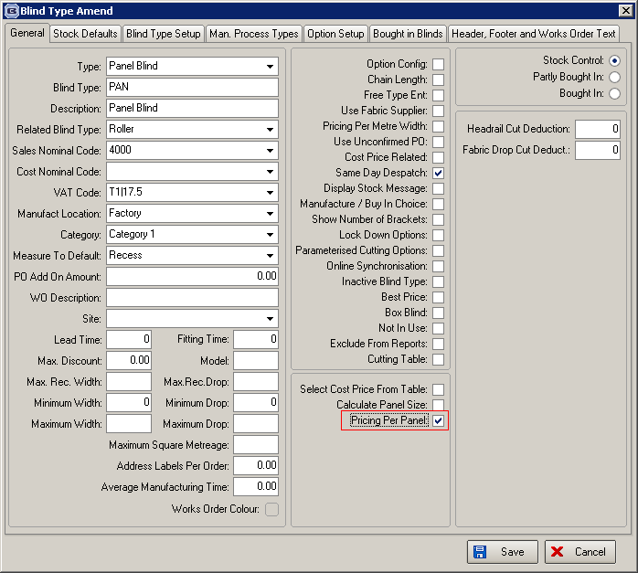

1743. Quotations / Orders Margins

This item is only for customers that have blind types set up as ‘Cost Price Related’.

It is now possible to calculate a margin for detail lines instead of adding an ‘Uplift Percentage’. But it is more complicated than that because the margin on the base price may be different from the margin on the options.

Administration > Parameters

There is a new parameter in the parameters form called ‘Display Margins’.

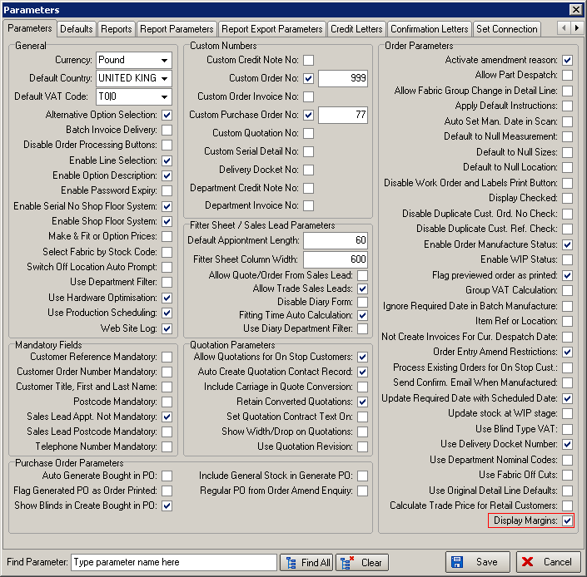

Changes to Blind Type form

If ‘Display Margins’ = true and if ‘Cost Price Related’ = true, there is a field for ‘Default Margin’. This defaults to zero.
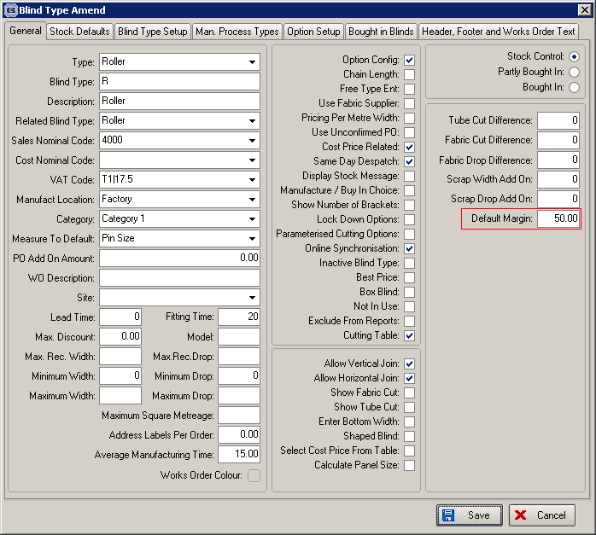

In the ‘Option Setup’ tab, there should also be a field for ‘Default Margin’.

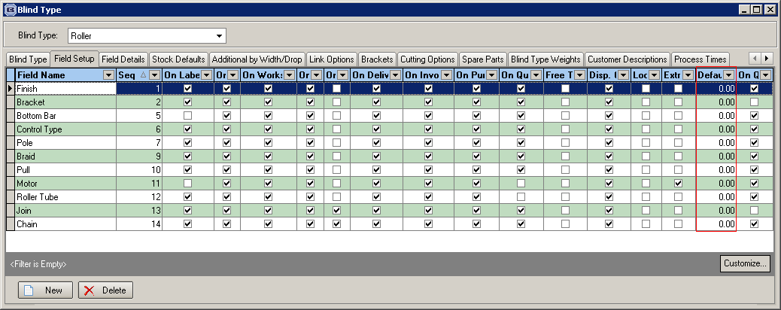

Quotations / Orders

If ‘Display Margins’ = true and ‘Cost Price Related’ = true, then the margins are displayed on the detail line entry. The margin for the options is in a new column in the subform.

It is possible to change a margin for either the base price or an option.

If a margin is entered, then nett price = ((cost price * 100) / (100 – margin %)) * ((100- discount %) / 100) + sum of (((option cost price * 100) / (100 – option margin %)) * ((100- discount %) / 100)).

Also, if an option is flagged as a ‘Non Discount Item’, then discount is not applied to that option.

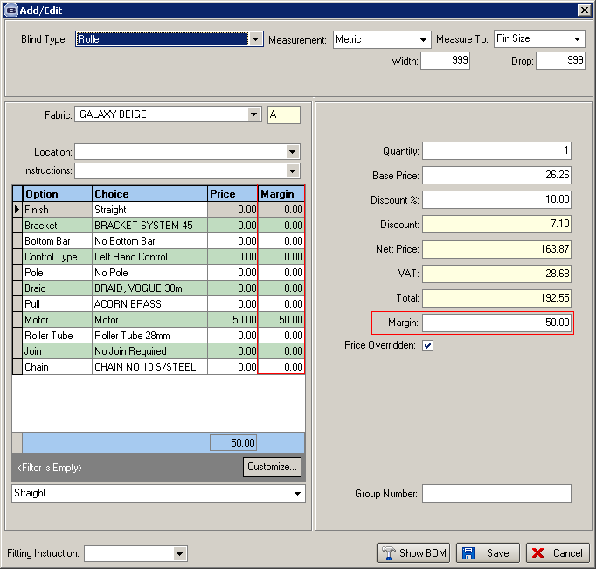

1744. Advanced Quote Analysis

There is a new report that can be printed out on the Quotation Enquiry form. It is only relevant if ‘Display Margin’ = true in Administration > Parameters.

There is a new button called ‘Quote Analysis’ – this has an advanced permission flag.

1745. Roman Creases

In dev 1705, we developed a routine to import a spreadsheet with Roman creases information in it. We have expanded the spreadsheet so it has extra columns for crease 7 up to crease 16. We therefore have adjusted the import routine to handle these extra fields.

We have also adjusted ‘Works Order – Label Blind Size’ so it will print out the extra creases.

1747. Administration > Import From Excel > Fabrics

It is now possible to import more fields into the ‘Fabrics’ record from the spreadsheet.

Fabric Type
Colour
Scrap Allowance %

