Blindata Release Note 4.9.5 

21 May 2010

Bug Fixes and Enhancements

3014. Order Processing > Orders > Delete Order

If you delete an order that has scheduled dates calculated for it, the underlying schedule records are now removed and the scheduled times do not get updated in ManLocationDateAndTimes.

3015. Works Order – Bespoke 28

This is no longer required on this works order and has been removed.

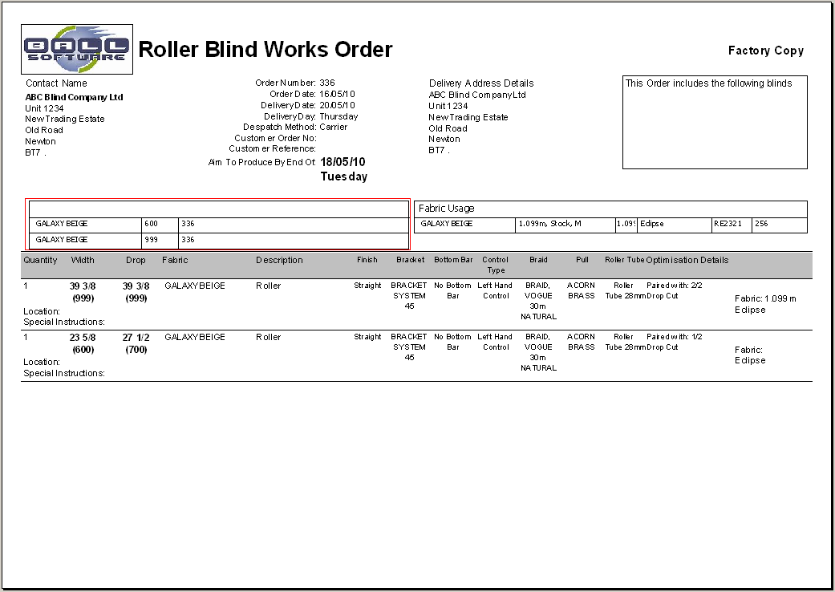

3016. Invoice – Laser Print (Letterhead Logo)

If ‘Hide Detail Line Discount’ is set to true, then the discount % no longer appears on this invoice.

3017. Invoice – Laser Print (Letterhead)

If ‘Hide Detail Line Discout’ is set to true, then the unit price discount % no longer appears on this invoice.

3018. Purchase Order Regular – Standard

The stock description was being cut off here. It has been extended further to the right.

3019. Works Order – Bespoke 28

If you did not optimise the fabrics, an error occurred when trying to print this report. Fixed.

3020. Reports > System Reports

These report titles have been put into alphabetical order.

3021. Sales Files > Customers

If ‘Check Sage Customers’ is switched on in Administration > Parameters > Sage Parameters / Invoicing, and there is a Sage company set up in Departments, when the customer is saved, it should look at the Sage company that is set up in Departments rather than the one that is set up in Administration > Parameters.

3022. Archive Enquiry > Print Acknowledgement

If an order had been completely archived (ie it is in the archived tables), then you could not print an order acknowledgement. Fixed.

New Work and Customer Requests

1528. Archive Enquiry

The indexing in the archive orders tables has been significantly improved.

1700. EDI Import Amendments

There is now a facility so an EDI order amendment file can be received.

There is a new tab on the EDI Enquiry form for EDI Amendments.

The import routine (automatic and manual) has been amended to also include importing EDI amendments after normal EDI orders are imported.

The EDI amendment files are called EDA-*, * being the customer reference. The XML file only contains four fields: ‘Account Code’, ‘Customer Reference’, ‘Amendment Date’ and ‘Amendment Notes’.

There is a new field called ‘EDI Amendment Email’ that is held in Administration > Parameters > Internal Email Addresses.

There is a new table called ‘EDI Amendments’. This contains id, order id, account code, customer reference and ‘Amendment Notes’.

There is a new menu option in Order Processing (below EDI Enquiry) called ‘EDI Amendments’. This displays ‘Amendment Date’, ‘Order No’, ‘Account Code’, ‘Customer Reference’ and ‘Amendment Notes’. There is also a flag to say the order has been updated – similar to the flag in ‘Quality Control’.

This menu option has an advanced permission.

When the EDI amendment record is read, there are the following potential outcomes:

- It updates the sales order in Blindata which has the same account code and customer reference, and if the order status is before ‘Work In Progress’ changes the order to ‘On Customer Hold’. An email is then sent internally to say the order has been amended (to the email address in ‘EDI Amendment Email’).
- If the order status = ‘Work In Progress’ or later, the order is not amended and an email is sent internally saying it was too late to be amended.
- If the XML file cannot be read, it goes into the broken files folder.
- If the order with the same account code and customer reference cannot be found, the file stays where it is and is read again the next time the EDI import is run.

1731. Archiving After Invoice Posting

There is now an automated task that archives all orders that have a status of ‘Invoice Posted’.

Previously there was only an automated invoice creation. There is now another flag here called ‘Also Enable Invoice Archiving’. If this is set to true, then after the orders have their status changed to ‘Invoice Posted’, the ‘Invoice Posted’ orders are archived.

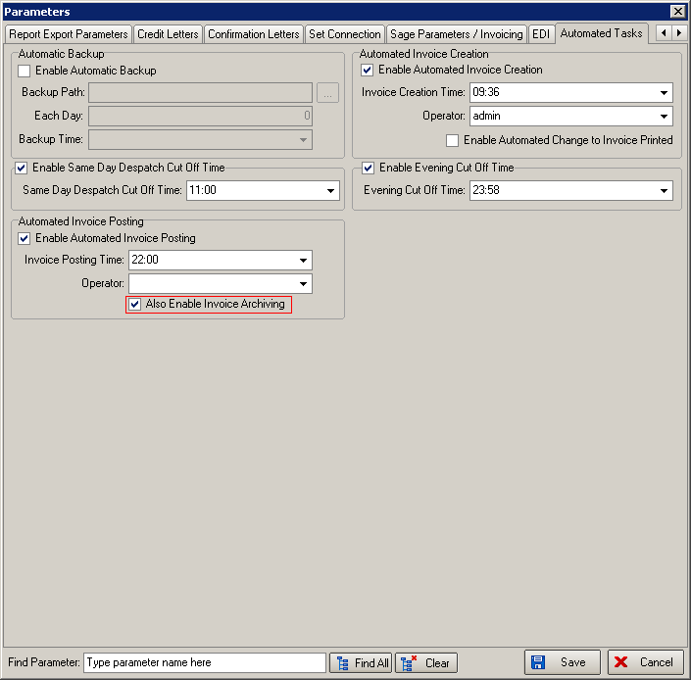

1746. Scheduling

Previously if an order had a quantity of blinds that exceeded the maximum scheduling number, then scheduling dates had to be assigned automatically.

Now if the number of blinds in an order exceeds the maximum scheduling number, then only the maximum scheduling amount is scheduled on any day for the same order.

For example, if the maximum scheduling amount is 20, and an order has 100 blinds for the same manufacturing location, the blinds will be fitted across 5 days (providing 20 blinds can be fitted into the first available day).

27/05/10 20
28/05/10 20
31/05/10 20
01/06/10 20
02/06/10 20

