Blindata Release Note 4.9.4 

14 May 2010

Bug Fixes and Enhancements

3005. Fitter Worksheet

Some details and comments were being cut off. Fixed.

3008. Acknowledgement – Laser Print (Letterhead)

There were a couple of places where text is being chopped off. Fixed.

3009. Label Print – 3 ½ x 2 A

- All text has been moved right by 5mm. Also, the font in all the fields has been made larger.
- This has been moved up 4mm, and the font made larger.
- This has been moved left so it is next to order number and the font made larger.
- This has been moved up to where the blind type started, and the font made bold and larger.
- The postcode from the delivery address in the order now appears here.

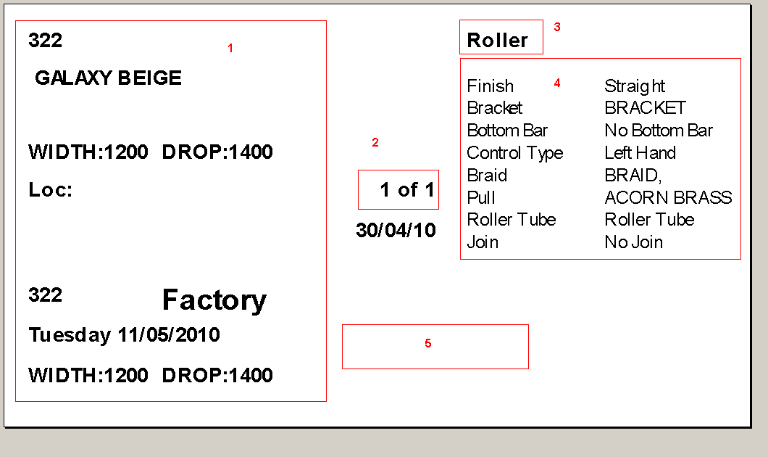

3010. Label Print – 3 ½ x 2 A

- The width and drop fonts have been made bigger again, and moved up 3mm.
- This has been moved up 3mm, and the font made larger.
- This has been moved to the top right of the label, to the right of blind type description – right justified in the corner.

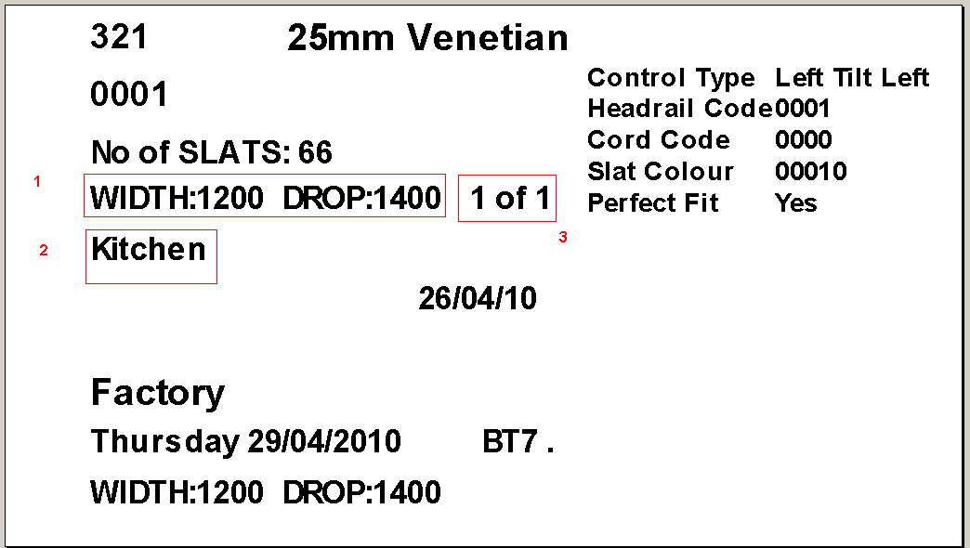

3011. Label Print – 3 ½ x 2 A

- The number of vanes now prints if blind identifier = ‘Vanes Only’ or ‘Track’ or ‘Headrail Only’ as well as for ‘Vertical’.
- If ‘Repair is ticked in an order, the repair comment text now prints instead of width and drop.
3. The order of label print has been changed. It is by order number, then by Label Control free type, then by order detail id.

3013. Invoice – Laser Print 11 Detail Lines

If ‘Hide Detail Line Discount’ is set to true, then the base price and discount % no longer print on the invoice.

New Work and Customer Requests

1680. Label Print – Bespoke 28

Special instructions now print on the large label.

1682. Tagging Label – Bespoke 1

These labels now print off in same order as the works orders ie blind type order, then order number order. They also show the weekday required.

1698. Production Scheduling Optimisation

We have changed a number of queries and transactions in Scheduling and Order Entry / EDI functionalities, to make sure they do not block tables and records. Also when EDI orders are being created, it calculates only once per order.
In additional, we optimized queries in the scheduling functionality and fixed a bug – sometimes it re-calculated the scheduling for a whole order, when it should only have re-calculated it for one detail line only.

1714. EDI Import Improvements

In the last few versions we have made improvements to the EDI import functionality.

4.9.2:

- Loading EDI Enquiry > Receiving Data form
- Loading EDI Import Wizard;
- EDI tables (indexes were added).

4.9.3:

- Option price find algorithm
- Option creation routine
- Bunch searching routine
- Decreased number of queries to DB in EDI creation Sales Orders routine

1733. Works Order – Bespoke 28

We have added information on fabric cuts for roller blinds and increased the font size of the blind/factory/frame/track copy identifier label on the top right of page.

1734. Sales Analysis by Fabric

The ‘Running Total’ column now calculates as follows. Example: for fabrics there is a total of 461.94 metres. So Carnival Claret would represent 10.9% of that fabric. Ex-Lite White (the next highest use) would represent 7.8%, Tessa Mink 7.5% and Guardian Royal 7.2%. This column now sums the percentages as you move down the list, as follows:
Carnival Claret 10.9%
Ex-Lite White 18.7% (10.9 + 7.8)
Tessa Mink 26.2% (10.9 + 7.8 + 7.5)
Guardian Royal 33.4% (10.9 + 7.8 + 7.5 + 7.2) etc.

There is also a ‘Number of Blinds Column’, between No. of Orders and Meterage used.

1735. Sales Analysis By Fabric Class

- The metreage is now in descending order.
- The stock/cut column has been removed.
- There is now a ‘No of Blinds’ column.

1736. Roll Out Production List

Previously this report showed a line for every blind on the order at the moment. The records are now grouped by fabric within each order to cut down the size of the report.

1737. Production Lists > Order Control Report by Order Category

A new report has been created called ‘Order Control Report by Order Category’. This is based on ‘Order Control Report (Extra), but is grouped by ‘Order Category’.

1738. Sales Lead Individual Tractor Feed

This is a new report, based on ‘Sales Lead Individual Normal’. The only difference is that it is for tractor feed paper and so the page length is 11”. We have removed lines 19 and 20 so it will fit properly.

