Blindata Release Note 4.9.3 

5 May 2010

Bug Fixes and Enhancements

2998. Cost Price Table Calculation

When running for box blinds, it now changes the box blind cost prices between the size increments.

2999. Invoice – A4 Batch Print

The company name is now taken from Administration > Company Details.

3000. EDI Import

When EDI orders were imported from Blindata Online, they were generating duplicate header records. Fixed.

3002. Quotation Laser Print (Letterhead) pdf

The text was overlapping on the pdf file – it was ok if you do a print preview. Fixed.

3003. Administration > Company Details

An error occured when you tried to change the company name. Fixed.

New Work and Customer Requests

1720. Sales Analysis by Blind Type

We have added a column to this report called ‘Contribution’. This has been placed between ‘Profit’ and ‘Sales Quantity’.
The Unit Contribution Margin (C) is Unit Revenue (Price, P) minus Unit Variable Cost (V):
C = P − V
The Contribution Margin Ratio is the percentage of Contribution over Total Revenue, which can be calculated from the unit contribution over unit price or total contribution over Total Revenue:
For instance, if the price is £10 and the unit variable cost is £2, then the unit contribution margin is £8, and the contribution margin ratio is £8/£10 = 80%.

1721. Sales Analysis by Customer by Nett

There is a new column for ‘Contribution’ which goes between ‘Profit’ and ‘Sales Quantity’.

1722. Sales Analysis by Rep by Customer Detailed

There are some extra columns in this report.

Order No Order Date List Price Total Sales Nett Sales Variance % Variance

Variance is List Price – Total Sales and the % variance is (Variance/List Price)*100.

1724. Cooling Off Period / Child Safety Text

There are two new text fields in Administration > Company Details. These are called ‘Cooling Off Period’ and ‘Child Safety’. These have been placed in the ‘Sales Lead Text’ tab.

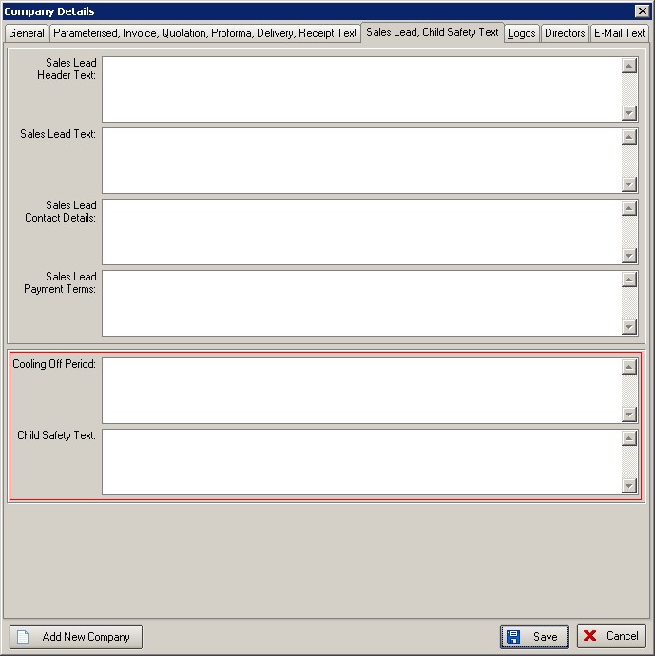

They now print on ‘Sales Lead Individual Normal’. We have taken out lines 21-24, and put both of these new fields in boxes here. There is also a field for writing in ‘Fitting Date’.

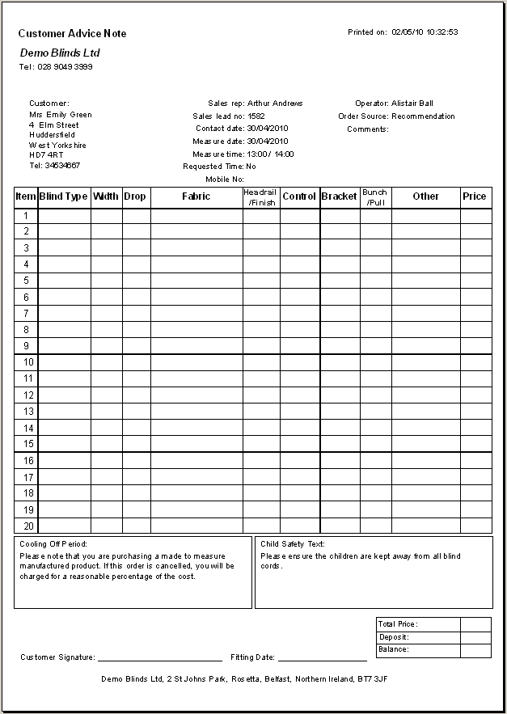

1725. Label Print – 3 ½ x 2 A

There is a new label print is required called ‘Label Print – 3 ½ x 2 A’. This is based on ‘Label Print – 3 ½ x 2’ – it is the same size but the information on the labels is different.

1726. Acknowledgement Laser Print (Letterhead) / Invoice Laser Print (Letterhead)

Location now appear on these order acknowledgements and invoices.

