Blindata Release Note 4.9.2 

16 April 2010

Bug Fixes and Enhancements

2985. Order Processing > Orders

For curved headrails, the headrail size has been moved right so it lines up vertically with the ‘Drop’ field.

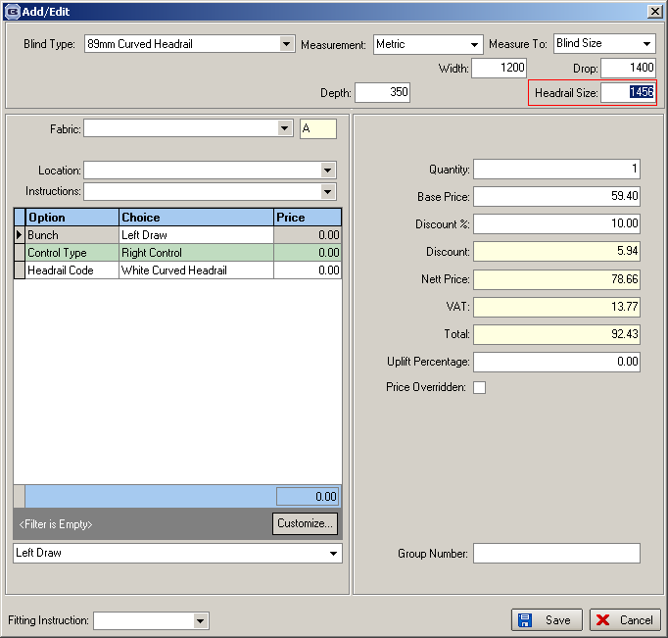

2987. Order Processing > Orders

If a price is set up for an option in Pricing > Number of Vanes Pricing, then that price is multiplied by the number of vanes and put in the option price.

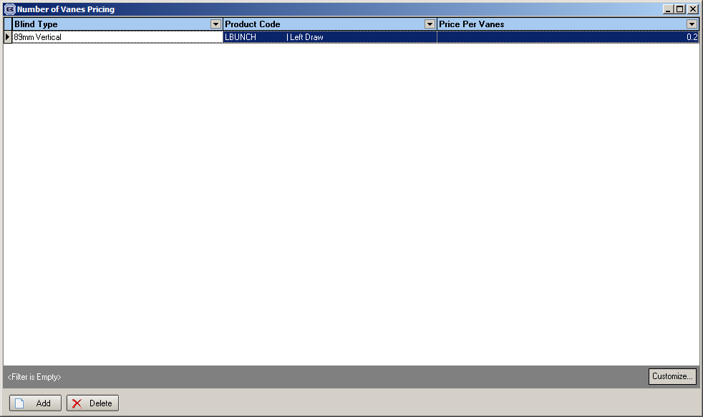

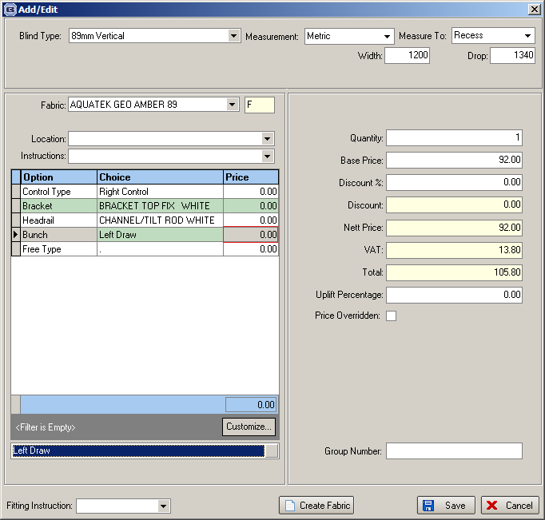

2988. Pricing > Option Price Enquiry

When an option is copied using the ‘Copy Option Prices’ button and there is a formula, the formula is now also copied.

2989. Scheduling

If you tried to clear records, an error message appeared. This has been replaced by the following message.

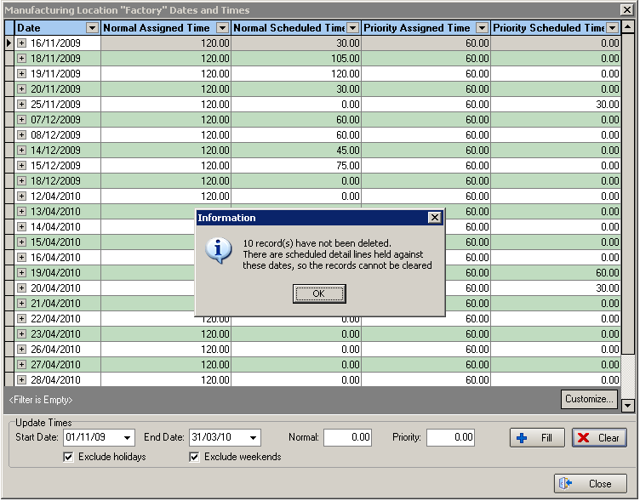

2990. EDI Enquiry > Receiving Data

When you tried to import an order for an EDI file that has come from Blindata Online, it was not obvious what to do. This has been clarified..

2991. Fabric Usage Reports

The fabrics appeared multiple times on this report because the report broke usage down by customer. It now only appears once.

The same thing happened on the Sales Analysis by Fabric Class report.

2993. Sales Analysis Performance Report

The variance figures are now correct. It is the difference between the ‘List Price’ and ‘Sales in VAT’.

2994. Administration > Archiving

An error message appears when you tried to run Archiving. Fixed.

2995. Sales Analysis By Fabric

The running total column always had 100% in it. It is now the % of sales for that fabric within the blind type.

2996. Administration > Export Date > Blind Type Dataset

The export file contained some errors:

- If there was a comma in the stock description, then an extra field was created and everything else was moved one column to the right.
- The blind indicator was the id, when it should have been the blind indicator code. Fixed.

2997. Invoice – Batch Print A4

There was payment information missing from the bottom of this invoice.

New Work and Customer Requests

1690. Scheduling

Must go, repairs, remakes now go into priority schedule time, and also apply the cut off time rule. If an order is imported via EDI before the cut off time, then it should go into the first available priority scheduled time.

1713. Fabric Roll Length

There is a new field in the Fabrics table called ‘Roll Length’. This will have an impact on fabric optimisation. For example, a roller fabric may have a width of 2000m and a length of 30000mm. If there are a lot of blinds that are being optimised, they might not all be able to be cut from the same roll.

We have altered the fabric optimisation routine so it can handle the roll length as well as the roll width.

1715. Off Cut Fabric Optimisation

It is now possible to calculate off cuts (if relevant parameters are switched on) during the fabric optimisation process. It contains the same functionality as the off cut calculation when the order is being saved, except the process may involve multiple orders.

1716. Administration > Export Data > Blind Type Dataset

There is now a method of exporting data easily from Blindata to a spreadsheet so it can then be imported to Blindata.net.

The spreadsheet we export is very similar to the ‘Blind Type Dataset’ spreadsheet that is imported, but we also hold records for the blind type.

The record in the spreadsheet for the blind type have the blind type code in the blind type field and the blind type description in the fabric description field.
Blind identifier goes into the blind identifier field.
Manufacturing Location to the Fabric Code field
Category to Fabric Group
Sales nominal code to nominal code
Measure To to Default code
Cost Nominal code to Cost Nominal

If the blind type record being exported has ‘Bought In’ = true, then the supplier code goes in the supplier code field. If ‘Stock Control’ = true, then the supplier code is blank.

The idea is that we can export all relevant information for a blind type and then import it into Blindata.net. This will make the setup for Blindata.net a lot easier.

There is a button on the ‘Export Data’ form called ‘Blind Type Export’. This will allow the user to create a spreadsheet for exporting.

We have also changed the ‘Blind Type Dataset’ import so it imports the ‘Blind Type’ record.

1717. Administration > Users > Advanced Permission

There is now an advanced permission flag for the ‘Order Made’ button on the order amend enquiry form.

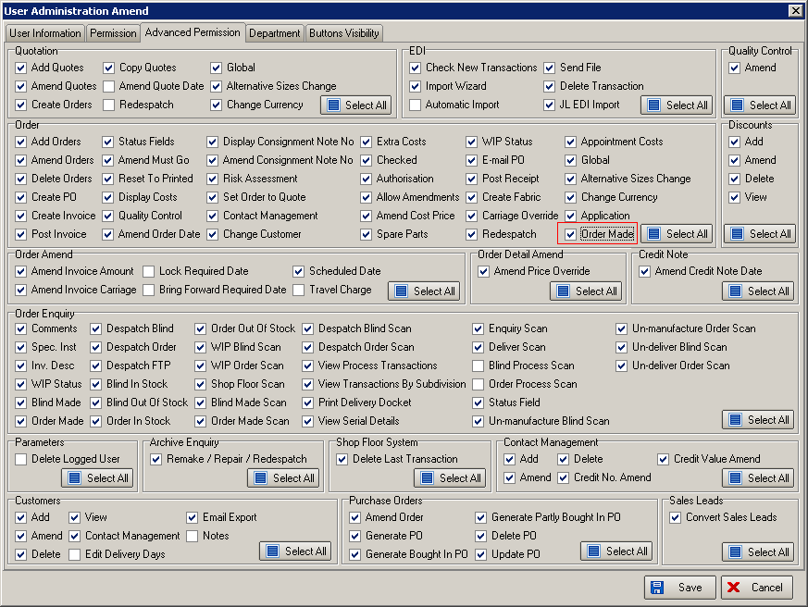

1718. Invoice – A4 Batch Print

A new layout has been created for this report.

1719. Sales Analysis Performance Report

Some columns have been renamed and the order of column printing has been changed.

