Blindata Release Note 4.9.1 

9 April 2010

Bug Fixes and Enhancements

New Work and Customer Requests

1203. Sales Files > Customers

It is now possible to have discount by quantity for particular customers. In Customers > Special Pricing, there is a new discount % field, which can be applied instead of the price field.

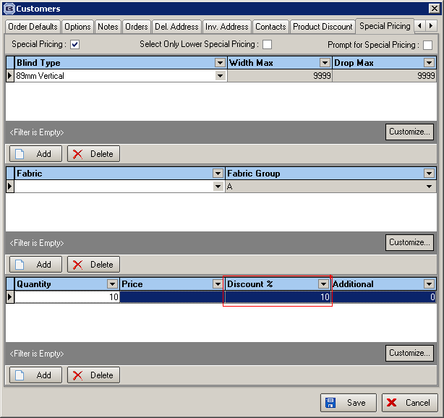

So, for example, we could have a situation where a customer gets a quantity discount if they buy 10 or more blinds of a particular blind type and fabric group. They may get a further discount if they buy more than 20 blinds in an order.

As with special pricing, the discount is applied at the end of the order.

1689. Curved Headrails

It is now possible to work out the number of vanes on a curved headrail. When a curved headrail is entered, we enter the width (a), drop and the depth (b). We can then work out the length of the headrail (c) needed for the curve, as

c = ((4b² + a²)/4b) * arcsin(4ab / (4b² + a²)) * ∏ / 180.

This will give the length of the headrail required, which is displayed on the order entry form (to the right of depth). When the number of vanes is calculated, this calculated headrail size is used instead of the width.

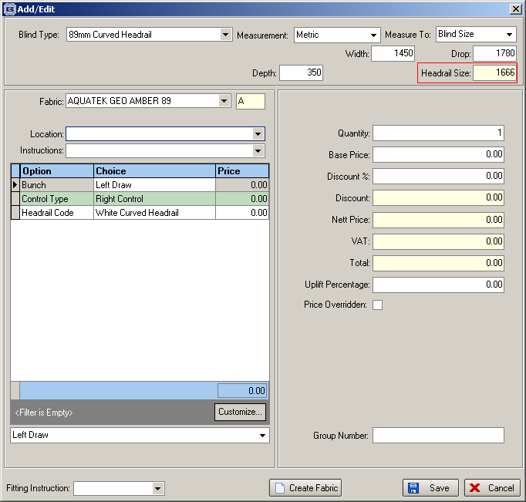

1707. Off Cuts (Without Optimisation)

When a roller blind is made, there are often bits of fabric left over. These are called ‘off cuts’. It is sometimes possible to use these off cuts to make other blinds. Therefore we have created a method of recording off cuts and then being able to find them later.

There are new parameters called ‘Use Fabric Off Cuts’ in Administration > Parameters and in Blind Details > Blind Types.

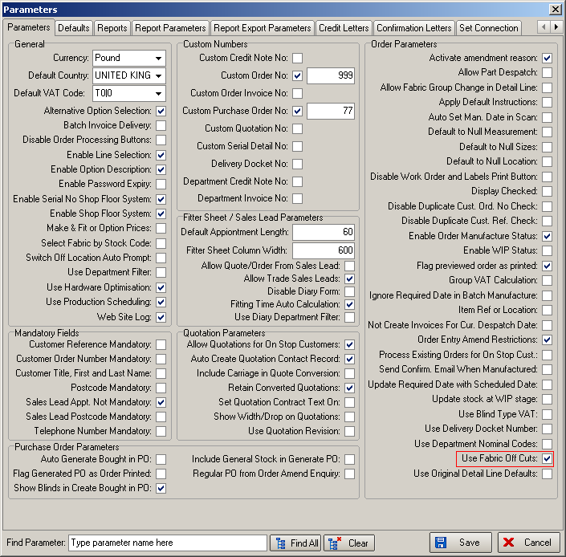

The latter only appears if blind identifier = Roller or Austrian/Roman or Pleated or Panel or Woodweave.

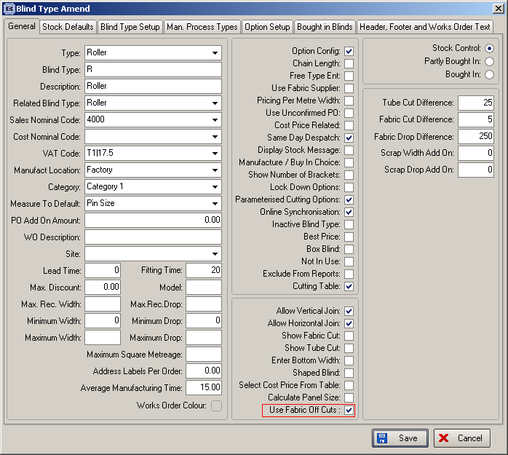

There is also a new table called ‘Fabric Off Cuts’. This holds fabric id, date, width, drop and location. There is a new tab against the Fabrics form called ‘Off Cuts’ which will show the fields in this table. The tab will only be displayed the blind identifier = Roller or Austrian/Roman or Pleated or Panel or Woodweave.

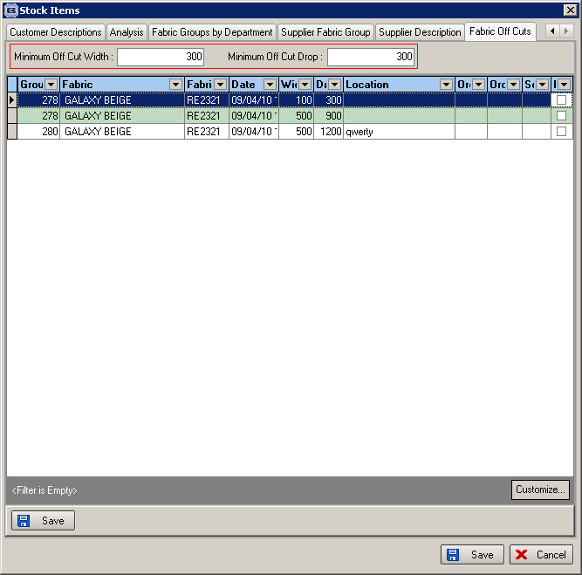

There is a new report in Reports > System Reports called ‘Fabric Offcuts’. This lists all the off cuts in the table, showing fabric description, date, width, drop and location. It is grouped by blind type.

When an order is being saved, the program now checks to see if ‘Use Fabric Off Cuts’ is switched on for each blind type in the order detail lines. We also take into account whether ‘Fabric Optimisation’ is switched on for the fabric in the order detail line. If fabric optimisation is switched on for a fabric, then nothing is done with off cuts at this point.

If ‘Use Fabric Off Cuts’ = true and ‘Fabric Optimisation’ = false, when the order is saved, the detail lines are analysed to see whether a fabric off cut can be used or not. For example, if there is a detail line for a roller fabric with fabric = Fabric A, we should check to see if there is an off cut record for it and to see if a blind can be cut from it ie width and drop in the detail line < width and drop in off cut record (usual rules for calculators apply – ‘Width or Drop’, ‘Width’ and ‘Drop’). If there is a cut off that can be used, then it is used and the fabric cut off record is removed. If there is not one available, then the size of the piece of fabric is calculated, and a cut off record is created for the bit that is left over.

Example: a fabric roll width is 2000mm and the calculator is ‘Width or Drop’. The blind required is 1200mm width, with a drop of 1400mm. The BOM is calculated as being 1200mm width x 1650mm drop. The fabric will then be cut so it leaves a piece that is 350mm x 1200mm. This piece should be stored in the ‘Fabric Off Cuts’ table.

If there is only one detail line for this fabric, that that is fine. If there is more than one, then it becomes a lot more complicated.

For example, let’s say there are 7 detail lines in an order, all for the same fabric, and fabric optimisation is switched off, but ‘Use Fabric Off Cuts’ is switched on. The best way to do this would be to actually run a fabric optimisation just for this fabric in this order. It should first check to see if the off cuts table contains record to fulfil the blinds for that fabric. The off cuts will be used only if all the blinds can be made with off cuts. If not, a fabric optimisation should be run and then fabric off cut records created.

Finally, we can also hold a location for the off cuts. This will only be known when the order is manufactured. If an off cut has been created, then we need to enter the location of where it is being stored. This is done at the ‘Order Made’ stage.

1714. Administration > Import From Excel > Blind Type Dataset

It is now possible to import records from this spreadsheet that are used for calculating the BOM. The ‘Blind Type Dataset’ now imports records for blind type stock defaults and stock item additional items. These are added to the existing ‘Blind Type Dataset’ spreadsheet prior to importing.

The records in blue are the records that need to be imported to the StockDefault table and the record in red is the format for importing to Fabric_Fabric.

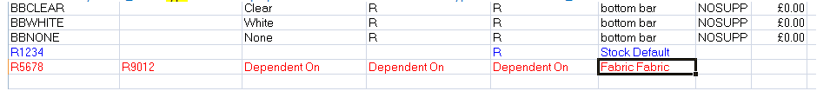

For the Fabric_Fabric record, the fabric code is the stock code of the parent code, ‘Fabric Group’ is the stock code of the additional item and ‘Fabric Description’, ‘Blind Indicator’ and ‘Blind type’ are the 3 ‘Dependent On’ fields.

1715. Stock Items > Additional Options

There is now a ‘Save’ button on this form.

