Blindata Release Note 4.9.0 

2 April 2010

Bug Fixes and Enhancements

2981. EDI Import

EDI discount was not being applied when EDI orders were imported. Fixed.

2982. Pricing > Option Price Enquiry

- Validation was not calculating to 2 decimal places. Fixed
- The sizes no longer have a comma in them ie the format is 1234, not 1,234.

2983. Order Processing > Orders

If you entered an order that had an option price that was dependent on a formula, it was calculating it as a whole number – now it calculates to 2 decimal places.

New Work and Customer Requests

1698. Production Scheduling Optimisation

We have made a number of changes to stored procedures to optimise the system when production scheduling is switched on.

1708. Invoice – Bespoke 2

It is now possible to print Company Details > Invoice Text on this invoice, centre justified and in bold at the bottom of the page.

1709. Administration > Users

There is now a menu option permission for Stock Setup > EDI Product Codes.

1710. System Tables > Departments

Previously we could specify a different report layout for delivery dockets and invoices by department. We have now included choices for quotations and order acknowledgements. The relevant ‘Print’ buttons in Quotations and Orders have been changed to check to see if there is a layout set up in the department record.

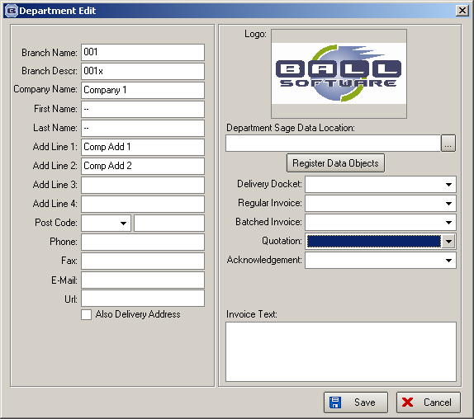

1711. Order Processing > Orders

If ‘Square Metre Pricing’ is switched on for a fabric then the square metreage and the square metre price is now shown on the order detail entry. It is possible for the user to change the square metre price, which in turn recalculates the base price and flag ‘Price Overridden’ = true.

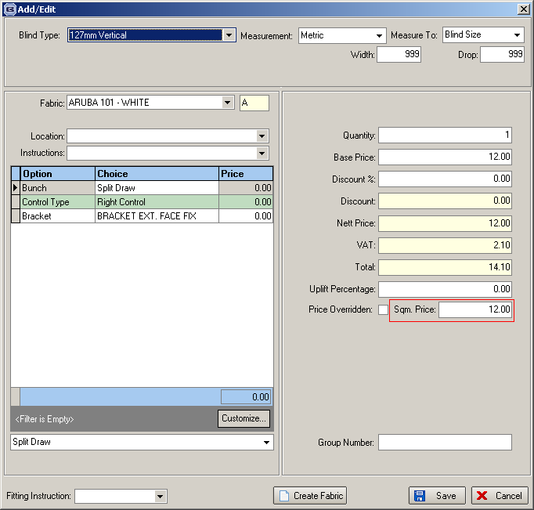

1712. Sales Analysis by Nominal Code

There are now two more columns on this report, ‘Cost Price’ and ‘Gross Profit’. ‘Gross Profit’ = ‘Nett Price’ – ‘Cost Price’.

There are also totals for these two columns, which fit between ‘Nett Price’ and ‘% of Sales’.

