Blindata Release Note 4.8.8 

23 March 2010

Bug Fixes and Enhancements

2971. Financials > Post Invoices to Sage

If a customer is set up as ‘Batch Invoice’ = true, then multiple orders can have the same invoice number. When the orders are posted to Sage, they are now posted as one invoice, not multiple records with the same invoice number.

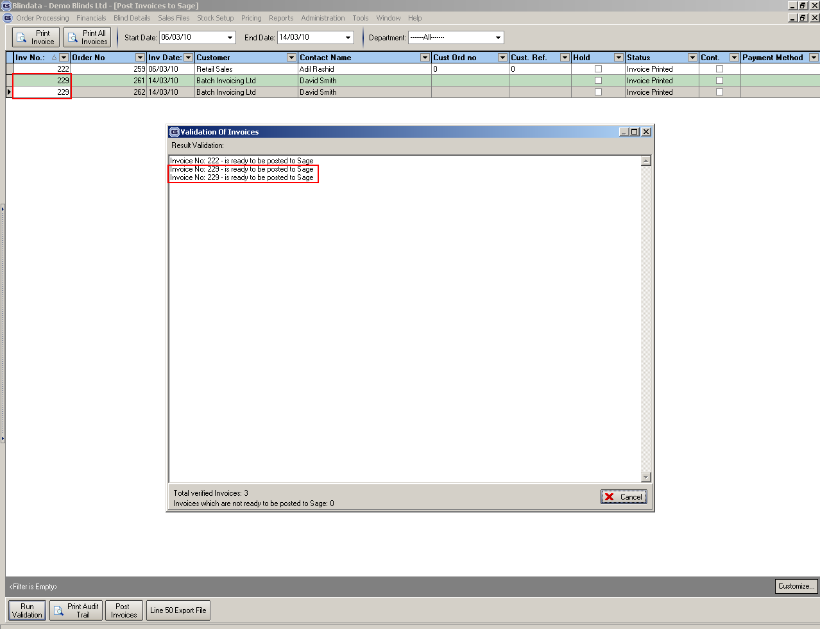

2973. Delivery Docket – Bespoke 4

The delivery date printed out as 31/12/1899 when you do this print. Fixed.

New Work and Customer Requests

1701. Works Order – Label Blind Size

For blind identifier = Venetian, we now show the headrail cut size here. It is called ‘Rail Cut:’. The calculation is Width (blind size – headrail cut).

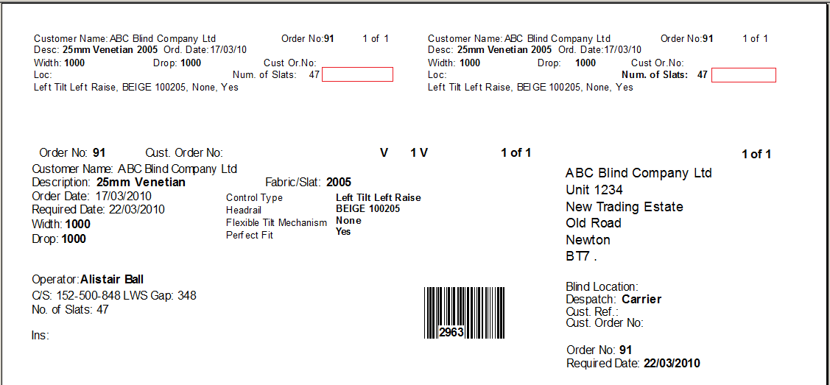

1702. Spacer Calculation for Verticals

It is now possible to calculate the size of spacers to be used in a vertical blind, for up to three different sizes of spacer. These are used in the headrail to connect the vanes together. The system will work out the best combination to use, depending on the width of the headrail, which is calculated as width (blind size) – headrail cut.

Example: a 127mm vertical blind is 1000mm width (blind size) and the headrail cut deduction is 15mm, so the headrail size is 985. There are two spacer sizes, 110mm and 106mm. 985/110 = 8 remainder 105, so we would use 8 x 110, 1 x 106 which totals 986. But if the headrail size was 954, you could use 9 x 106, which is exactly correct.

It is further complicated by the fact that the vanes might be in a split bunch ie the blind opens from the middle. This means an even number of vanes on each side, which complicates the problem. We then divide the headrail size by two and do the calculation for one side, then add the results together.

In Administration > System Tables, there is a new table to hold spacer sizes against blind types.

There is a new parameter in Blind Details > Blind Types called ‘Fixed Size Spacer Calc’. This cannot be switched on at the same time as ‘Calc Spacer’. If ‘Fixed Size Spacer Calc’ is switched on, then the result is printed on ‘Works Order – Label Blind Size’.

1703. Austrian / Roman Blind Identifier

There is a new parameter called ‘Holes Calc’ which is a true/false flag. If this is switched on, then data that is held in the spreadsheet ‘Holes Calc’ is accessed by the system.

This spreadsheet can be imported to a table in Administration > Import From Excel > Holes Calc..

The spreadsheet contains the following columns

Width | Holes | Ist Hole | 2nd Hole | 3rd Hole | 4th Hole | 5th Hole | Control hole | 1st Hole | 2nd Hole

1500 | 3 | 100 | 750 | 1400 |  |  | 110 | 375 | 1125

If a blind is 1495 wide (blind size), then the following information is required to print on ‘Works Order Label Blind Size’. But we only show Rout Holes: 100, 750, 1400 Control Holes: 110, 375, 1125

1704. Panel Blinds

If blind identifier = ‘Panel Blind’, there is a new flag called ‘Calculate Panel Size’. If this is true, the panel width size is calculated by a formula instead of looking up a table.

If ‘Calculate Panel Size’ = true, another field is displayed called ‘Overlap Size’. This is also required to calculate the panel size.

The formula is:
Panel width = (Width (Blind Size) – Headrail Cut Deduction + (Overlap Size * (number of panels – 1))) / number of panels.

If ‘Calculate Panel Size’ = true, then the panel size prints on ‘Works Order Label Blind Size’.

