Blindata Release Note 4.8.7 

12 March 2010

Bug Fixes and Enhancements

2969. Financials > Invoice Batch Print

In one customer database, there were examples of orders with status = ‘Part Posted’ printing each time you ran the ‘Invoice Batch Print’. The same invoices printed each time. Fixed.

2970. Order Processing > Orders > Status Field

If an order had a status of ‘Invoice Created’ or ‘Invoice Printed’ and it was changed back to ‘Despatched’ using the ‘Status Fields’ button, it was not possible to then use ‘Create Invoices’ because a message appeared saying ‘There are no details to create invoice’. Fixed.

2972. Quotations > Technical Data Sheet

These blinds are all square ie there should be no ‘LH Taper Offset’ amount. Fixed.

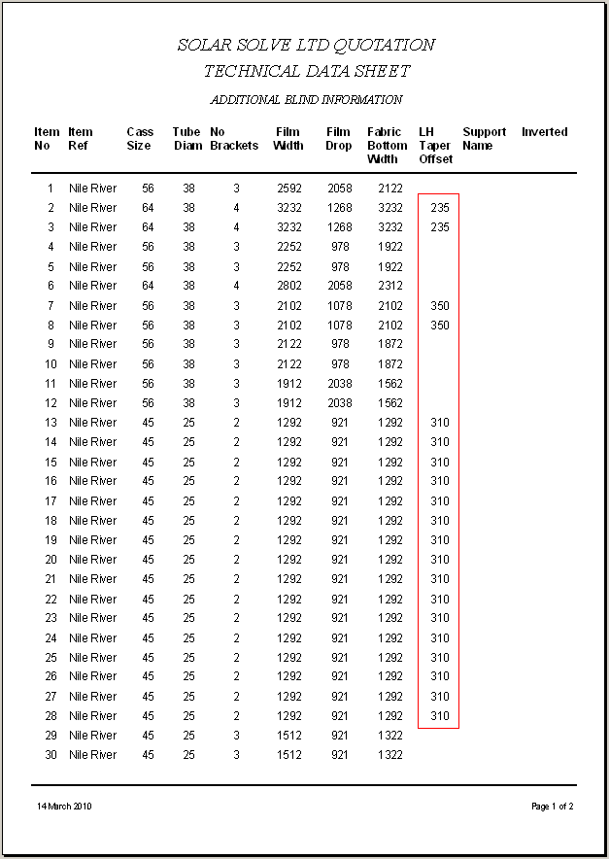
We have added a new flag called ‘Sq/Rect Item’ in the Fabric table and analyzed it for option “Blind Shape”, similar to what was done for “Fabric > Equal Taper” flag for the ‘Shape’ option.

New Work and Customer Requests

1691. Reports > Sales Analysis > Sales Analysis Day Book by Category

- There is a new sales analysis report called ‘Sales Analysis Day Book by Category’.

1692. Sales Analysis Summary Of Orders

There is a new sales analysis report called ‘Sales Analysis Summary Of Orders’.

1693. Administration > System Tables > Order Source

There is now an ‘Is Null’ field in the order source record. When an order is entered, if the order source is null, then it is validated (in the same way as was done for the despatch method recently).

1694. Sales Files > Customers

Previously a user could only enter ‘Notes’ against a customer if they had the correct advanced permission. There is a new button at the bottom of customer enquiry called ‘Customer Notes’. This now has its own advanced permission called ‘Notes’, and if switched on, will allow a user to add or amend the customer notes.

1695. Customers / Sales Analysis Performance Report

There is a new field in Sales Files > Customers called ‘Daily Sales Target’. This is a numeric field to 2 decimal places.

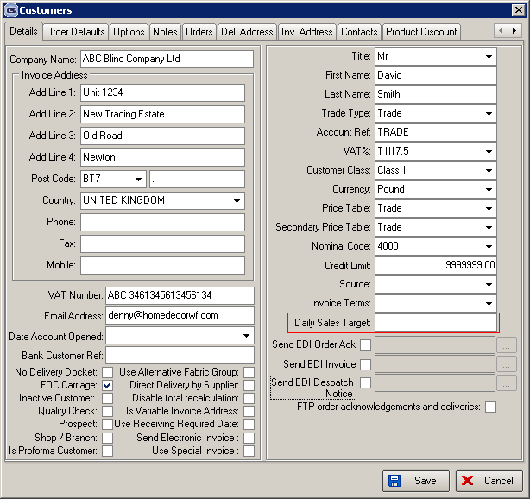

This field is used in the Sales Analysis Performance report. There are two new columns in the report, one called ‘Target’ and the other ‘Target Variance’. The ‘Target’ field contains the ‘Daily Sales Target’ figure from the customer multiplied by the number of work days the report covers. The ‘Target Variance’ field is ‘Total Nett Sales’ – ‘Daily Sales Target’. A negative figure will be in brackets.

1696. Post Invoices to Sage

Previously when an invoice was posted to Sage, all the detail lines for the invoice get posted into Sage like this.

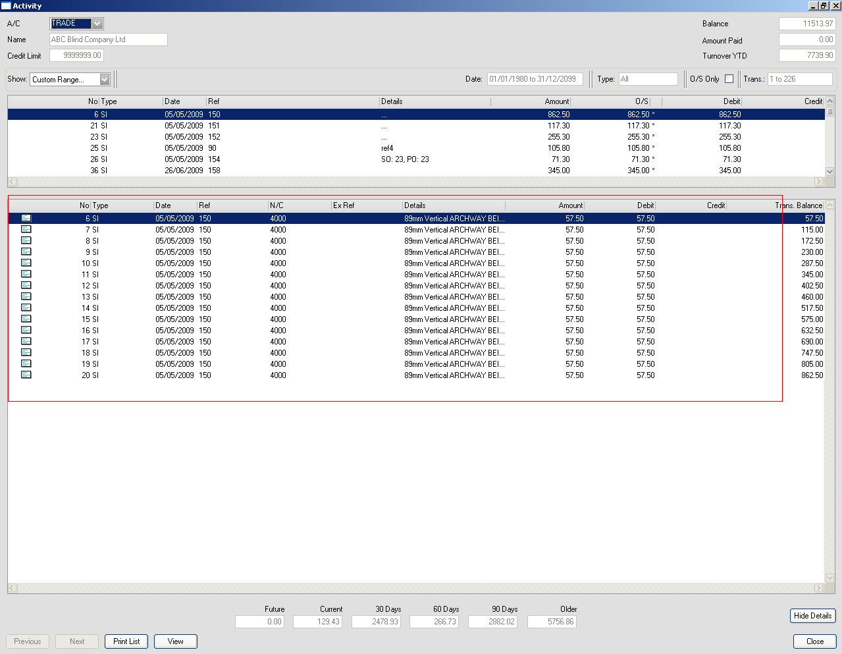

If ‘Use Customer Nominal for Posting to Sage’ is set to true, there is no need to post all these transaction detail lines. We now post one transaction line with the total amount in it, because it is going to only one nominal code.

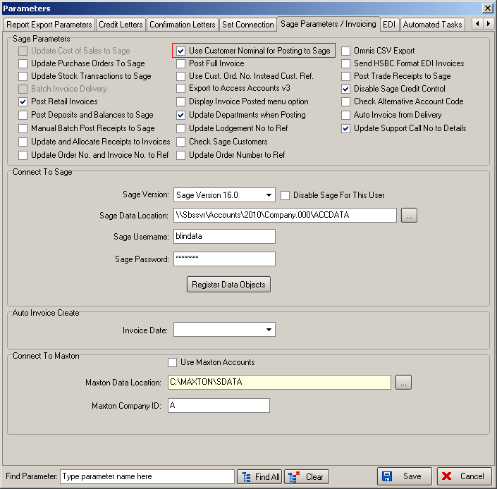

1697. Sales Analysis by Customer Class by Customer by Category

The report now shows up to 18 categories horizontally.

