Blindata Release Note 4.8.6 

9 March 2010

Bug Fixes and Enhancements

2958. Works Order - Three Copies

- Special instructions now print on this report.
- The report now only prints one blind identifier per page.

2959. Stock Setup > Stock Items > Uplift Prices

If records were filtered by supplier and then uplifted, only certain records were updated. Fixed.

2960. Invoice – Batch Print A4

- A page was being printed without any detail lines on it – fixed.
- The widths and drops have been tidied up.

2961. Delivery Docket – Batched Orders

This report is now grouped by customer.

2963. Invoice – Batch Print A4

The totals are now at the bottom of the page.

2964. Works Order – Bespoke 22

Four lines of special instructions now appear.

2965. Label – Bespoke 22

- Contact name no longer prints (in either delivery address).
- Number of vanes and length of vanes now print if blind identifier = ‘Vanes Only’.
- The special instructions and location have been tidied up. There is now room for four lines of special instructions, ‘Location’ has been moved down to below ‘Spec Ins’ and ‘1L etc’ moved right a bit.

New Work and Customer Requests

851. Order Processing > Cancelled Orders

There is a new menu option on the Order Processing menu to view cancelled orders.

1681. Works Order – Bespoke 28

1. Works order groupings – the report is now grouped by blind identifier (it was like this originally).
2. Delivery notes (from Order Amend Enquiry > Delivery Notes button) now appear on the works order in the bottom right hand corner.
3. The words ‘Remake’, ‘Repair’, ‘Redespatch’ now print on works order, beside ‘Must Go’ prints.

1683. Production List By Customer Report

The customer name is now included in the sub total at the bottom of the group. This makes the report easier to read if the blinds for one customer cover more than one page.

1684. Sales Analysis Performance Report

1. The variance is now working out as Sales Price - List price. Negative variances are in brackets.
2. Subtotal now state customer class etc descriptions
3. The final page now shows Customer Class subtotals then Grand total, as well as the existing sub totals after each group. This is printed as a separate report after the main performance report.

1685. Sales Analysis by Customer by Order Source

There is a new report, based on ‘Sales Analysis by Order Source by Customer’, called ‘Sales Analysis by Customer by Order Source’, which shows the same data but grouped differently.

1686. General

On tabular forms ‘Customise’ now appears as a default. Previously the ‘Customise’ button only appeared after a filter had been created. It now appears when the form is opened. This applies to all forms like this.

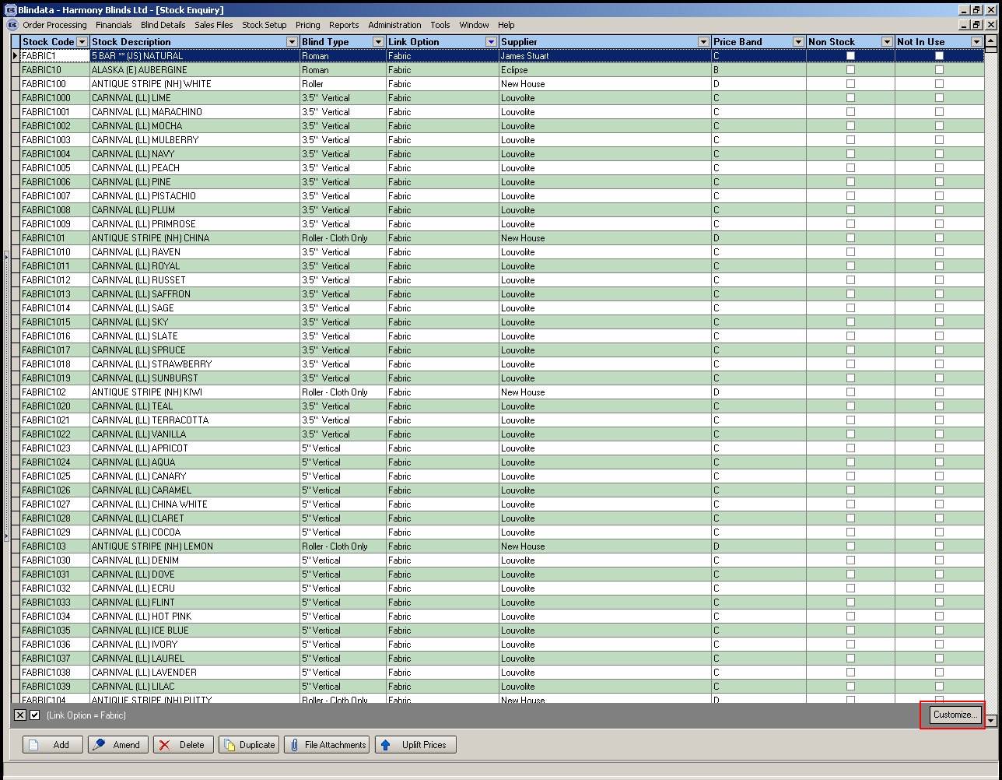

1687. Vertical Fabric Calculation

There is a new calculator called Louvres Plus One * Fabric Length. This calculate stock as (Louvres + 1) * Fabric Length.

1688. Invoice Batch Print

Invoice layout can now be determined by the department that is set up in a customer record. This means that the invoice batch print run can be done by department. There is a new invoice layout field in the department record, and is checked when the invoice print (individual and batch print) is run.

When the invoice batch print is done, and if department is selected, the program checks the department record for an invoice layout. If it is null then the invoice layout in the parameter record is used.

1691. Acknowledgement – Lead Time Text

We made a change recently to this report to show the scheduled date instead of the lead time text. Both versions of this report are now available. The original is called ‘Acknowledgement – Lead Time Text’ and the new one (with the scheduled date) is called ‘Acknowledgement – Schedule Date’.

1692. Works Order – Delivery 8

Despatch Day now prints on this works order.

1693. Blind Types / Works Order Label 1 (re-release of 4.8.3)

There are now two more fields on the blind type record if blind identifier = Panel Blind. These are ‘Headrail Cut Deduction’ and ‘Fabric Drop Cut Deduction’.

‘Works Order Label 1’ now includes these fields if blind identifier = Panel Blind.

Headrail Cut = Man width – Headrail Cut Deduction
Fabric Drop Cut = Man Drop – Fabric Drop Deduction Cut.

1694. Label Print – A4 2 x 11 v2

There is a new label layout based on 'Label Print - A4 2 x 11 - called 'Label print - A4 2 x 11 v2'. It has the same number of labels ie 2 x 11, but top and bottom margins are 5.5mm, label depth is 26mm.

