Blindata Release Note 4.8.5 

26 February 2010

Bug Fixes and Enhancements

2946. EDI Import

Every XML that was imported opened a new FTP connection but did not close any after it was imported. It then blocked a customer from sending in orders through the FTP. Fixed.

2947. Purchase Order Enquiry

The ‘Generate Regular PO’ hung in v4.8.4 when you run it for a lot of data. This has been optimised.

2951. Production Lists > Order Control Report

- ‘Order’ now prints ‘Order Manufactured’ and ‘Part’ now prints ‘Part Manufactured’.
If a blind identifier = ‘Austrian/Roman’, the blind type code did not print in the blind type code column. Fixed.

2952. Post Invoice to Sage

Since the new validation routine was introduced in v4.8.4, if there was a detail line with a zero amount in it, when the posting is done to Sage, the following error occured.

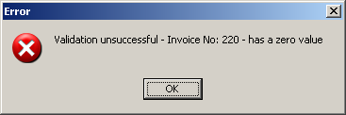

This no longer appears and the invoice is posted, provided there are other detail lines with values > 0.

2954. Sales Analysis by Customer Class by Customer by Category (Order)

This report is now grouping properly. It groups by customer class, then by customer.

2955. Sales Analysis by Fabric

No. of orders was printing no. of blinds – now prints no of orders

2956. Sales Analysis by Fabric Class and Colour

This report is now grouped by fabric class and prints no. of orders, not blinds.

2957. Stock Setup > Stock Items

Some items were showing too many decimal places in the columns. Fixed.

New Work and Customer Requests

1593. Order Processing > Orders > Global

When the fabric is changed in the ‘Global’ functionality, previously it only changed the fabric. It now also applies all the defaults (from the Default Options tab in Stock Items) that are set for the fabric that is selected. The other options remain the same.

1615. Works Order – Bespoke 28

This customer runs the fabric optimisation for roller blinds before the works orders are printed. The works order for roller blinds now prints which other blinds should be cut out of the same width of cloth. This means we now list the other order numbers for the same optimisation run for the same fabric on this report.

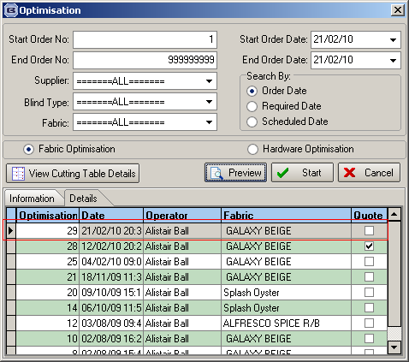

1676. Sales Analysis by Blind Type by Customer Descending Value

This is a new report, based on ‘Sales Analysis by Blind Type by Customer’, but lists the customers in order value rather than alphabetically within blind types. There should also be a column saying how many blinds there are.

1677. Sales Analysis by Customer Class by Customer by Category (Order)

Previously this report only included columns for categories if they have been ordered. The report now shows all category columns, even if the amounts are zero for the column.

1678. Sales Analysis by Order Source by Customer (Order)

There is now a column for number of orders to this report.

1679. Stock Setup > Stock Items

There are now column choices for ‘Blind Type Code’ and ‘Supplier Code’ on the stock enquiry form.

