Blindata Release Note 4.8.4 

22 February 2010

Bug Fixes and Enhancements

2940. Sales Analysis Performance Report

- The ‘Blinds Per Order’ now only displays to one decimal place.
- Actual Order Value = actual nett / number of orders.
- Actual Blind Value = actual nett / number of blinds.
- List Price has been rounded to the nearest pound.
- The variance calculation was wrong. Previously the report would show this: List price 100; sale price 80; variance 20; variance percent 80. Now it is List Price £100; Sale Price £80; Variance (£20); Variance percent (20%).
- Sales Inc VAT has been rounded to the nearest pound.
- Total Nett Sales has been rounded to the nearest pound.

Previously there was a page break after each customer class. The page break now only takes place after a change in the first letter of the customer class description ie ‘H Retail Division’ and ‘H Trade Sales’ would go on the same page, but ‘J Retail division’ would go on a separate page. There are still sub totals for customer class but also sub totals for ‘first letter grouping’.

2941. Pricing > Cost Price Table Calculation

An error occurred when you try to run this. Fixed.

2942. Fitter Sheet / Sales Leads > Google Maps

At one customer site, when you go to Google Maps for a day, it brought up six waypoints on the map before anything was selected. Then when you selected an employee and clicked on ‘Get Waypoints’ you got a script error. Fixed.

2943. Purchase Order Enquiry > Regular PO > Amend

When you save the ‘Supplier Performance’ as something other than ‘Completed’, it did not save the field. Fixed.

2944. Quotation – Bespoke 17

- The totals no longer print on a second page if there are 8 detail lines on the quotation – they print on the first page.
- If a component detail line is entered, the nett price was printed as zero. It now prints the correct amount.

New Work and Customer Requests

1619. Sales Analysis by Order Category by Customer

There is a new report called ‘Sales Analysis by Order Category by Customer’. This is the same as ‘Sales Analysis by Customer’ but is grouped by order category, with group totals by order category.

1635. Stock Setup > Stock Items

There is now a stock item history ie the system records changes to stock items, who made the change, when the change was made, what was the field, and the old value and new values.

The history can be accessed via the context menu.

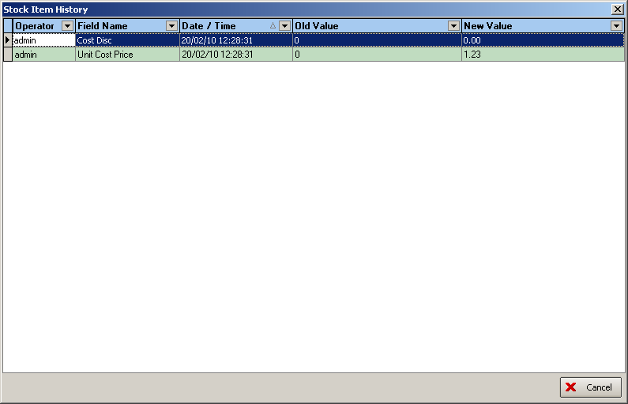

1647. Purchase Order Enquiry > Amend (Regular PO) Improvements

1. Once a GRN number has been entered it is remembered for the next item in the purchase order. In most cases the PO will be delivered all at once in the same delivery and will therefore have the same goods received note (GRN) for all detail lines.

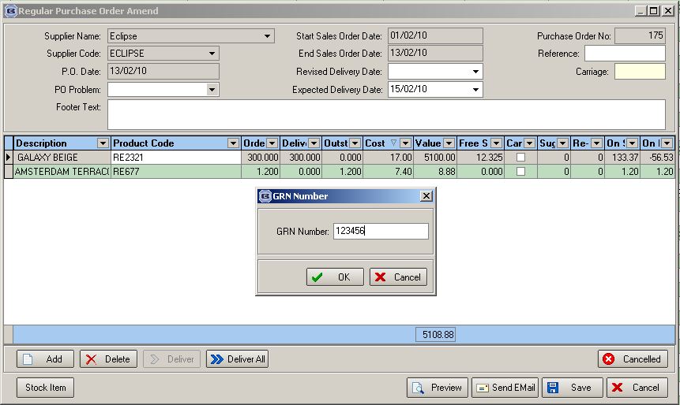

2. There is now an option for saving a file attachment for each purchase order: this could store the GRN or written copy (these would be scanned documents). Therefore there is a new button on the ‘Purchase Order Enquiry’ form called ‘File Attachments’. This works in the same way it does for Orders and Quotations.

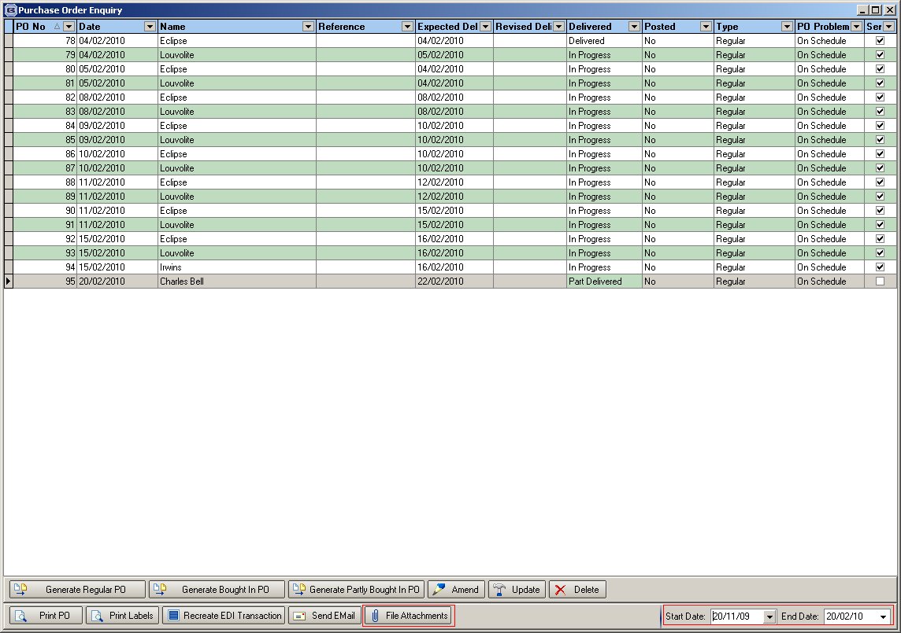

3. There is now an option to undeliver a detail line if the wrong amount is entered. There is a new button placed to the left of the ‘Cancelled’ button. This also amend the ‘On Purchase Order’ and ‘Stock In Hand’ amounts as well as the purchase order detail line.

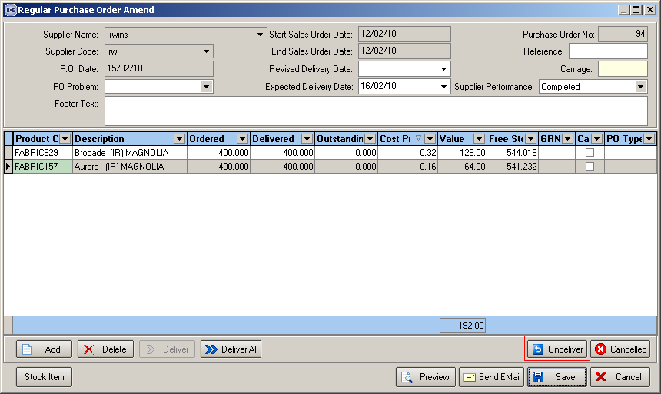

1648. Purchase Ordering Supplier Performance

There is now functionality to monitor supplier/factory performance for stock. This means it will be possible to calculate stock reorders due to quality, shortfalls and overages. For example, it will be possible to see how much extra stock is received per year because suppliers send too much, also how much stock is as a result of ‘Quality Issues’ eg flawed fabrics.

This has been done by recording reasons against detail lines in regular purchase orders.

There is a new ‘System Tables’ form called ‘PO Type’ in Administration > System Tables. Two records have been created there – one called ‘Stock Order’ and another called ‘Requested Order’. The user can then enter other records such as ‘Replacement Supplier Fault’, Replacement Our Fault’ etc.

When a regular PO is generated or entered, a PO type is stored against the PO detail line. If the stock item has ‘Stock Held In House’ = true, then the PO type will default to ‘Stock Order’, if the stock item has ‘PO Generation’ = true, PO type = ‘Requested Order’. It is possible to see these PO types on the detail line. If the regular PO is being manually entered, the same defaults should appear, but it is possible to change them.

There is also an option to complete an order even if it is not delivered completely or delivery is for a greater amount. This is recorded to monitor supplier performance and is held in the header of the PO record. There is a new table in Administration > System Tables called ‘Supplier Performance’ which has been filled with records for Completed, Accepted Under Order, and Accepted Over Order.

1649. Purchase Order Enquiry > Update Improvements

The unit price and nominal code are now shown in this form.

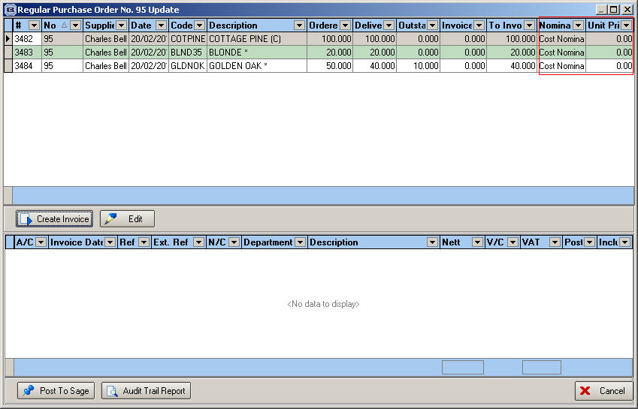

Settlement Discount

If the supplier record is set-up with a settlement discount figure then the VAT is now calculated on the discounted amount.

Example

A purchase invoice is for £100.00 ex VAT and the supplier offers 5% settlement discount.

The VAT shown and the VAT posted to Sage equal £100.00 *.95 = 95*17.5% = £16.65

The cost of the items are still displayed and posted as £100.00

The posting to Sage now also give an option to enter the supplier invoice number, and this is also be posted into Sage against the invoice posting and is stored in the reference field.

1665. Financials > Post Invoices to Sage

Some improvements have been made to the invoice posting to Sage. There are a number of issues that have been addressed.

- If there was a retail invoice and it had unposted receipts on it, it would pass the validation test, but then a message appeared when posting to say there were unposted receipts. A message now appears in the validation to say there are unposted receipts and that they must be posted first before the invoice posting is done.

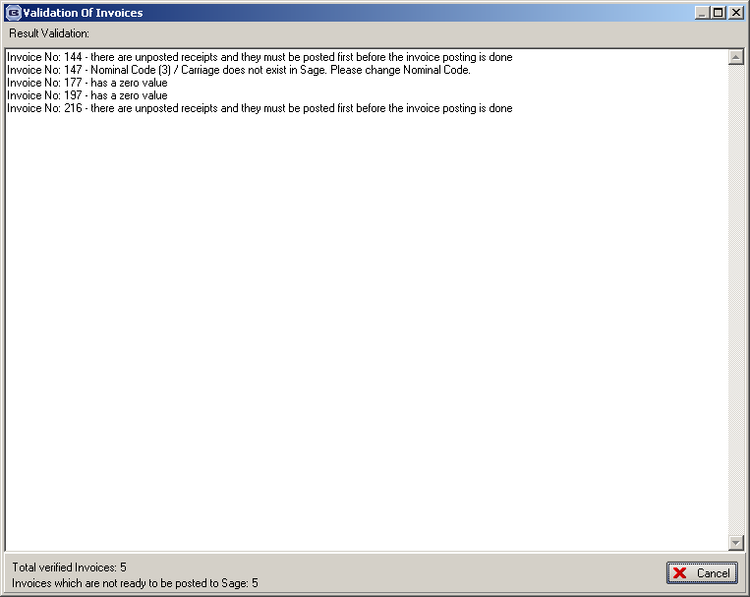

- If there were invoices for zero values, they passed the validation and appeared on the audit trail. When the posting to Sage was done, a message appeared saying ‘Transaction Post Unsuccessful’. They no longer pass the validation test – a message says ‘This invoice has a zero value’ – please change it manually to ‘Invoice Posted’.
- Records now only appear on the audit trail report if they have passed the validation test.
When an invoice is posted to Sage, the transaction number is written back to the Orders table and the Order Detail table. The transaction number now appears in Financials > Daily Sales Report and this should be matched with the daily transaction report in Sage so all the records can be reconciled properly.

1666. Work In Progress

The WIP date is now held in the order detail line. The reason for this is so we can take a snapshot of orders that are in WIP at any given point. This is updated when the order status is changed to ‘Work In Progress’.

1668. Acknowledgement – Laser Print (Letterhead)

Fitting instructions now print on this report. If the fitting instructions are blank for a detail line, then they do not print.

1669. Stock Setup > Purchase Order Enquiry

There is now a start and end date filter (by PO date) for displaying purchase orders on this form, similar to the modification we made for the quotation enquiry form. See screenshot for dev 1647.

1670. Work In Progress By Nominal

This report now includes all orders where status = WIP or Part Manufactured or Order Manufactured or Despatched.

1671. Reports > Sales Analysis > Sales Analysis by Nominal’.

The nominal code has been added as the first column in this report.

1672. Sales Analysis by Customer

This report now has additional columns for account code and % of sales.

1673. Sales Files > Customers

VAT Code now appears as a column choice in the context menu.

1674. Invoice – Bespoke 22

The order number is printed instead of the invoice number on this report.

