Blindata Release Note 4.8.3 

12 February 2010

Bug Fixes and Enhancements

2929. Invoice / Delivery Docket Printing

One customer reported a delay in printing delivery dockets and invoices, so further optimisation work has been carried out.

2932. Order Processing > Orders > Print Works Order

If you tried to print a works order for an order with a status of ‘Part Manufactured’, it did not print. Fixed.

2933. Purchase Order Regular – Bespoke 28

Metres/Units now shows the ‘Quantity Description’ field, not ‘Pack Quantity’.

Also, the ‘Expected Delivery Date’ now prints on this report.

2934. Stock Setup > Stock Items

The ‘On Sales Order’ figure now only displays to 2 decimal places.

2936. Regular Purchase Orders

If you deleted a purchase order (before it is delivered), it left a stock transaction record in the transaction table. This has been removed.

2937. Order Processing > Orders > Component Detail Line Entry

- When the detail line is first entered, the amount entered is now copied to the ‘Original Order Amount’. It is now possible to change the ‘Quantity’ which will then update the ‘Original Order Amount’ until the ‘Order Manufactured’ stage. At that point if the quantity is changed, it will then not update the ‘Original Order Amount’.
- The VAT Amount field is now read only.

2938. Label Print – A4 2 x 11

The imperial size for the drop was being cut off (if both metric and imperial sizes are selected to print). ‘Cust Ref’ has been moved slightly to the right to make room.

2939. Acknowledgement – Laser Print (Letterhead)

The options were running into the ‘Measurement’ and ‘Spec Ins’ fields if there were a lot of them. Fixed.

New Work and Customer Requests

1543. Order Processing > Orders > Deliver

It is now possible to hold order amount ordered and order delivered for component items. Previously a quantity could be entered for a component line, and before it is delivered, the amount could be changed. There was no record kept of what the original order amount was for.

The original amount is now stored when the order is entered and is also now printed on ‘Delivery Docket – Laser Print’.

1656. EDI Import

If an order is entered online or is transmitted via EDI, when it is imported, the scheduled date now takes into account the evening cut-off time (Administration > Parameters > Automated Tasks). If the order is imported after this time then the scheduled date is based on the order date and not the current date.

1659. Stock Setup > Optimisation

There is now an option to choose start and end date by ‘Scheduled Date’ as well as either ‘Order Date’ or ‘Required Date’.

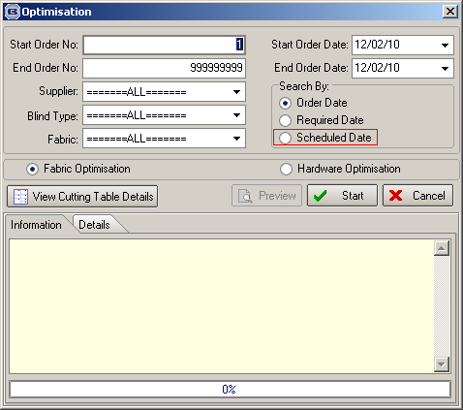

1660. Quotations > Optimisation

There is now a button on the quotation form that allows you to optimise fabrics that are in that particular quotation. This is required so the user can see the cost price of a quotation after the optimisation has been done.

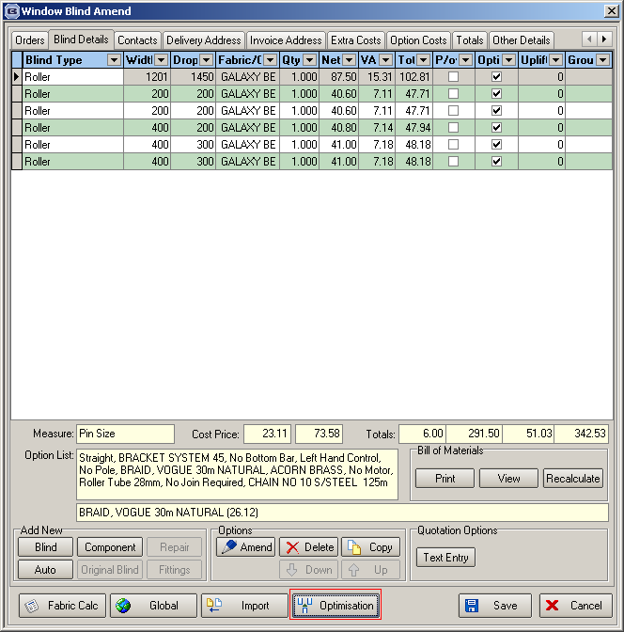

1664. Stock Setup > Stock Items

There is a new field in the stock file called ‘Quantity Description’, which is a 20 character alphanumeric field. It is used on the regular purchase order reports to indicates the quantity description for a product.

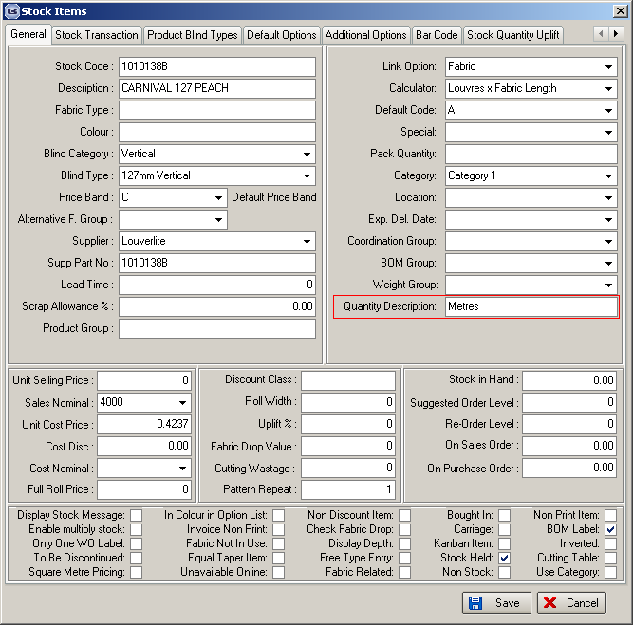

1667. Order Processing > Archive Enquiry

‘Order Category’ is now a column choice on this form.

