Blindata Release Note 4.8.1 

29 January 2010

Bug Fixes and Enhancements

2918. Order Processing > Orders

When you set the ‘Carriage Override’ button to true, it did not save it unless ‘FOC Carriage’ = true in the customer record. It is now possible to save this, regardless of whether ‘FOC Carriage’ = true or false in the customer record.

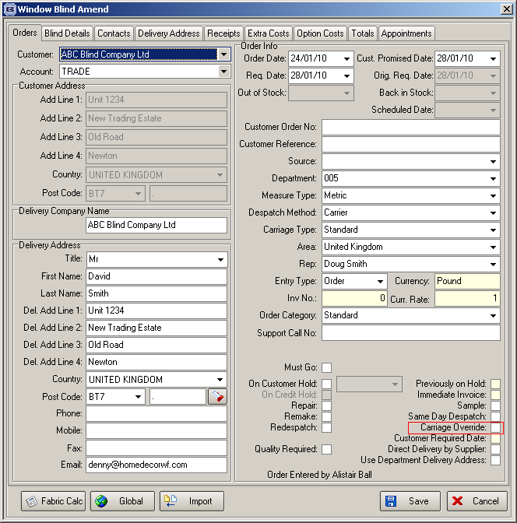

2921. Acknowledgements / Invoices

The total was incorrect if a quantity of > 1 is entered on a detail line. Fixed.

2922. Quotation – Bespoke 17

- This is now the base price and not (base price + option prices).
- This is correct.
- This is now the base price less discount for the base price and not (base price + option price) less discount.
- This is correct.
- This is correct and is equal to the sum of the amounts in the ‘Nett’ column.

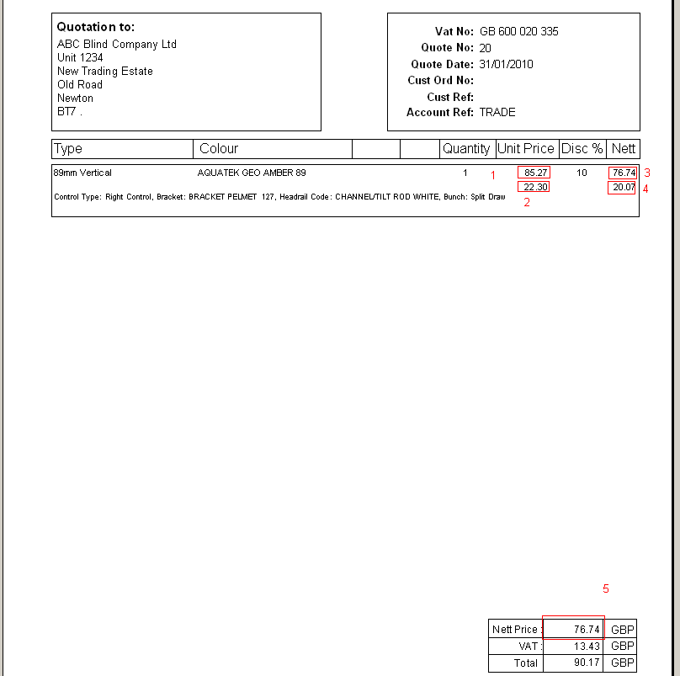

New Work and Customer Requests

1632. Suppliers

There is a new field in the Suppliers form called ‘Supplier Own Ref:’. This is a text field. It is also now printed in the header for all the purchase order reports under ‘Account Ref’.

There is another new field in the supplier form called ‘Settlement Discount %’. This is a numerical field with 2 decimal places.

There is a new tab in the supplier form for ‘Contacts’. This contains fields for ‘Contact Name’, ‘Job Title’, ‘Telephone’, ‘Mobile’, ‘Fax’, ‘Email’ and ‘Title’.

1636. Stock Setup > Stock Items

‘Re-Order Level’ and ‘Suggested Order Level’ now appear as column choices on the stock enquiry form.

1637. Purchase Order Processing > Generate Regular PO

For regular purchase orders, if ‘Stock Held In House’ = true, a stock amount is now generated if (stock in hand + on purchase order – on sales order) < re-order level, and then the purchase order amount is brought up to the suggested order level by multiples of ‘minimum order quantity’. For example, if

Suggested Order Level = 500
Reorder Level = 300
Stock In Hand = 400
On Sales Order = 160
On Purchase Order = 100
Minimum Stock Quantity = 100

Then (400 + 100 – 160) is not < 300 so no PO amount would be generated for that item.

Example 2

Suggested Order Level = 500
Reorder Level = 300
Stock In Hand = 400
On Sales Order = 260
On Purchase Order = 100
Minimum Stock Quantity = 100

Then (400 + 100 – 260) < 300, so 240 is less than 300, so we would have to generate an amount of 300 to bring it up to the Suggested Order Level.

1638. Purchase Order Processing > Generate Regular PO

- Cost price now displays to 2 or 3 decimal places depending on what is held in stock item.
- Value is displayed to 2 decimal places
- Free Stock = Stock In Hand – On Sales Order + On Purchase Order
- The buttons have been tidied up – they were too close to the edge of the form
- ‘Suggested Order Level’, Re-order Level’, ‘On Sales Order’, ‘On Purchase Order’ and blind type description now appear as column choices on the regular PO form.

1639. Purchase Order Processing > Generate Regular PO > Amend

There is now a button to deliver all items at once on the regular PO form.

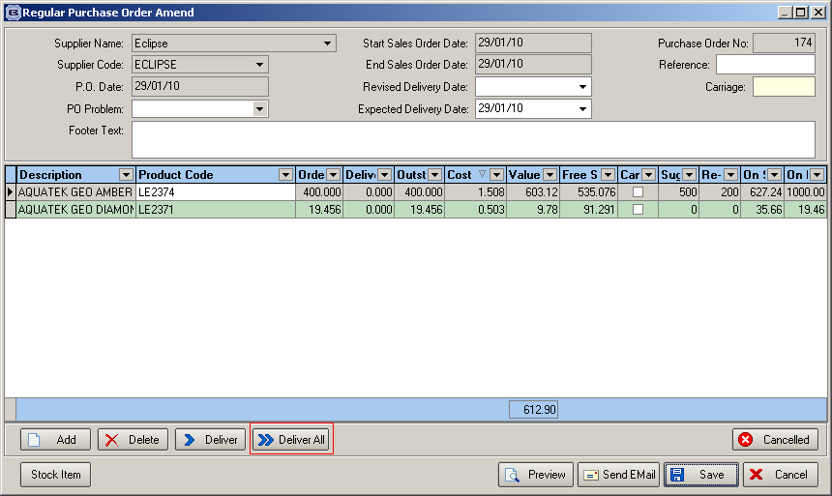

1640. Purchase Order Regular – Bespoke 28

A new report has been created – based on ‘Regular Purchase Order – Standard’

- Removed cost price and total value
- Detail lines are grouped by blind type description, then split by stock/cut length
- Included metres/units

1641. Fabric Requirement Report

There is now a choice on the form for showing ‘Stock Held In House’ or not, or ‘All’.

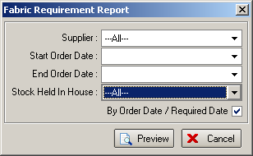

1643. Sales Analysis By Fabric

Fabrics are now printed in descending metreage amount.

1644. Sales Analysis By Fabric Class

A new sales analysis report has been created called ‘Sales Analysis by Fabric Class’. This is similar to ‘Sales Analysis By Fabric’ but shows fabrics grouped by fabric class.

1645. Sales Analysis By Dept by Customer by Fabric Class

A new sales analysis report has been created called ‘Sales Analysis by Dept by Customer by Fabric Class’. This is similar to ‘Sales Analysis By Dept By Customer by Fabric’ but shows fabric grouped by fabric class.

