Blindata Release Note 4.8.0 

22 January 2010

Bug Fixes and Enhancements

2903. All Acknowledgement / Quote / Invoice Prints

A rounding problem has occurred since we did a development for 3 decimal places for the base price. This has been fixed.

2904. Posting Invoices

This bug caused the duplicate copies of invoices to be posted to Sage for retail accounts. When a retail invoice is posted to Sage, it checks to see if the balance = 0. If so, it gets archived. But a problem occurred when the balance was < 0.01. Fixed.

2905. Label – 5161

- Imperial LWS now prints to the nearest 1/8 inch, and does not show 2 decimal places.
- Options (switched on or off) now print instead of the option list. Previously you could not switch off printing an option using Blind Types > Blind Details > Field Setup > Label.
- Special instructions now print on the last line of the label

2906. Bespoke Works Order 8.5 x 11

`Height` has replaced the word `Drop`

2907. Order Processing > Orders

When width and drop is entered as imperial, it now redisplays as imperial eg 67 ½, not 67.50.

2908. Invoice – Bespoke 28

The totals have been moved slightly – there is no longer a gap between the £ sign and the amount, and the figures have been moved left to the £ sign.

2909. Label Print – Bespoke 28

- There are now brackets round the metric sizes
- The customer name is now printed in a larger font..
- Moved fabric description down a line, and moved options a bit lower so fabric description can print further across.
- Number of vanes prints if blind identifier = Vertical or Vanes Only or Headrail or Track
- Number of vanes and blind type are included on top label if blind identifier = Track

‘Works Order – Bespoke 28’ and ‘Label Print – Bespoke 28’ now both print in blind type order then by order number because it makes it easier to match them up.

2910. Works Order – Bespoke 28

Options no longer fit since we made the font bigger. Therefore the font for options has reverted to the previous size.

2911. Tagging Label – Bespoke 1

The tagging label is now printing immediately after ‘Label Print – Bespoke 28’

2913. Roll Out Production Planning Report

Production day is now correct.

2914. Administration > Parameters

The Sage password is now displaying properly.

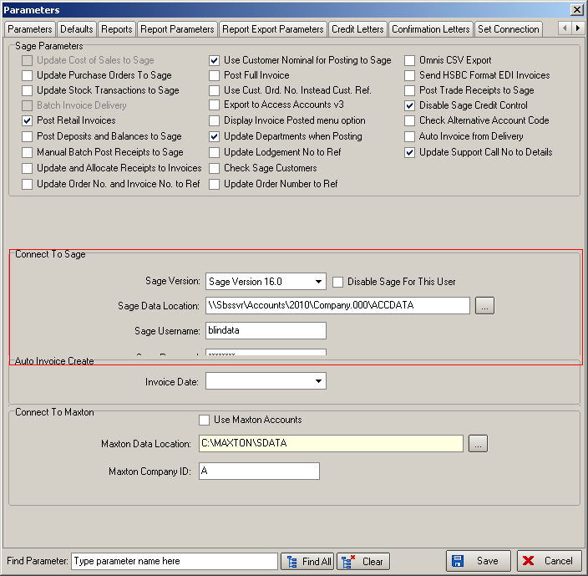

2915. Delivery Docket – Despatch Manifest

A Despatch Number is now generated correctly if ‘Use Delivery Docket Number’ in Administration > Parameters = true.

2916. Purchase Order Enquiry > Amend

If you generated a regular PO for an item and it calculates an ‘ordered’ quantity of 100, and you change that ‘ordered’ amount to 500, it did not save the ‘ordered’ amount as 500. Fixed.

2917. Label Print – A4 2 x 11

- The ‘Number of Vanes’ was printing twice - fixed.

2919. Remake / Repair / Redespatch

If ‘Remake / Repair / Redespatch’ is run from ‘Order Amend Enquiry’ or ‘Archive Enquiry’, and the order selected has ‘Same Day Despatch’ = true, the ‘Same Day Despatch’ true flag is not copied to the new order. It is set to false.

New Work and Customer Requests

1614. Delivery Docket Batch Print > Delivery Docket – Despatch Manifest

It is now possible to include detail lines on this report for orders that have been partially manufactured.

To do this we have made some minor amendments to the logic of the software. The following logic is now applied. The best way to describe this is with an example.

An order has 3 blinds on it. After it is entered and works orders are printed, it has a status of ‘Order Entered’ and the detail lines have a status of ‘Awaiting Manufacture’.

If you manufacture one of the detail lines, it will then have a status of ‘Blind Manufactured’ and the order will have a status of ‘Part Manufactured’.

If ‘Allow Part Despatch’ is switched on in Administration > Parameters, it is now possible to include this blind on the ‘Delivery Docket – Despatch Manifest’ when it is printed. The blind will then have a status of ‘Despatched’ and the order will have a status of ‘Part Despatched’.

When the next blind is manufactured, the blind will have a status of ‘Blind Manufactured’ but the order status will remain unchanged.

When the final blind is manufactured, the status of the blind will change to ‘Blind Manufactured’. The status of the order will remain as ‘Part Despatched’ until all blinds are delivered and then it will change to ‘Despatched’.

Other Changes

The ‘Delivery Docket – Despatch Manifest’ report was developed for ‘Order Processing > Delivery Docket Batch Print’ form only and can now only be used there.

The delivery note number and the delivery date now print on this report.

1622. Reports > Financial Reports > Work in Progress by Nominal

There is a new report in Reports > Financial Reports called ‘Work In Progress By Nominal’. This shows all blinds for orders with status before ‘Invoice Created’, grouped by nominal code. There is a total at the bottom of the report for the ‘Nett Price’.

1623. Sales Analysis by Nominal

There is a new report in Reports > Sales Analysis called ‘Sales Analysis By Nominal’ that groups records by nominal code from the order detail line. There is a grand total at the bottom of the report and a column for ‘% Sales’.

1624. Sales Analysis by Order

There is a new report in Reports > Sales Analysis called ‘Sales Analysis by Order’. This prints out all orders/invoices between specified dates. If ‘Order Date’ is selected instead of ‘Invoice Date’ then the ‘Invoice Date’ column is ‘Order Date’. There are totals at the bottom of the report.

1625. Order Processing > Orders > Despatch Method

We have a customer who wants to make sure ‘Despatch Method’ is filled in each time. Therefore we have introduced an ‘Is Null’ column in System Tables > Despatch Method’. If this is ticked and an order is entered with a despatch method where ‘Is Null’ = true, a message appears saying ‘Please enter a despatch method’ and the despatch method has to be changed.

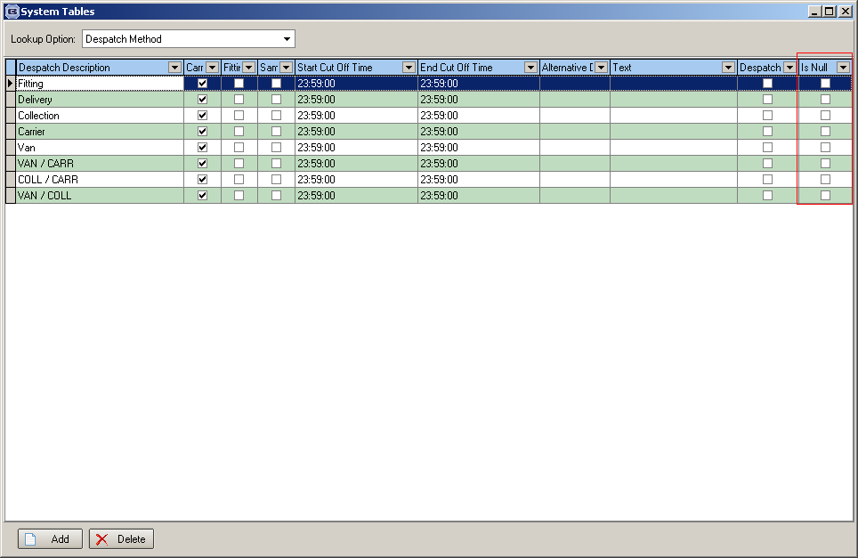

1626. Order Processing > Orders

There is a new parameter to make the sizes blank for each new blind entered. It is called ‘Default to Null Sizes’ and is held in Administration > Parameters ‘Order Parameters’ section. The new flag defaults to false. If this is set to true, then ‘Width’, ‘Drop’ and all other entered sizes are null when a new blind is entered ie it won’t copy the sizes from the previous blind.

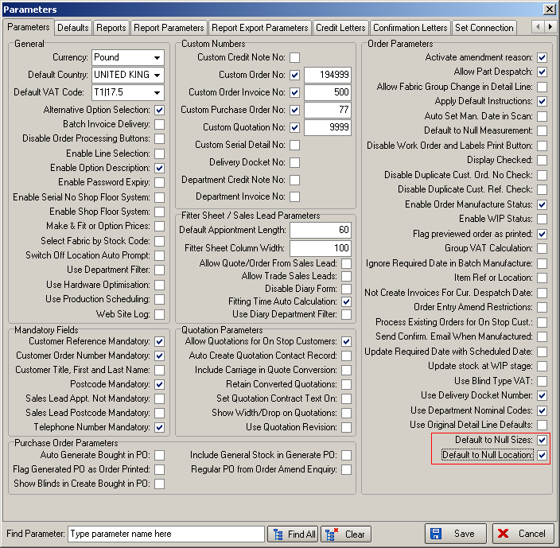

1627. Order Processing > Orders

There is a new parameter to make the ‘Location’ blank for each new blind entered (see screenshot above). It is called ‘Default to Null Sizes’ and is held in Administration > Parameters ‘Order Parameters’ section. The new flag defaults to false.

1628. Order Processing > Orders > Component Detail Entry

- The ‘Instructions’ field now has the same properties as ‘Comment’. It is possible to do a carriage return, the field displays as the same size on the form and there is be a vertical scroll.
- There is a new field called Qty/Mtr on this form. It defaults to zero and has no effect any other calculations.

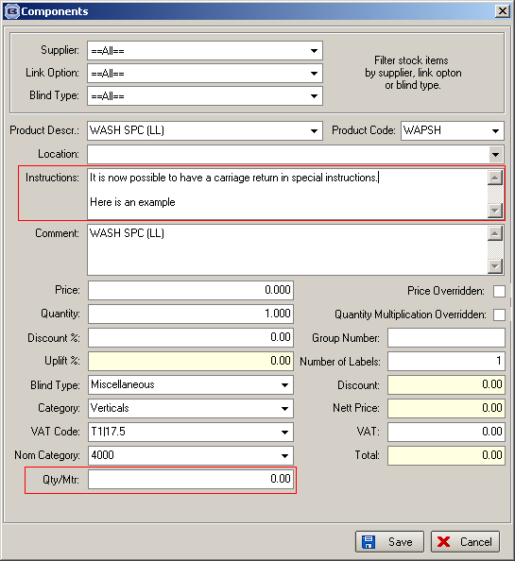

1629. Blind Details > Blind Types

For Blind identifier = Curtain, there is a new flag called ‘Width Not Required’. It defaults to false. If this flag is true, then ‘Width’ does not display in the order detail line entry and it does not appear on works orders or labels (only for ‘Works Order – Bespoke 22’ and ‘Label Print – Bespoke 22’).

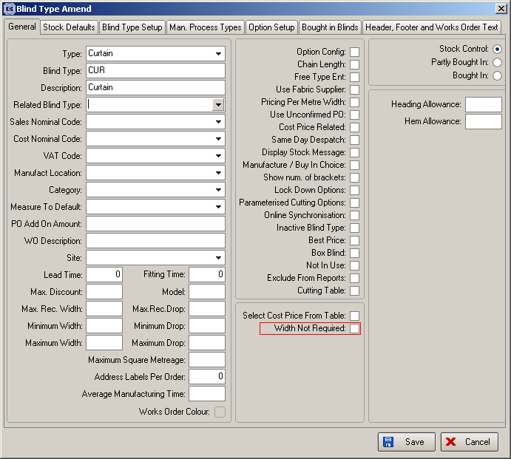

1630. Blind Details > Blind Types

For Blind identifier = Track, there is a new flag called ‘Drop Not Required’. It defaults to false. If this flag is true, then ‘Drop’ does not display in the order detail line entry and it does not appear on works orders or labels (only for ‘Works Order – Bespoke 22’ and ‘Label Print – Bespoke 22’).

1634. Posting Sales Invoices

There is a new parameter called ‘Update Order No. and Invoice No. to Ref’ in Administration > Parameters > Sage Parameters. If this is set to true, then ‘Update Order Number to Ref’ is set to false and vice versa. If ‘Update Order No. and Invoice No. to Ref is set to true, ‘Ord: 123456, Inv: 654321’ style of data should be posted to the Ref field in Sage.

