Blindata Release Note 4.7.9 

12 January 2010

Bug Fixes and Enhancements

2888. Works Order – Bespoke 28

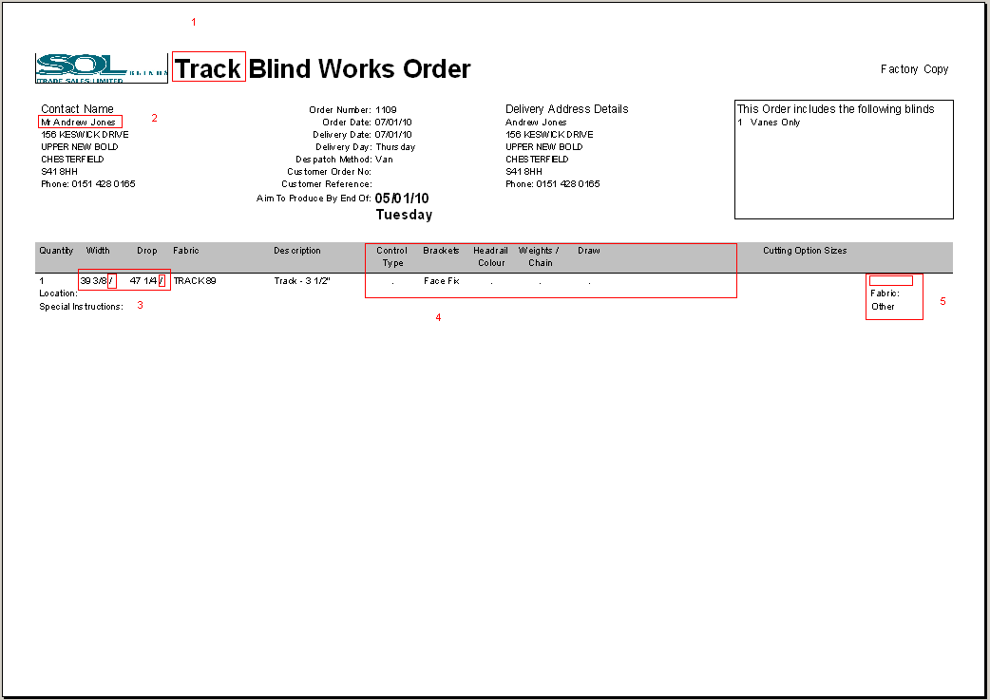

1. The title is now the blind type description and not the blind identifier description.
2. The wrong name was here if trade type = retail. It is now the company customer name.
3. The width and drop figures are now in bold. Removed ‘/’ because it is making the sizes difficult to read. The metric sizes are in brackets eg 23 ¼ (590).
4. The options spaced out more – allowing for a maximum of 7 options to print on a line.
5. If blind identifier = Track, number of vanes now also print here, but ‘Fabric’ does not print.

2891. Blind Details > Blind Types

For blind identifier = Track and blind identifier = Headrail Only, there is a field for the slat table – the same as blind identifier = Vertical or Vanes Only.

2894. Sales Analysis by Customer Class by Customer by Category

An error occured when you tried to run this report. Fixed.

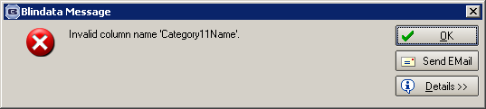

2890. Roll Out Production Planning Report

P/Fit columns were appearing for some of the blind identifier pages. Fixed.

2892. Sales Analysis Performance Report

It was printing each customer on a different page. The report is now grouped by customer class with page breaks between customer class. Also it includes all customers on this report, even if they do not have orders/invoices between the dates selected.

- The order and blind totals were the same – fixed.
- The average order and average blind values are now correct.
- The variance was wrong. This column is now the discount amount.

2893. Sales Analysis by Department By Customer by Fabric

Some header information was meaningless if the report was printed for all departments. Fixed.

2895. Sales Analysis by Customer Class by Customer by Category

Previously it was only possible to view 10 categories horizontally on this report, now it will print up to 15.

- The category titles now start further left.
- We have combined ‘Blind / Order Quantity’ into one column.
- This could have the word ‘Sales’ below ‘Total’.
- The font is slightly smaller for all the figures.

2896. Works Order – Bespoke 28

- Width is no longer shown if blind identifier = Vanes Only.
- The fabric amount is now showing – this was accidently removed when we grouped the works order by blind type instead of blind identifier.
- The metric size now print below the imperial size, and brackets are still required around the metric sizes. We have moved location down to allow for this. The font is also slightly larger for the imperial and metric measurements.
- Delivery notes now print.
- The company name is in bold.
- All the fonts on the works order are slightly larger.

2885. Roll Out Production Planning Report

The categories now all print on the same page.

2898. Sales Analysis by Customer Class by Customer by Category

There are now only sub totals by customer class, and not by customer as well.

2897. Tagging Label – Bespoke 1

The customer name and fabric description fonts are bigger.

2901. Label Print – Bespoke 22

1. ‘Location’ now prints further to left to allow more space for spec ins.

2902. Invoice – Bespoke 28

- Made the font larger and in bold
- We have removed the detail line prices
- Moved the totals down so they fit into the 3 boxes.

New Work and Customer Requests

951. Administration > Parameters

The parameter ‘Allow Non Admin Users to Convert Sales Leads’ has been replaced by. a new advanced permission called ‘Convert Sales Leads’ in a new section for ‘Sales Leads’.

The parameter ‘Generate Live Stock orders’ is no longer required and has been removed..

The parameter ‘Techno TS200 Bar code Required’ has been moved to the ‘Report Parameters’ tab, in ‘Works Order and Label’.

‘Multi view on Fitter Sheet’ is no longer required and has been removed.

‘Use Blind Type Process’ no longer required and has been removed.

1517. Administration > Parameters > Forms tab

There are now ‘Colours By Order Status’ fields for ‘Part Manufactured’ and ‘Part Invoiced’.

1529. Order Processing > Orders

The ‘Quotation Group’ field entry has also been enabled for orders.

The group no is now printed on ‘Works Order – Bespoke 22’ and ‘Label Print – Bespoke 22’ as /1 after works order. Also grouped these reports so there is a separate page for each group.

1610. Administration > Parameters

This form has been redesigned. The two main tabs that have been redesigned are ‘Parameters’ and ‘Defaults’. There is now a search facility at the bottom of the form to find parameters.

1616. Stock Setup > Stock Items

There are now column choices for ‘Minimum Order Quantity’, ‘Stock Held In House’, ‘Purchase Order Generation’ and ‘Category’.

1618. Label Print – Bespoke 22

If ‘Venetian Barcode 2’ is switched on in Report Parameters, the slat code in the barcode now uses 5 characters instead of 4.

1620. Post Invoice to Sage

There is a new parameter in Parameters > Sage Parameters / Invoicing called ‘Update Support Call No to Details’. If this is set to true, then the support call no field in the order header is updated to the ‘Details’ field in Sage.

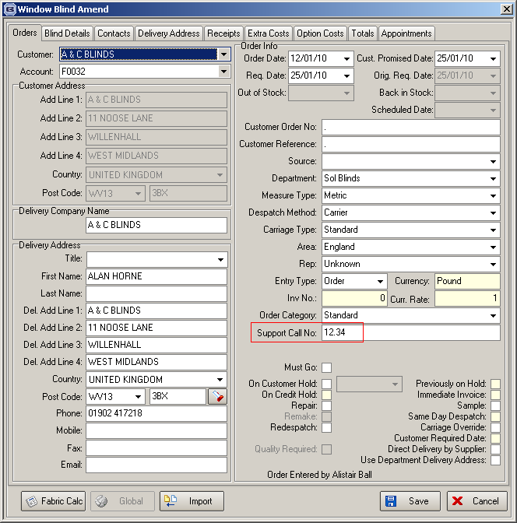

1621. Label Print – Bespoke 28

A new label print has been created, based on ‘Label Print – Bespoke 8’ and is called ‘Label Print – Bespoke 28’. Some adjustments have been made.

1: For trade type = Retail customers, the customer company name is printed.
2: Removed ‘1 of 1’ from all labels.
3: The only information that appears on the top two small labels is Customer name (customer company name), Order number, Cust order number, customer reference, blind sizes, fabric colour and location.

