Blindata Release Note 4.7.8 

11 January 2010

Bug Fixes and Enhancements

2755. Google Maps

There was a problem with the postcode search – it was not finding the correct place on Google Maps. This has been resolved.

2884. Works Order – Bespoke 28

- This is now in a larger font – the depth is almost be as large as the depth of the logo.
- This is now the required date
- This is now the day from the required date
- This is 2 working days before the required date and the day as well.

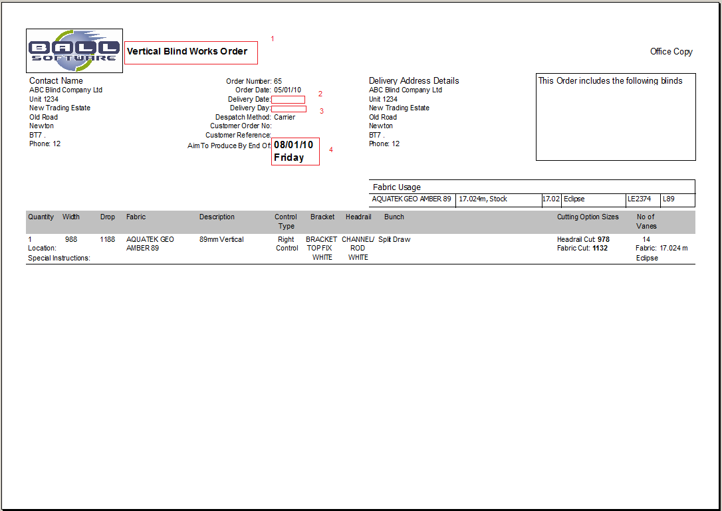

2886. Production List By Customer

Previously this was printing off in order number order. It now prints in alphabetical customer order and then order number within customer.

2887. Tagging Label – Bespoke 1

1. The customer name was wrong. It is now customer company name, not the contact name.

2889. Delivery Docket - Despatch Manifest

- The report was grouped incorrectly – fixed.
- This now prints the customer company name, not the contact name, even if trade type = Retail.
- The fields are now lined up properly horizontally.
- The options now only print if they are flagged to print in Blind Details > Blind Types > Field Setup.
- At the bottom of each delivery docket (per customer) we have added ‘Received By: …………………………. Date Signed: ………………………………….’.

New Work and Customer Requests

1581. Sales Files > Customers

We have added a button for file attachments to the customer record (same as Stock Items).

1582. Quotations > Create Orders
Attachments for quotations are now copied when an order is created from a quotation.

1609. Grid Component

Previously when you filtered on forms that use the grid, the filter would remember what you have filtered by previously. This was added about 18 months ago (possibly by a component upgrade). A lot of customers did not like this and so we have removed it.

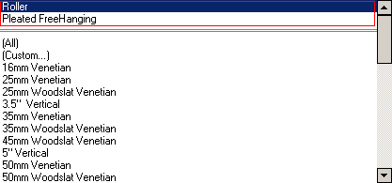

1611. Invoice – Bespoke 28

There is a new invoice print called ‘Invoice – Bespoke 28’.

1612. Acknowledgement – Laser Print 8.5. x 11

The addresses now print in USA format ie

Address Line 1, Address Line 2
Address Line 3, ZIP Code

1613. Invoice – Laser Print (Letterhead Logo) 8.5 x 11

The addresses now print in USA format.

