Blindata Release Note 4.7.7 

29 December 2009

Bug Fixes and Enhancements

2816. Vertical Vane Production Report

The bar code was still not being read by the vertical machine scanner. The font is ABC Code 39 Regular. Fixed.

2879. Works Order – Bespoke 28

- This has been moved up so it is in line with the top of the logo.
- The report is now grouped properly.
- The ‘Measure To’ column has been removed.
- These fields have been moved to the left to where ‘Measure To’ was.
- ‘No of Vanes’ only prints if blind identifier = Vertical or Vanes Only. If blind identifier = Venetian, ‘No of Slats’ prints.
- ‘Free Type’ from the ‘Works Order Control’ now prints here.
- Cutting option sizes now print here.

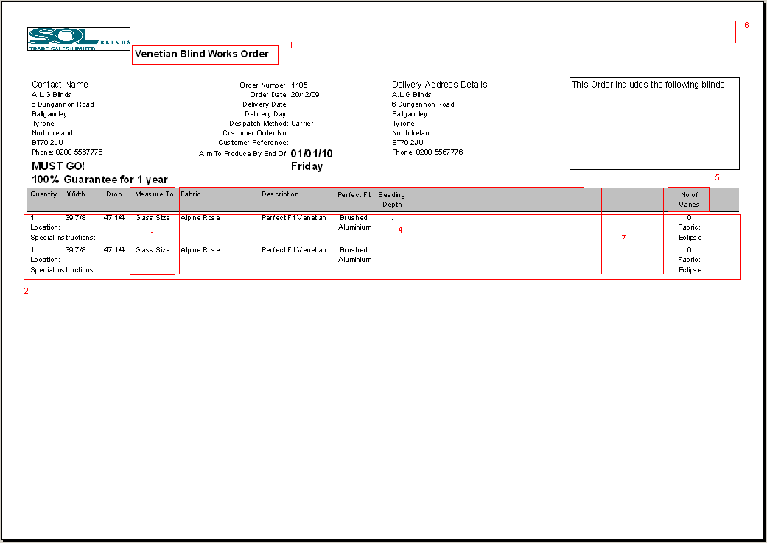

2880. Quotation – Laser Print (Normal and Email Version)

The unit price is now including the option price

2882. Administration > Company Details

The deleting and/or changing of the logo was not working. Fixed.

New Work and Customer Requests

1526. EDI Import

Occasionally deadlocks occur when EDI orders were being imported. This could cause quite serious consequences. For example, if 10 XML files had been brought in from the ftp server, and 3 of them have been imported into the EDI import tables, if a deadlock or an import error occured, then none of the other files got imported but the remaining XML files then went into the archive folder and were missed. This caused problems because the archive file had to be checked each time a deadlock or import error occured.

We have amended the import routine so it is only brings in one XML file at a time, importing it and then archiving it. This will stop files going into the archive without being imported.

We have also made sure that if a deadlock or error occurs or there is a problem with the XML file, then the XML file does not go into the archive, but is put into a separate folder to be examined separately.

Therefore we have added a new field in 'Parameters > EDI' called 'Broken Transaction Folder'. If this field is not null then all the transactions which were broken will copy to 'Broken Transaction Folder'.

1586. Scheduling

There is a new parameter called ‘Update Required Date with Scheduled Date’ in Administration > Parameters. If this is set to true, then after an order has been scheduled, if the scheduled date is after the required date, then the required date is changed to the scheduled date.

1597. Tagging Label Prints

We have a customer that wants to print a label for the fabric that has to be purchased for the blinds. The fabric must have flag ‘Stock Held In House’ = false. These labels are printed along with the normal label print.

There is a new choice in the Administration > Parameters > Reports called ‘Tagging Label’.

For example, there may be an order with 10 blinds on it, with 3 blinds for fabric A, 3 blinds for fabric B and 4 blinds for fabric C. Fabric A and fabric C have ‘Stock Held in House’ = false. Therefore there will be two tagging labels printed out, one for fabric A and one for fabric C. These should print after the production and customer labels have printed.

1602. Stock Setup > Stock Items

‘Fabric Class’ is now a column on the stock enquiry form.

1603. Help / Release Notes

Previously users could access documents by going to our website and selecting ‘Downloads’.



The following screen is then shown. The username is ‘documents’ and the password is ‘documents*’.

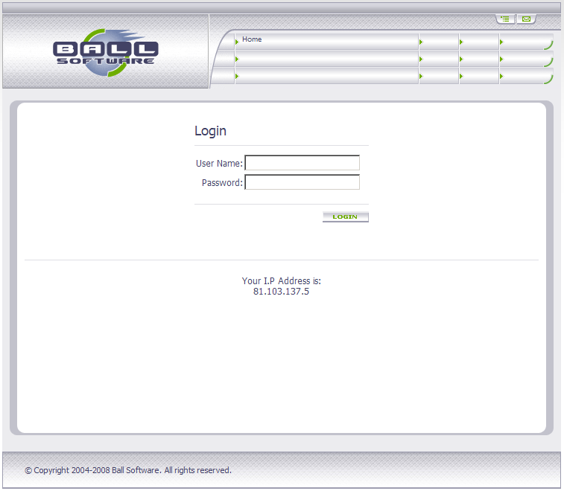

Then this page displays:

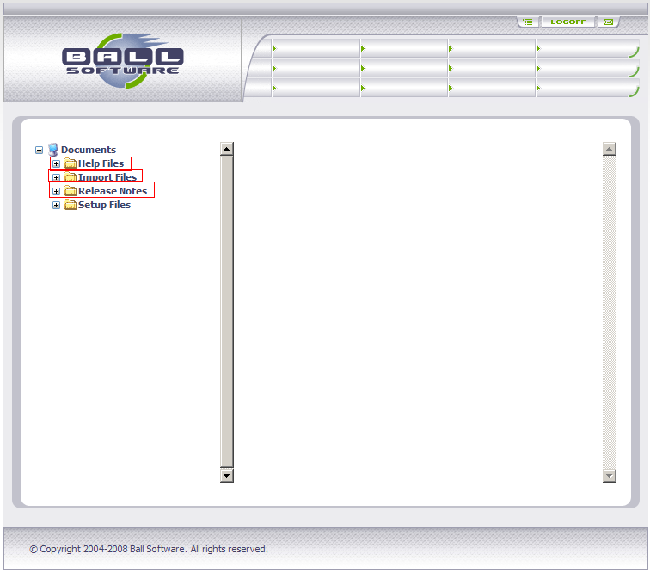

We can then select ‘Help Files’, ‘Import Files’ or ‘Release Notes’ and display the documents that are here and download them.

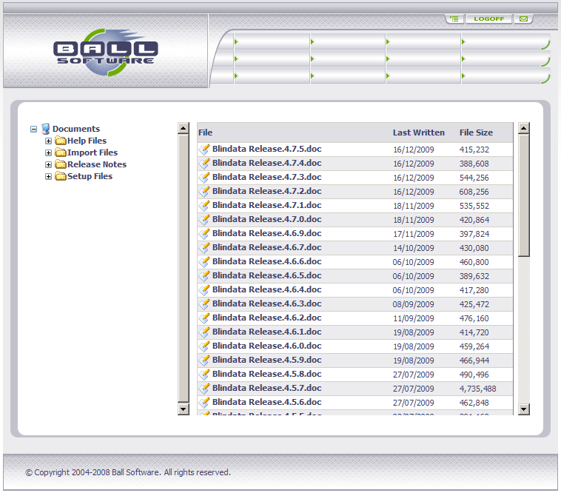

This has been added to the Help menu option in Blindata, so when ‘Help’ is selected, it jumps straight to this web page.

1604. Financials > Invoice Batch Print

When an invoice is printed using ‘Invoice Batch Print’, a record is now written to the order history table. The description is ‘Invoice Printed from Batch Print’.

1605. Financials > Invoice Batch Print > Email

There is now an option to email invoices instead of printing them. There is a new field in the customer record called ‘Email Invoice Only’. If this is set to true, then pdf invoices should be sent rather than being printed out.

We have changed the ‘Invoice Batch Print’ form so there is an option for either ‘Print Only’ or ‘Email Only’. The default is ‘Print Only’. If ‘Print Only’ is chosen, invoices are printed if ‘Email Invoice Only’ in the customer record is false. If ‘Email Only’ is chosen, invoices are emailed if ‘Email Invoice Only’ is true in the customer record. Also, if ‘Email Only’ is chosen the order history should say ‘Invoice Emailed from Batch Email’.

1606. Blind Types > Cutting Option

We have added the ‘Free Type’ lookup from ‘Works Order Control’ / ‘Label Control’ as a field in the cutting sizes setup. If this is left blank, then the cutting size will print on the works order or label depending if ‘on work order’ or ‘on label’ is selected. If there is a ‘Free Type’ entry selected, then it will only print on the relevant works order / label.

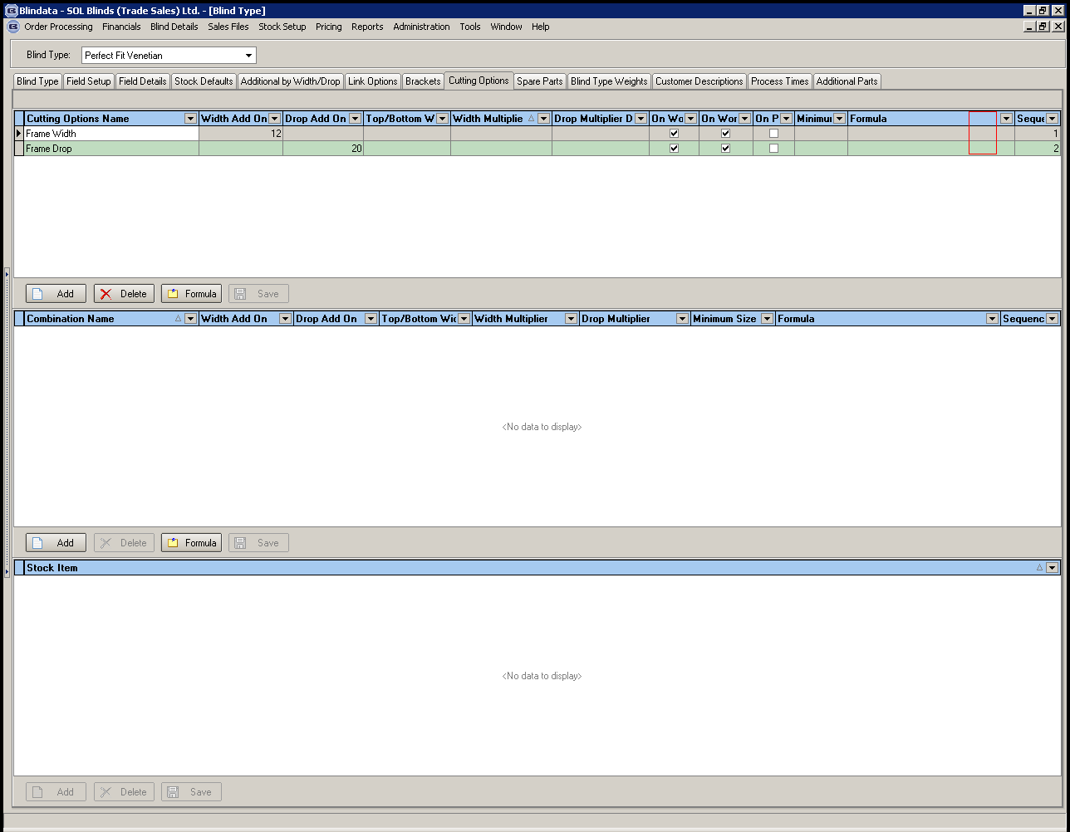

1607. Cutting Sizes on Labels

There is a new field in Blind Types > Cutting Options tab called ‘On Label’. If this is set to true, then cutting options will appear on some labels reports. We will only change the reports when necessary. ‘Label Print – Bespoke 8’ has been changed first.

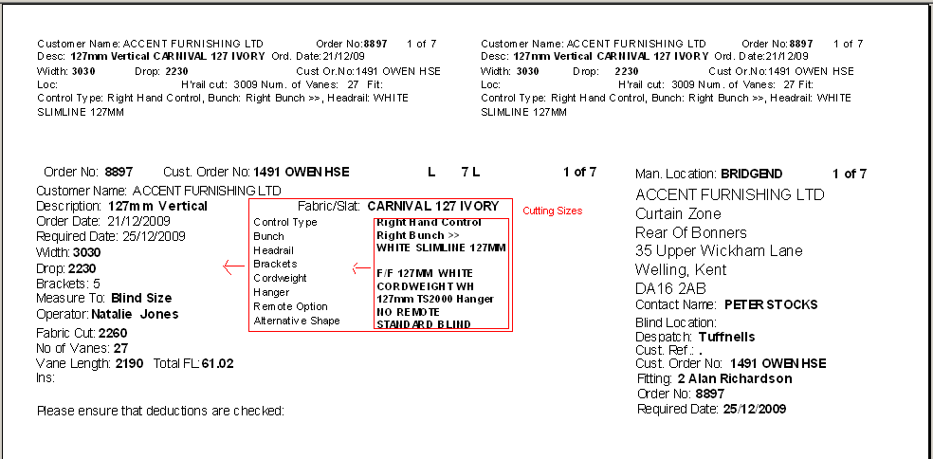

1608. Label Print – Bespoke 22

We have alter the vertical line up of this report to make it the same as ‘Works Order – Label Blind Size’, because the customer has changed their printer.

