Blindata Release Note 4.7.6 

18 December 2009

Bug Fixes and Enhancements

New Work and Customer Requests

1525. Fabric Optimisation

The fabric optimisation now takes into account joins in fabric ie if a blind is too big for the roll width, a join is required.

Example: roll width = 2000, blind width = 2200, blind drop = 1750, drop add on = 300, calculator = ‘Width or Drop’. The fabric size required is therefore 2200 x 2050. If the calculator = ‘Width or Drop’, this means we will need to cut two pieces of fabric. The join will nearly always be a horizontal join (it could be a vertical join if the calculator = ‘Drop’ and the blind width > roll width and the customer agrees).

Therefore we will need two pieces of fabric: one 2000 x 2200, and another 50 x 2200.

1584. Fabric Optimisation

If ‘Cutting Table’ is switched on for a blind type and the fabric optimisation is run, records now go into the cutting table even if fabrics are not optimised. For example, if a roll width is 2000mm for a fabric and there are only three blinds to be optimised, and they are all 1600 x 1600, it will not optimise this fabric. However the details of the fabrics are still passed to the cutting table records.

All blinds should go in here unless they are:

Customer Hold
Unchecked
Authorisation Hold

1591. Administration > Parameters

There is now an option for the posting of orders where the order status = ‘Invoice Printed’, also Sage is not installed and ‘Display Invoice Posted Menu Option’ = true.

This is an automated routine and can be set up in Administration > Parameters > Automated Tasks.

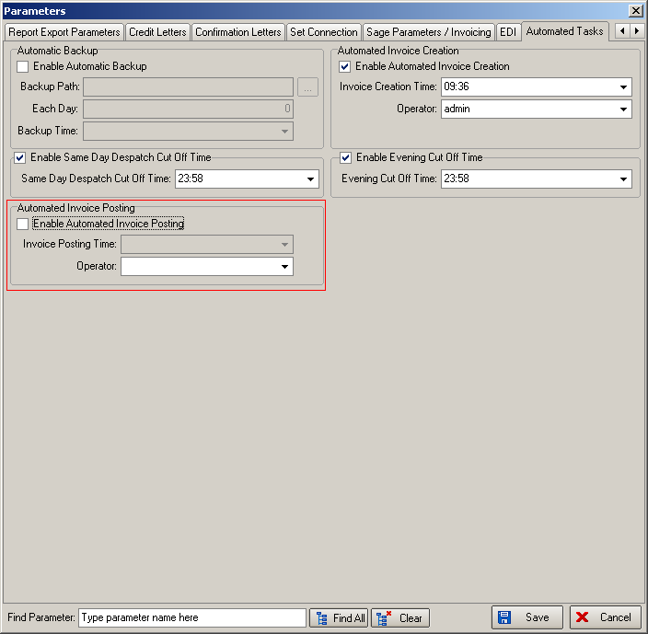

1592. Customer / Blind Type Default Instructions

There is now a table for holding default special instructions for customers and blind types. If there is a record held in this table for the order being entered for that customer and blind type, then the special instructions in the order detail line will be filled with these special instructions.

There is a new tab in the customer form called ‘Spec Ins’, where the blind type and the special instructions text can be entered.

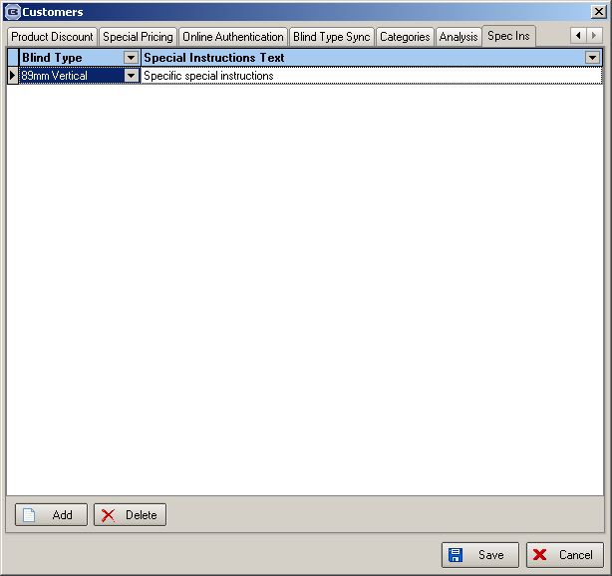

1595. EDI Import

If an XML file is imported and there is a blind on an order that cannot be made or that requires a join, then the order is put ‘on customer hold’.

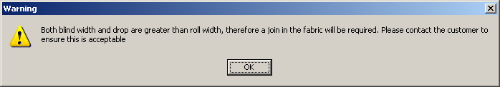

1596. EDI Import

An EDI order no longer imports if the quantity = 0.

1598. Label Print – A4 2 x 11

‘Fabric required’ now prints on the label (to the right of the fabric description) if blind identifier = vertical or roller or pleated or vanes only.

1599. Sales Analysis by Customer by Blind Type By Month

A new sales analysis report has been created that is based on a combination of ‘Sales Analysis by Customer by Month’ and ‘Sales Analysis by Customer by Blind Type’. It prints the figures out monthly across the way, but also shows blind types within customers. This report is available if ‘By Month Horizontally’ is selected.

1600. Sales Analysis by Blind Type by Customer by Month

A new sales analysis report has been created that is based on a combination of ‘Sales Analysis by Blind Type by Month’ and ‘Sales Analysis by Blind Type by Customer’. It prints the figures out monthly across the way, but also shows blind types within customers. This report is available if ‘By Month Horizontally’ is selected.

1601. Works Order – Bespoke 28

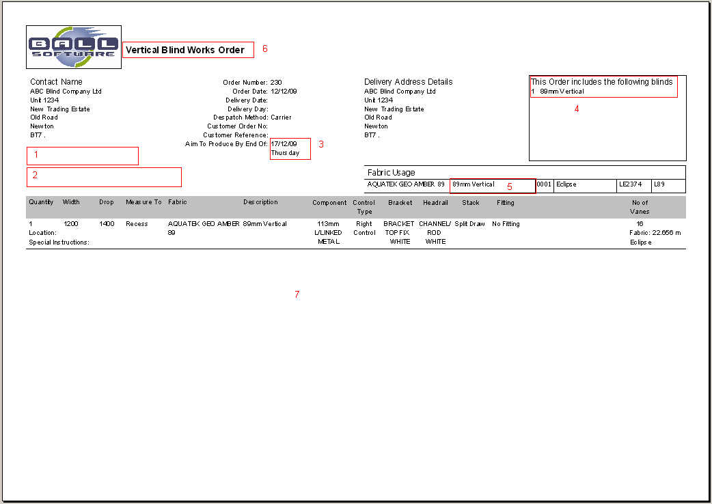

- If ‘Must Go’ = true in the order, ‘MUST GO!’ now prints in bold and larger font.
- ‘Guarantee Text’ from the Order Totals tab now prints in bold, large text.
- These fields now print in larger, bold font.
- This now only mentions the other blinds on the order eg if there are 2 verticals and 3 rollers on the order, then the vertical works order will say ‘3 Roller’ here.
- The blind type has been removed from here, to be replaced by fabric usage (in metres eg 23.45m), if the fabric is ‘Stock Held In House’ or not, (‘Stock’ if ‘Stock Held In House’ = true, ‘Cut’ if ‘Stock Held In House’ = false). For a roller blind, the calculator should print (‘Turnable’ if ‘Width or Drop’, ‘Width’ or ‘Drop’.
- This is now in a larger font. If the blind identifier = ‘Vanes Only’, the works order says ‘Vanes Only Works order’.
- There are separate works orders for each blind identifier.

