Blindata Release Note 4.7.5 

11 December 2009

Bug Fixes and Enhancements

2865. Scheduling

If a blind is manufactured, it only reduces the normal or priority scheduled time if the manufactured date is before the scheduled date.

2866. Archive Enquiry > Print Order Acknowledgement

The following message appeared when you tried to print an order that had been fully archived. The print preview was ok, but the message appeared when you tried to actually print it. Fixed.

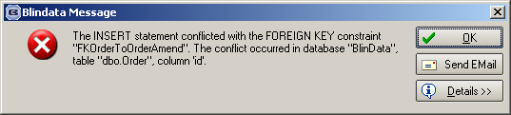

2867. Order Processing > Orders

When link options are set up, and there are choices involving sizes, these sizes are ‘Blind Size’ and not entered size. Therefore the ‘Man Width’ and ‘Man Drop’ is now used when checking link options and not the entered sizes.

2868. Order Processing > Orders

If you enter a detail line for a blind type where ‘Cost Price Related’ = true and the fabric has a calculator ‘User Defined Turnable’, the fabric was not costed properly. Fixed.

2869. Financials > Post Invoices to Sage

We have had two reported cases of invoices being updated to Sage twice when customers are using the ‘Post Invoices to Sage’ menu option. In both cases when the history was checked they look like they had only been posted once. In both cases they were batches of invoices.

A new history record has been added, called 'Invoice Posted (Application)' and it will give us additional information if this problem happens again.

2870. Invoice – Laser Print 11 Detail Lines

The selling price now displays 3 decimal places when relevant.

2871. Invoice – Laser Print (Letterhead Logo)

The selling price now displays 3 decimal places when relevant.

2872. Purchase Order Bought In (Blind Size)

This was a serious bug. This report was printing the entered size of the blinds instead of the ‘Blind Size’ ie the man sizes. Fixed.

2873. Order Processing > Production List > Production List By Blind Type

We have included the ‘Part Manufactured’ status in the status lookup here. In the ‘Production List By Blind Type’ report, if you exclude records after ‘Work In progress’, it now works out which detail lines are manufactured and which aren’t for the report.

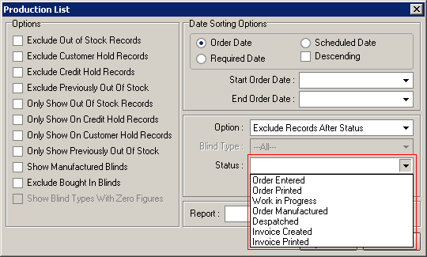

2874. Order Processing > Orders > Print Invoice

If you had an order that is ‘Invoice Printed’, change the status to ‘Order Entered’ (not recommended), then change the status back to ‘Invoice Printed’ and then print the invoice, the invoice date was wrong and the invoice number was missing. Fixed.

New Work and Customer Requests

1549. Purchase Orders

It is now possible to transmit an EDI file for regular purchase orders. See EDI layout ‘EDI-SampleOrder12345.xml.

At the point a regular purchase order is saved, a message appears saying ‘Create EDI Transaction?’.

We have amended the logic in the ‘Recreate EDI Transaction’ button on the ‘Purchase Order Enquiry’ form so it can handle the creation of a XML file for a regular order.
The Order Processing > EDI Enquiry > Sending Data form has been amended so that regular PO transaction EDI records are displayed and can be sent.

1585. Order Enquiry > Blind Out of Stock Scan

If scheduling is switched on and a blind is scanned as being out of stock, all other blinds on that order that have the same manufacturing location also have the scheduling date removed. When the ‘Blind In Stock’ scan is done, all the blinds that have the same manufacturing location also have their scheduling dates updated.

1587. Order Processing > Quotations > Create Order

If a quotation has ‘Proforma’ = true and there is a carriage line on the quotation, the carriage is now always retained in the order when ‘Create Order’ is done.

There is a parameter called ‘Include Carriage in Quote Conversion’. It does not matter what this parameter is set to if ‘Proforma’ = true.

1588. Archive Enquiry

There is now a ‘Remake/Repair/Redespatch’ menu option in the context menu in Archive enquiry.

1589. Purchase Order Enquiry > Generate Regular PO

When a regular PO is created, a stock transaction is now created. There is another stock transaction created when the PO is delivered. In the first one the PO Date and PO number are recorded, and in the PO delivery transaction the receipt date and PO number are recorded.

1590. Reports > Stock Valuation

There is now criteria to suppress the printing of stock records where the stock in hand quantity = 0. It is called ‘Show zero value quantities’ and defaults to false.

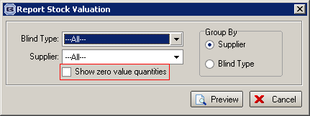

1594. Works Order – Label 1

If ‘Option Config’ is switched on for Roman blinds, the cutting sizes from ‘Cutting Options’ are now printed on this report.

