Blindata Release Note 4.7.3 

27 November 2009

Bug Fixes and Enhancements

2853. EDI Import

Discount is now being calculated properly when EDI orders are imported.

2854. Administration > Maintenance > Repricing

When certain orders were repriced, the discount % was being picked up incorrectly. Fixed.

2855. Bespoke Works Order

If the ‘Small Height’ is entered in Imperial, and in Administration > Parameters > Report Parameters ‘Use Measurement in Works Order Label’ is set to ‘Entered Size, Metric’, then the ‘Small Height’ now prints out in metric.

2856. Financials > Create Invoices

If an order has been imported via EDI and it is ‘Same Day Despatch’ = true, and ‘Carriage Free Over’ = 0 in System Tables > Currency Types, then same day dispatch carriage did not get added. It is now added regardless of what amount is in ‘Carriage Free Over’. ‘Carriage Free Over’ only relates to normal carriage charges.

2857. Invoice – Bespoke 2

The VAT on the left was incorrect if this invoice was run from Financials > Invoice Batch Print.

2859. Invoice Batch Print

When the invoice batch print was run, some invoices print but others did not print. Fixed.

2860. Invoice – Laser Print 11 Detail Lines

For an invoice with this number of detail lines, it now prints the totals on the first page as well.

2861. Order Enquiry > Blind Process Scan

If a blind was scanned as manufactured, but there were other blinds on the order that were not yet manufactured, the status of the order now changes to ‘Part Manufactured’. This worked if you used ‘Blind Made Scan’ or ‘Blind Made’.

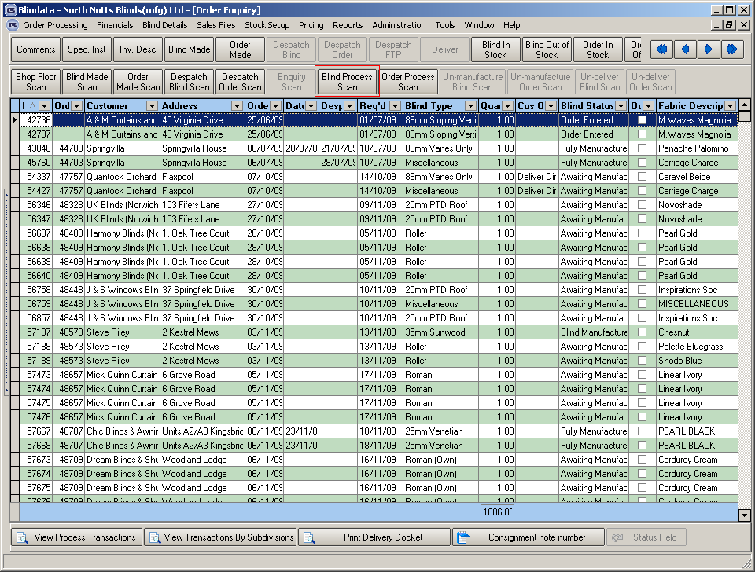

2862. Order Enquiry > Blind Process Scan

If you tried to do a ‘Blind Process Scan’ for blind type ‘89mm Headrail Only’, a message appeared saying ‘There are no processes to scan’, but there were processes set up.
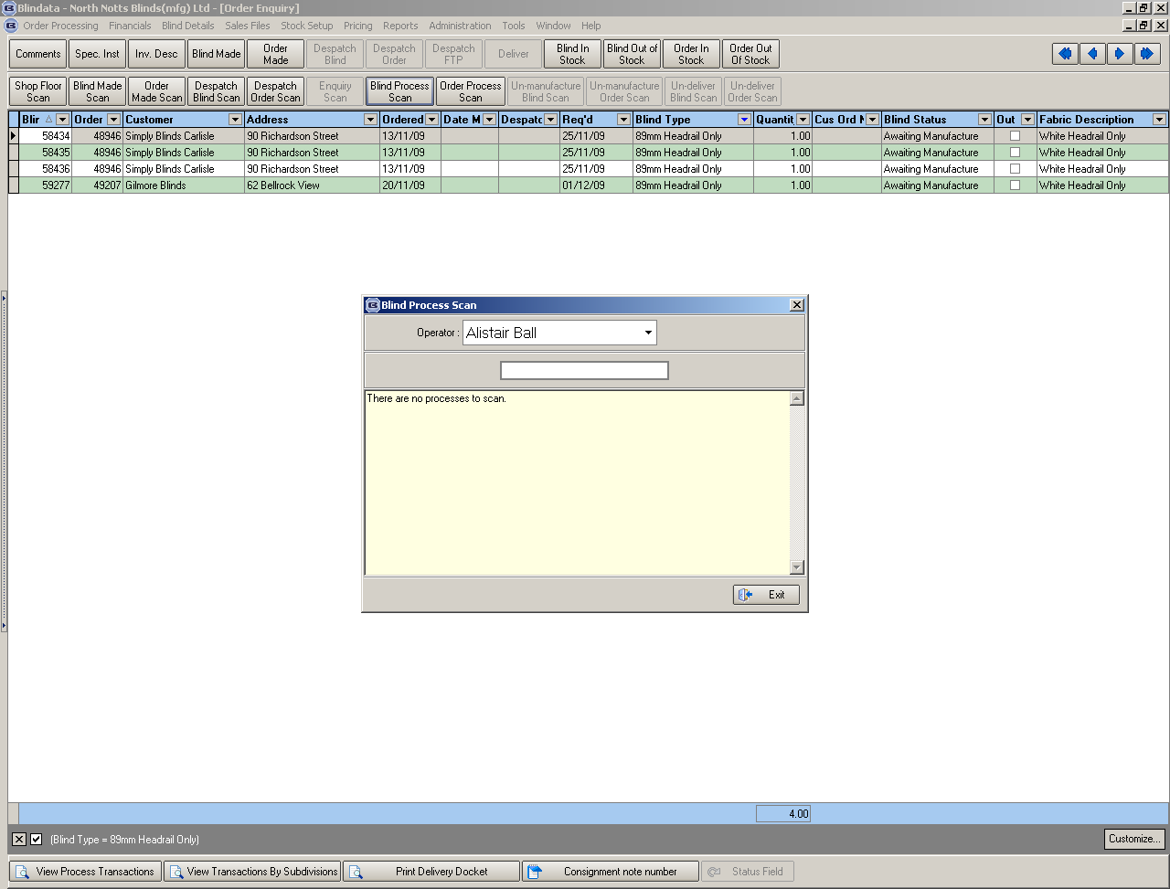

We have fixed this bug, but we cannot fix existing incorrect records. To get this working you should amend all the details with Headrail Only blinds. I.e. you should amend each detail, change quantity to another, save detail, then amend it again and change quantity to the old value.

New Work and Customer Requests

1519. Order Processing > Orders > Import

There is now an extra column in the detail line import for ‘Location’.

1566. Order Processing > Orders

Height is used instead of Drop in the USA. There is a parameter in Administration > Parameters > Defaults for setting ‘Postcode / ZIP Choice’. If this is set to US Zip Code’, then the word ‘Height’ will be used instead of ‘Drop’ throughout the system.

1567. Delivery Docket - Van Despatch Manifast 8

- There are now columns for ‘Order No’ and Cust Ref.
- The ‘1L, 1V’ style of info now prints instead of just the total number of blinds.

1570. Reports > Sales Analysis

The ‘Sales Analysis by Blind Type by Fabric report now shows ‘Sales Value %’. This is the same as the calculation for ‘sales value %’ in ‘Sales Analysis by Blind Type’.

1571. US Version

Despatch is now spelt Dispatch throughout the system.

1573. Order Processing > Orders

‘Original Order No’ is now a column choice on this form.

1574. Sales Analysis Invoice Audit Report

The contact name, email address and delivery address are now printed below the customer name on the ‘Sales Analysis Invoice Audit Report’.

1576. Venetian Barcode 2

On the report ‘Label – Bespoke 22’ we have moved the barcode and made it smaller.

In Administration > Parameters > Report Parameters, there is a new parameter called ‘Venetian Barcode 2’ If this is selected, then the shorter barcode prints. It is not possible to have both Venetian barcode parameters switched on.

Here is the specification for what appears on this barcode.

Characters | Description | Choices | Blindata
1 | Hardcoded | Always 1
2-3 | Model | 01 = LS16 21 = WL25  02 = LK16 22 = FK16  03 = LW16 23 = FE16  04 = EL16 24 = FK25  05 = LS25 25 = FE25  06 = LK25 26 = ZS16  07 = LW25 27 = ZW16  08 = EL25 28 = ZE16  09 = VS25 29 = ZS25  10 = VK25 30 = ZW25  11 = VW25 31 = ZE25  12 = VE25 32 = SS16  13 = LS35 33 = SK16  14 = LK35 34 = SS25  15 = LW35 35 = SK25  16 = EL35 36 = spare  17 = LR25 37 = spare  18 = SL16 38 = spare  19 = WL16 39 = spare  20 = SL25 40 = spare | Taken from Blind Type record, field ‘Model’
4 | Option 630/631 | 1 = STAN Standard  2 = SIDE Side Guiding  3 = FIXE Fixed Bracket  4 = MONO Mono Command  5 = DOUB Double  6 = SPBR Spring Bracket  7 = MOSI Mono+SideGuide  8 = SPDO SpringBr+Double  9 = Spare | Taken from option ‘Type’
5 | Control | 1= L---R  2= R---L  3= L---L  4= R---R  5= L---N  6= R---N  7= N---L  8= N---R  9= N---N | Taken from option ‘Control’
6 | Options 622 | 1 = STAN Standard  2 = SIDE Side guiding  3 = RAND Random  4 = ENDL Endless cord  5 = RASI Rand+SideG  6 = REAN Rand+EndlessC  7 = SIEN SideG+EndlessC  8 = COMB SideG+Rand+Endless | Taken from option ‘Cut’
7-10 | Headrail Colour | Headrail Code | Taken from option ‘Headrail Code’
11-14 | Width | Exact Width | Taken from ‘Man Width’
15-18 | Height | Exact Drop | Taken from ‘Man Drop’
19-22 | Slat Colour | Slat Code | Taken from option ‘Slat Colour’
23-26 | Tape colour |  | Taken from option ‘Cord Code’
27 | Quantity | Quantity | ‘Quantity’ from detail line
28 | Spare field | Always 1
29-32 | Control Length |  | Taken from ‘Chain Length’

W83. Order Entry

If you save a blind, then click the back button on the browser and click save for a second blind, two blinds were created on the order but the second had no options. Fixed.

W84. Order Entry

If a stock item is marked not available online, but a customer has this as a customer default, it caused error messages saving blinds online. Fixed

