Blindata Release Note 4.7.1 

13 November 2009

Bug Fixes and Enhancements

2842. Purchase Order Enquiry > Update

The text in the message box has been altered.

2843. Order Processing > Credit Notes

The credit note number (num_invoice) being shown on the credit note enquiry form was different from the credit note number printed on all credit note prints (credit_id). Fixed.

2844. Works Order – Delivery 8

The option list now wraps round on this report. Previously it was going off the end of the page.

2846. Order Processing > Print Invoices / Invoice Batch Print

If you create an invoice from an order, then add a component line, and then print the invoice, there were two things wrong.

- The invoice date was incorrect.
- The invoice splits into two pages.

Both of these items have been fixed.

New Work and Customer Requests

1462. Scheduling

There is now functionality in Blindata for the scheduling of orders. This means the system is capable of working out when there is available time to manufacture blinds.

Available time is held against manufacturing locations. There is a new menu option in Order Processing called Scheduling to enter and display available times for normal an priority orders. Priority orders are those that have ‘Same Day Despatch’ = true or where ‘Must Go’ = true. The assigned times can be set by updating times between a start and end date, entering the normal and assigned time for a day and then clicking ‘Fill’. They can also be cleared by clicking ‘Clear’.

This form can only be seen if the user has permission for it (Administration > Users > Permissions).

A user will only be able to amend a scheduled date if they have permission to do so in Administration > Users > Advanced Permissions’.

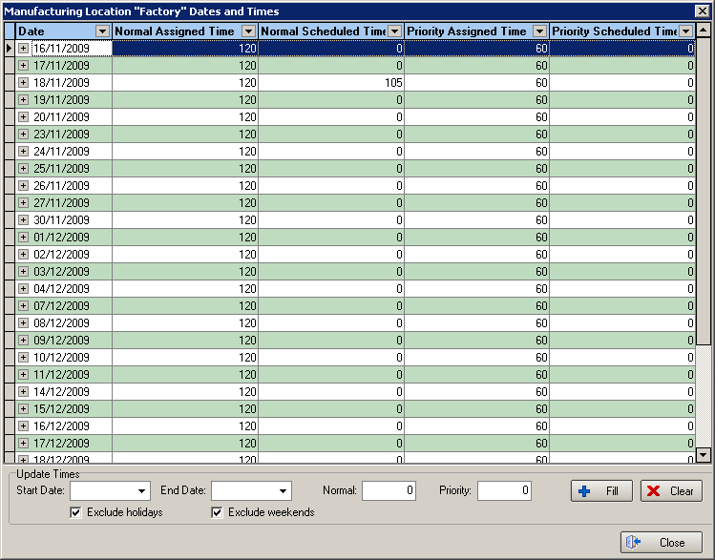

There are two different places where you can determine the amount of time it takes to make individual blinds. The first, and simplest method, is by going to Blind Details > Blind Types and filling in the ‘Average Manufacturing Time’.

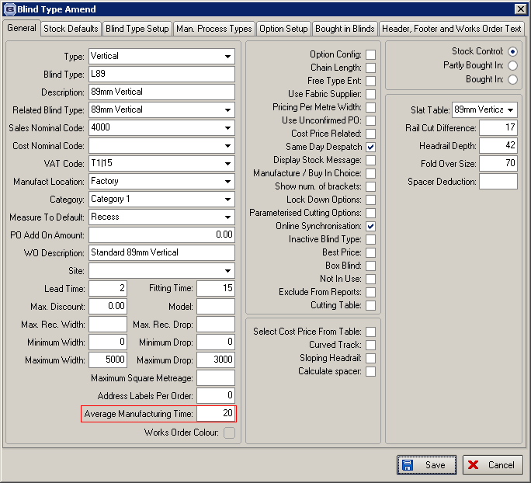

The second method is more complicated and requires ‘manufacturing process times’ to be set up against the blind type records. This can be done in Blind Details > Blind Types > Process Times. A ‘Process Type’ record has to be set up first in Administration > System Tables > Process Type’.

It is then possible to hold times by width and drop against process types. When a detail line is entered, it will add up all the relevant process times for that blind type and apply the time to the schedule. This will take priority over the ‘Average Manufacturing Time’ in the blind type record.

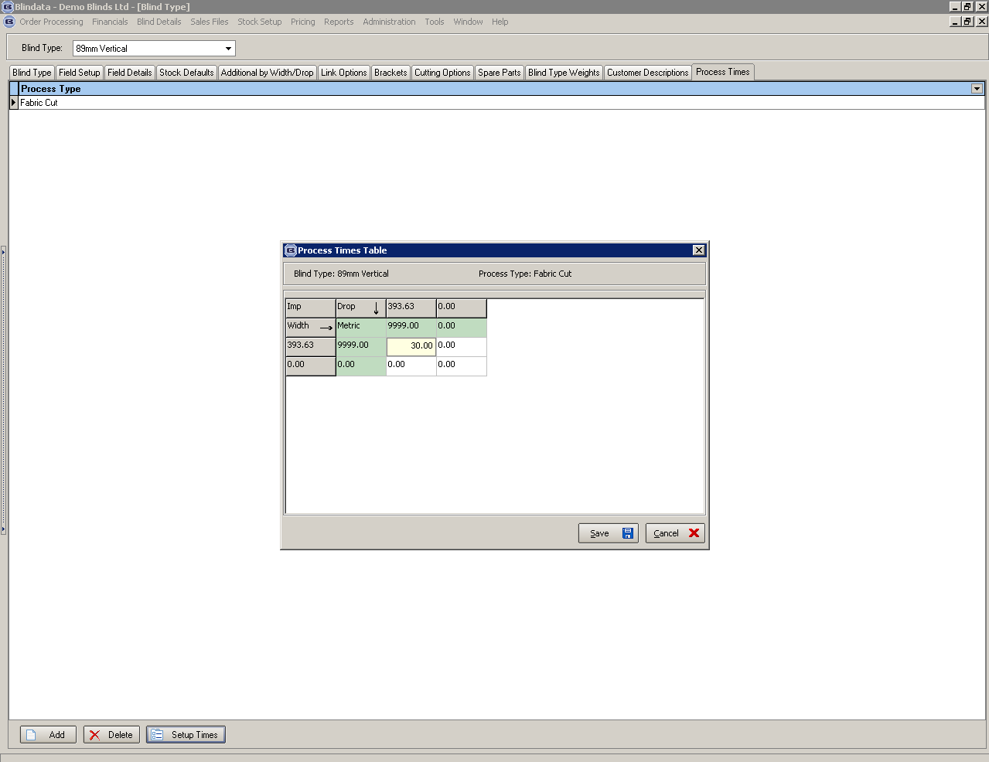

There is also a parameter in Administration > Parameters that needs to be set to switch on the production scheduling.

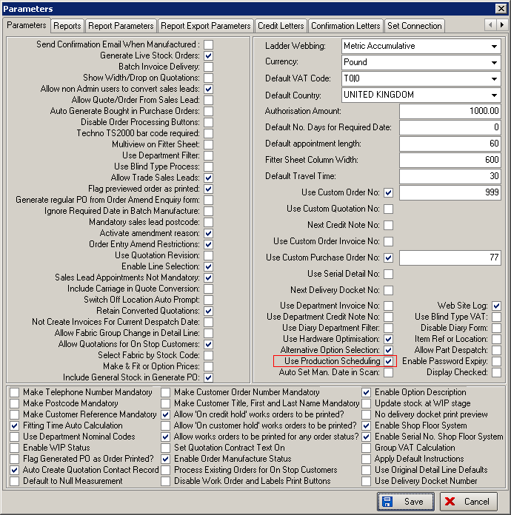

Order Processing

A scheduled date is calculated for each blind entered in the system, according to the lead time and calculated at order entry. It applies the scheduled date according to the lead time, per blind. If there are two detail lines on an order with different lead times, then they will have different scheduled dates on the detail lines. The scheduled date held against the order will be the latest scheduled date from the order detail lines. The required date will then be the next delivery day that is on or after the scheduled date that is held against the order.

Scheduling also takes into account the ‘Display Checked’ parameter. If this is set to true, then the scheduled date is calculated when the order is flagged as ‘Checked’, otherwise it is calculated when the order is saved.

Scheduling also takes into account whether the serial number shop system is switched on or not. If it is switched on, then the scheduled date is held against the serial detail line. It is therefore possible to hold different schedule dates against serial detail lines where the quantity in the order detail line > 1. This could happen if the schedule for the day is filled up. The latest schedule date will be held against the order detail line.

If an order goes ‘on customer hold’ or is scanned as ‘Out of Stock, then the scheduled date is removed from it, and the time deducted from the ‘Normal Scheduled Time’ or ‘Priority Scheduled Time’. This happens for all the blinds on that order. If an order is updated or deleted, then the schedule is updated. If an order is taken off customer hold or scanned back into stock, the scheduled date is calculated from the current date, not the order date.

If a blind is manufactured before its scheduled date, then the schedule is updated because there will then be more time available to make other blinds.

If ‘Use Production Scheduling’ = true and ‘Display Checked’ = true, the scheduled date is calculated until the ‘Checked’ box has been ticked on the order form.

Other Rules

- Quantity in the order detail line is taken into consideration when working out the scheduled time.
- Scheduled date is recalculated each time an order is saved (or checked).
- Same day orders go under priority scheduled time.
- If you do set a scheduled date with permissions, the manufacturing time goes into the relevant assigned time
- It is possible to manually schedule orders by serial detail line (scheduled date is on this record)
- Orders can be scheduled with multiple lines over multiple days – if there is not enough time in one day, then the next available schedule date is used.
- Delivery Day customers - scheduled date is the next free slot as normal. Required date is the next delivery day on or after scheduled date
- Standard Customers - scheduled date = required date
- The schedule is updated for delete, amendments, customer holds, OOS scans etc.
- OOS Scan - all other blinds on the order in that manufacture location are unscheduled (then rescheduled for ‘Back In Stock’ scan)
- Manufacturing blinds depletes the schedule time capacity, but only if the manufactured date is before the scheduled date (date only, ignore time).

Key fields for order record:
Order Date – because this is the start point for searching free slots for scheduling. If an order is not Same Day Despatch the start point is Order Date + 1 day.
Same Day Despatch.
Checked (If the ‘Display Checked’ parameter is switched on).
Customer hold.

Key fields for order detail record:
Out Of Stock.
Width,
Drop,
Blind Type,
Quantity,
Manufacture location in Blind Type record.

When the program cannot calculate a scheduling date for one (at least) order (serial) detail, the order scheduled date will be NULL accordingly. If this happens a message appears when the order record is saved.

The ‘Scheduled Date’ is displayed on the following forms: Order Amend Enquiry, Order Enquiry, Order Amend > Blind Details, Order Amend Enquiry > View Details, Order Amend Enquiry > View Serial Details etc.
Also we can see scheduling information in full on two forms:

1. Order Processing > Scheduling > Date And Times. It’s old form, but it was changed:

First of all we added new level for serial details and several new fields there. So you can see scheduling information on each serial details individually. Especially because now serial details for one detail line may be scheduled on different dates.
As we discussed before, we added new checkboxes ‘Exclude holidays’ and ‘Exclude weekends’. It takes into account holidays and weekends when we fill data on this form.
Also we have disallowed to edit Date And Times information in the grid immediately. It may cause some errors we noticed before. Especially because we can add and delete records using ‘Fill’ and ‘Clear’ buttons only.

2. Order Enquiry > Scheduling.

It’s new form and it’s accessible if user has advanced permission only. Here we can see detailed information about order detail scheduling.
On this form only, user can change ‘Serial Scheduled Date’ manually clicking on ‘Select’ button. In this case, the ‘Order Processing > Scheduling > Date And Times’ form (the first form) will appear and user can tie ‘Dates And Times’ record to the serial detail line. We think that is the best way to enter ‘Serial Scheduled Date’ manually. After ‘Serial Scheduled Date’ is entered manually, the ‘Order Detail Scheduled Date’ and ‘Order Scheduled Date’ will be re-calculated automatically and you can see that on the top of this form.

We think that’s all we had to explain for new Scheduling functionality. All other logic is described in the specification. Please let us know if something is unclear.

Now let’s discuss what should happen if serial detail line, detail line or whole order is manufactured.

We wrote:

11.6We have manufactured Order Detail (Serial Detail):
S11.6: We will add new field called ‘Manufactured Date’ into Scheduling table where all the scheduling information about Order Detail (Serial Detail) stored at the moment.
Also we will not apply this logic to orders and details which status was changed using Status Fields button (as we think this is generally incorrect situation) or using ‘Order Enquire > Un-Manufacture’ functionality (for the time being). Ok.
11.6.1 Order Detail manufactured date more or equal to Order Detail Scheduled Date.
S11.6.1: We will update Manufactured Date field in the Scheduling table.
11.6.2 Order Detail manufactured date less than to Order Detail Scheduled Date.
S11.6.2: We will update Manufactured Date field in the Scheduling table and decrease Normal (SDD) Scheduled Time for Order Detail Scheduled Date. Correct.
Q11.6.2: Should we try to move other Order Detail lines from this Order taking into account new free slot? Not at the moment, but we could look at this in the future.
Q11.6.3: Should we remove this Order Detail line from scheduling and re-assign Order Scheduled date as described in point 7? Yes.

We have changed our mind about this. We think we should not delete anything from scheduling and don’t decrease Normal (SDD) Scheduled Time for it. If we have to move scheduling to another date we can get several incorrect situations.
For example, a serial detail line was scheduled on 13/11/09, but it was manufactured on 12/11/09. We haven’t ‘Dates And Times’ record for 12/11/09 and for current Manufacturing Location, so we can’t move it there. Another situation is we have ‘12/11/09’ record, but there are no free slots there or something like that. We discussed that question a lot, but we can’t find any solutions, because we don’t know what Decora wants exactly in the case if Scheduled Date not equal to Manufactured Date. So, please discuss that with Decora or send us your solution about that, if you sure in this.

Regard to our ideas.

Now there are many conditions when Scheduled Date isn’t calculated. For example, Customer On Hold = true, the order is not checked, Scheduled Max Number is exceeded, the order detail is Out of Stock etc.
So, sometimes it’s very difficult to understand why Scheduled Date isn’t calculated. We think it would be better if we write some log information.
There are two possible solutions there:

1. Add new memo field on Scheduling table, to fill that when Scheduled date is calculated and display that on the ‘Scheduled Update’ form like that:

2. Add new Log table with ‘one to many’ relationship with Scheduling table. And display this table on the ‘Scheduled Update’ form as well:

In this case, we will be able to display log information on reports, if necessary.

Please let us know what you think about this idea. If you like that, please specify what variant is prefer for you. Also, please specify what information we should write in log. Maybe it will be useful to write Operator, Time or something like that as well. Also, we have to know when we should clear log information or maybe never.

The second one idea is Scheduling Date recalculation.
For example, we may have the situation when Scheduled Date is not calculated if there are no records or free slots in the ‘Date And Times’ tables. User can add new records there, but he can’t just re-calculate Scheduled date for existing order detail or whole order as well. Now he can amend order or order detail record and change one of key fields there. In this case only, Scheduled Dates will be recalculated. We think it’s not very comfortably. Maybe there is a sense to add new buttons on the ‘Scheduling Update’ form called ‘Recalculate Scheduling for the Order’ and ‘Recalculate Scheduling for the Order Detail’ or something like that. Please let us know what you think about this.

Actually we think that our ideas aren’t high priority. They are just additional features. So, if you like that, you can just add them as separated development items for the future.

We think the most priority thing to complete 11.6 item and finish ‘1462. Scheduling’ dev item.

Please test existing scheduling functionality carefully and let us know if all logic is correct. It will be much easier to fix that now then when it will be used at Decora.

1505. Order Processing > Orders

There is now an option for Remake / Repair / Redespatch on the Order Amend Enquiry form. This is only enabled if the order has a status of ‘Order Manufactured’ and beyond.

It should have the same functionality as the ‘Remake / Repair / Redespatch’ in the archive enquiry form.

Instead of adding a new button we have created new context menu item called ‘Remake / Repair / Redespatch’.

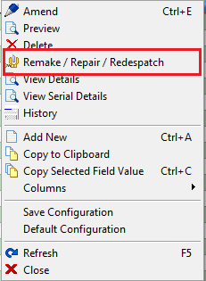

1548. Order Enquiry > Despatch

Previously the mixed order email was sent when the order was despatched. This was too late, it is now sent when the order is fully manufactured as this will alert despatch that they need to collect the multiple parts to despatch them.

1550. Stock Setup > Fabric Group Setup

There is now an option for updating the ‘Alternative Fabric Group’.

1552. Order Processing > Orders

Special instructions are now displayed after they are entered. Previously when you entered a detail line it was not possible to see if you have entered any special instructions or not. We have removed the word ‘Instructions’ from the ‘Special Instructions’ field and replaced it with the entered special instructions.

1553. Order Processing > Orders / Quotations

We have a customer that needs to be able to identify orders that are for conservatories. Therefore we have created a new table called ‘Order Category’ which has a maintenance form in Administration > System Tables. There is a default record added called ‘Standard’.

It is now possible to choose an order category when entering an order.

There is also a column for ‘Order Category’ in the context menu in ‘Order Amend Enquiry’.

1554. Purchase Order

When creating the purchase invoice it is now possible to amend the purchase invoice date. This is done immediately after ‘Create Invoice’ is clicked. A window appears with ‘Purchase Invoice Date:’ allowing the user to amend it. This happens before the carriage line question.

1555. Quotation – Laser Print by Option (Email)

There is now a layout for ‘Quotation – Laser Print by Option’ in ‘Report Export Parameters’ so the quotation can be emailed with this layout.

1556. Invoice – Laser Print 11 Detail Lines

The customer VAT number now appears in the right hand side of the header.

1558. Works Order – Label 1

If the order is ‘Same Day Despatch’, then this now appear on the label instead of ‘Must Go’.

If blind identifier = ‘Austrian/Roman’, then ‘Chain Drop’ now appear on the works order label, and also ‘Cord Spacing’.

1559. Order Processing > Orders > Delete

Previously you can delete an order before it is manufactured. There is a new parameter in Administration > Parameters > Defaults called ‘Only Delete Order if Order Entered’. If this is set to true, then it is only possible to delete an order if order status = ‘Order Entered’. If the order status is not ‘Order Entered’, a message appears saying ‘You cannot delete an order unless it has a status of ‘Order Entered’.

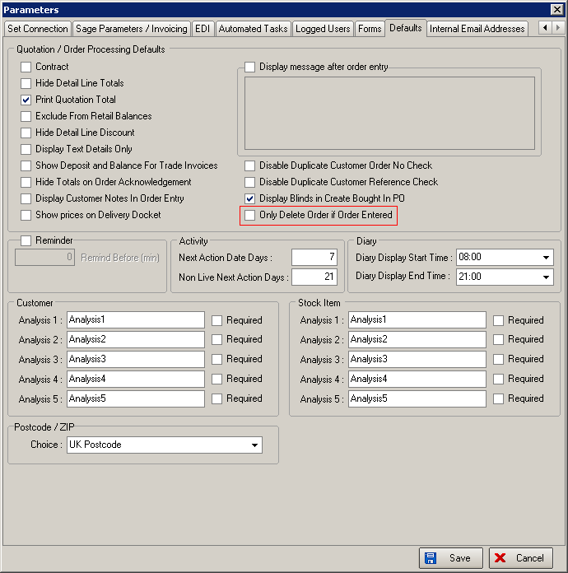

1560. Order Processing > Order Enquiry

There are now navigation arrows on this form similar to those on the ‘Order Amend Enquiry’ form.



