Blindata Release Note 4.7.0 

6 November 2009

Bug Fixes and Enhancements

2841. Order Processing > Orders

If you added a component line and amended the selling price, the ‘Price Overridden’ flag is ticked. This meant that you could not then enter a discount amount or % or adjust the total in the Totals tab, because a message appeared saying:

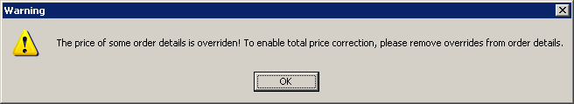

It is now possible to do this. However it is not possible to change discount in the Totals tab if there is a discount % in one of the detail lines.

New Work and Customer Requests

1509. Order Processing > Orders

There is a new method of applying extra costs to an order. Previously there was only a tab for ‘Extra Costs’. This is fine but did not suit the requirements of some customers, especially those that have blind types set to ‘Cost Price Related’. Here are some examples:

A customer wants to be able to include the cost of travel against all the detail lines. They don’t want to have a separate detail line for travel because they want to ‘hide’ this cost in the individual detail lines.

Another customer wants to hold a commission cost against orders, but this cost must be applied proportionately to the detail lines as well.

This to work for blind types where ‘Stock Control’ = true or ‘Bought In’ = true or ‘Partly Bought In’ = true.

There is a new tab on the Orders form called ‘Option Costs’. In here the user is able to select an option and then enter a cost price, or a percentage. If a cost price is entered, it will be apportioned across those detail lines that have that option in them. If a percentage is entered, it will calculate the apportioned amount to go into each detail line according to the value of the detail line.

Example 1

We have an order with 5 detail lines on it. All the blinds in the order are ‘Cost Price Related’. There are option choices in each detail line for ‘Travel’ and ‘Commission’.

Detail Lines

Blind Type Quantity Base Price Line Total

89mm Vertical 1 45.00 45.00
89mm Vertical 1 56.00 56.00
89mm Vertical 2 38.00 76.00
Roller 1 64.50 64.50
Roller 1 74.25 74.25

Total 315.75

Uplift % of 50% gives a total value of 473.63 (all these figures exclude VAT).

In the new ‘Option Costs’ tab we add a record for option ‘Travel’ with an amount of 180.00. Once this amount is saved, the option cost is proportionately spread across the detail lines. There are 6 blinds so 30.00 is added to lines 1, 2, 4 and 5 and 60.00 is added to line 3. We need to decide if we are going to hold this figure in a new field in the OrderDetail_Fabric table or not.

The total for this order now becomes (315.75 + 180.00) * 1.5 = 743.63.

If the user enters a commission amount and there is a detail line for a blind type that has ‘Cost Price Related’ = true, then it will not be possible to do this calculation. A message should appear saying ‘There is a detail line with a cost related price – this calculation cannot be done.

Example 2

We have an order with 5 detail lines on it. All the blinds in the order have ‘Cost Price Related’ = false. There are option choices in each detail line for ‘Travel’ and ‘Commission’.

Detail Lines

Blind Type Quantity Base Price

Blind Type Quantity Base Price Line Total

89mm Vertical 1 45.00 45.00
89mm Vertical 1 56.00 56.00
89mm Vertical 2 38.00 76.00
Roller 1 64.50 64.50
Roller 1 74.25 74.25

Total 315.75

In the new ‘Option Costs’ tab we add a record for option ‘Travel’ with an amount of 60.00. Once this amount is saved, the option cost is proportionately spread across the detail lines. There are 6 blinds so 10.00 is added to lines 1, 2, 4 and 5 and 20.00 is added to line 3.

The selling price of the order remains unchanged, but the profit on each detail line is reduced.

If a commission ‘Option Cost’ is entered with a percentage of 10%, the option cost for each detail line is worked out as 4.50, 5.60, 7.60, 6.45 and 7.43. This makes no difference to the selling price but does increase the cost price and lowers the profit.

1546. Purchase Order Reports

There is now an option to print the purchase orders in imperial as well as metric. There is a new parameter called ‘Use Measurement in PO’ that should have the choice of ‘Metric’ or ‘Imperial’.

This affects the following two reports: ‘Purchase Order Bought In – Standard’ and ‘Purchase Order Bought In (Blind Size)’.

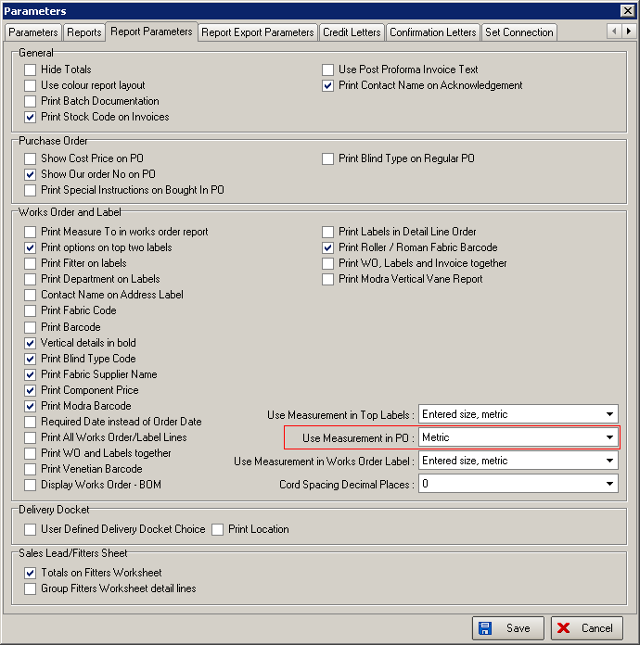

1547. Administration > Import From Excel

There are two import routines, ‘Price Tables’ and ‘Option Price Tables’ that import price tables. Both these spreadsheets include measurements that were only in Metric. There is now a facility to import these tables in metric or imperial. The spreadsheet file has been amended so the fourth column is now ‘Measurement’ and should be set to ‘Metric’ or ‘Imperial’.

W80. Synchronisation

If an order has been cancelled on the desktop system, when the Office > Site sync is done, it is now also removed from the online database.

W81. Synchronisation

When an online order is submitted, it’s status changes to ‘Submitted’. It is now also highlighted in green.

