Blindata Release Note 4.6.7 

13 October 2009

Bug Fixes and Enhancements

2792. Automate Create Invoice

The Same Day Despatch charge is now being applied to invoices when they are created by the automatic routine.

2793. EDI Import

If an XML file has a new customer description for a blind type or a fabric in it, it is added to the relevant customer / description table. It worked properly if there was no existing description for the blind type and fabric for that customer. If the customer changes the blind type description or the fabric description, this does now get updated if there is already a record in these two tables.

2804. Invoice – Bespoke 22

This invoice has been tidied up.

2809. Optimisation

On the fabric optimisation diagram report., the actual fabric cut size is now shown instead of the blind size.

New Work and Customer Requests

857. Optimisation

The following optimisation tasks have been carried out.

- Large text fields have been removed from OrderDetails and put in separate tables.
- All indices and fields in tables have been manually checked. Redundant fields should be removed.
- We have ‘archived’ records that have associated orders with status = ‘Invoice Posted’. See previous release note.

New ‘archive’ tables have been created for the following tables.

Address
Complaint
CuttingOrderDetail
CuttingTableDetails
HistoryOrderAmend
HistoryOrderAmendDetail
PurchaseOrder
PurchaseOrderTransaction
Order
Order_Letter
OrderAmend
OrderDetail
OrderDetail_BlindType
OrderDetail_Discount
OrderDetail_Fabric
OrderDetail_Options
OrderFabricCostPrice
OrderScheduledDate
OrderStatus_Change
ProcessTransaction
Receipt
Scheduling
SerialDetailLine
StockTransaction

We created a routine to move these records into the archive tables in v4.6.6. The form can be accessed from Administration with a new menu option called ‘Archive Records’. The records can be moved a month at a time.

Forms that have been changed

Order Processing > Archive Enquiry.
Order Processing > Archive Enquiry > context menu > View Details
Order Processing > Archive Enquiry > context menu > View Serial Details
Order Processing > Archive Enquiry > context menu > History
Order Processing > Archive Enquiry > context menu > View Receipts
Order Processing > Archive Enquiry > context menu > View Extra Costs
Order Processing > Archive Enquiry > Remake/Repair/Redespatch button. We have disabled this button for archived orders.
Order Processing > Archive Enquiry > Find button
Order Processing > Archive Enquiry > Contact Management button
Order Processing > Archive Enquiry > File Attachments button
Order Processing > Archive Enquiry > Note button
Order Processing > Archive Enquiry > Consignment Note button
Order Processing > Archive Enquiry > Email Invoice button
Sales Files > Customers > Orders tab
Stock Setup > Stock Items > Stock Transaction tab

Reports that have been changed (they now look at live and archived orders)

Order Processing > Archive Enquiry > Print Invoice (all reports).
Order Processing > Archive Enquiry > Print Acknowledgement (all reports)
Order Processing > Archive Enquiry > Print Delivery Docket (all reports)
Order Processing > Archive Enquiry > Preview Labels (all reports)
Order Processing > Archive Enquiry > Print Works Orders (all reports)
Financials > Daily Sales Report
Reports > System Reports > Blind Type Ordered
Reports > System Reports > Fitting Dates Report
Reports > System Reports > Orders By Operator
Reports > System Reports > Fitters Report by Department
Reports > System Reports > Stock Usage Report
Reports > System Reports > Contact Management by Employee
Reports > System Reports > Contact Management by Customer
Reports > System Reports > Employee Profit Report
Reports > System Reports > Work In Progress Report
Reports > Total Number of Blinds For Fitting
Reports > Daily Order Control Report
Reports > Sales Analysis > All Reports
Reports > Financial Reports > Appointment Bonus System
Reports > Financial Reports > Balances by Nominal
Reports > Financial Reports > Balances Invoice Report
Reports > Financial Reports > Balances Invoice Report (Totals)
Reports > Financial Reports > Balances Report
Reports > Financial Reports > Deposits by Nominal
Reports > Financial Reports > Discount Report by Department
Reports > Financial Reports > Fitter Commission Report
Reports > Financial Reports > Invoice by Nominal Report
Reports > Financial Reports > Order / Invoice Numbers
Reports > Financial Reports > Rep Commission Report
Reports > Financial Reports > Rep Commission/Discount Report
Reports > Financial Reports > Retail Discount Report
Reports > Financial Reports > Validation Report
Reports > Financial Reports > Zero Value Invoices

1064. Applications

We will need a method of printing part invoices. Maybe the ‘Print Invoice’ should print all invoices for that order if there is more than one invoice, or we have some way of displaying the invoices related to the order and then choose which one to print. Can we discuss this? Any other suggestions? It would definitely be useful to be able to see the invoice numbers on the form – maybe using the context menu?

We have adjusted Financials > Invoice Batch Print to allow for the printing of part invoices.

We have also adjusted ‘Post Invoices’ to allow for partial invoicing. It is possible to post more than one invoice per order to Sage. The order status only changes to ‘Invoice Posted’ once all of the invoices in the order have been posted to Sage. Orders where invoices are part posted have the status ‘Part Posted’.

1501. Order Processing > Orders

There is a new column choice for ‘Delivery Docket Number’ on ‘Columns’ in the context menu.

1502. Invoice – Laser Print (Letterhead Logo)

There is a new flag in Totals tab in the order form to say ‘Print Invoice Footer Text’. It defaults to true unless the customer is set to Proforma = true, in which case it defaults to false.

1504. Pricing > Discounts

There is a ‘Copy to Clipboard’ to copy the main discount lists to clipboard, in the same way as we did for online discounts.

1521. Administration > System Tables > Slat Description

It is now possible to select ‘Austrian/Roman’ in the type field.

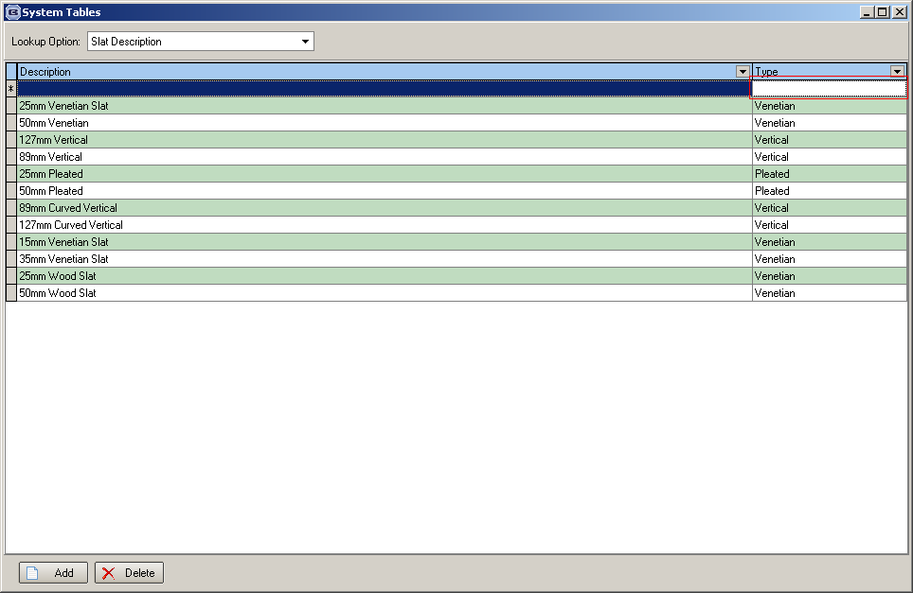

1522. Blind Details > Blind Types

If blind identifier = ‘Austrian/Roman’, there are new fields for ‘Panel Bar Table’, ‘Panel Bar Cut’ and ‘Bottom Bar Cut’. The ‘Panel Bar Table’ is a lookup field that looks up the ‘Slat Description’ table and only show type ‘Austrian/Roman’.

1523. Works Order – Label 1

If blind identifier = ‘Austrian/Roman’, then the following fields now print on this works order.
‘HR Cut Size’ = Man Width – Headrail Cut Size (from blind type).
‘Panel Bar Cut Size’ = Man Width – Panel Bar Cut
‘Btm Bar Cut Size’ = Man Width – Bottom Bar Cut.

1524. Administration > System Tables > Despatch Method

Previously there were two new fields: ‘Cut-Off Time’ and ‘Alternative Despatch Method’ added to this form. When the order was dispatched, after the cut-off time, the despatch method changed to the alternative dispatch method. We have added a ‘Start cut-off time’ and an ‘End cut-off time’ (End Cut Off Time is the current Cut Off Time). Any orders despatched between the two times will change to the alternative dispatch method. Any orders despatched outside the two times will stay with the current dispatch method.

