Blindata Release Note 4.6.6 

5 October 2009

Bug Fixes and Enhancements

2789. Order Processing > Orders

It is no longer possible to enter a discount % of over 100% in either the detail line or the totals tab.

2790. EDI Import

There was a problem where some customers that send in XML import files (not from Blindata) had orders where the number of vanes is included but the width is zero. The EDI import is now able to handle this ie when it is imported it imports the number of vanes and (if ‘Calc Width from Vanes = true in the blind type record) prices the blind and calculates the width as well.

2791. Order Processing > Orders

For a blind type with blind identifier = Vanes Only and ‘Calc Width from Vanes’ = true, if you entered the no of vanes, then overwrite the width, the no of vanes did not recalculate. It now recalculates the number of vanes by dividing the ‘Vanes Multiplier’ into the blind size width (exact width).

2794. EDI Import

The required date was calculating as Tuesday for weekend same day orders. It now calculates as Monday.

2797. Order Processing > Order Enquiry > Despatch

The mixed order email not working correctly. It now only create a ‘mixed order’ email if there is more than one manufacturing location in the order detail lines.

2799. Order Processing > Orders

If a blind type is ‘Cost Price Related’ and the quantity is changed and price overridden = true, the nett price now gets updated immediately.

2800. Order Processing > Orders

If a blind type is set to ‘Cost Price Related’ and an uplift % is added to the Totals tab, it is now possible to change that uplift % without having to alter each detail line.

2801. Works Order – Bespoke 22

1. If the works order is set up with more than one WO Control record, the grouping was incorrect. There are now separate pages for each copy of the works order.

2802. Label – Bespoke 22

1. Moved whole page down 1mm but keep the page length the same
2. Top label – date and ‘n of n’ has been moved left by 10mm.

2805. Production List By Day

Several modifications have been made to this report.

- Removed these headings
- Put a horizontal line between sub total and next group
- Moved lines slightly closer together horizontally.

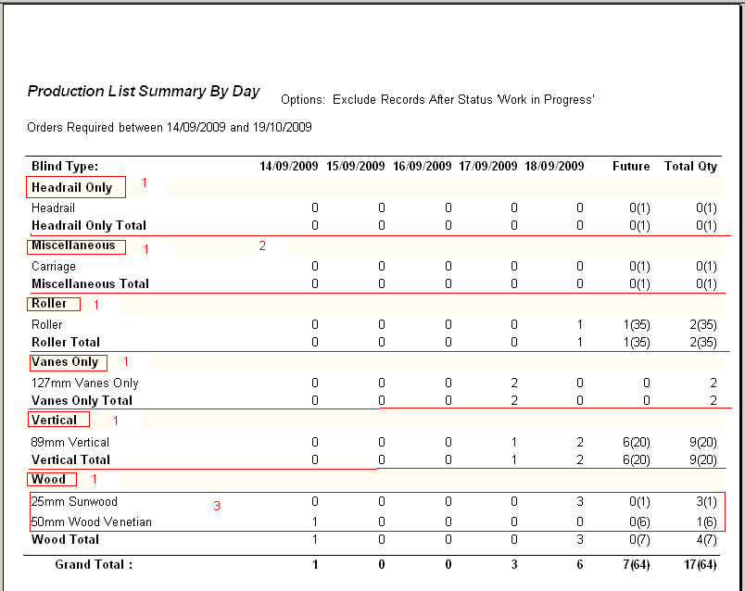

2806. EDI Import

If an order is imported as an EDI import and the order goes on credit hold, when you view the ‘Orders On Hold’ form, it showed two fields set to true: ‘On Credit Hold’ and ‘Taken Off Credit Hold’. ‘Taken Off Credit Hold’ is no longer set to true.

New Work and Customer Requests

857. Archiving (Incomplete)

We have introduced functionality to archive records. Previously all orders, quotations and credit notes were held in the ‘Orders’ table, regardless of status. This was going to create performance issues in the future, so we have introduced archived order tables. It is possible to archive records on a monthly basis by going to a new menu option, Administration > Archiving. In this form, records can be moved in and out of the archive table.

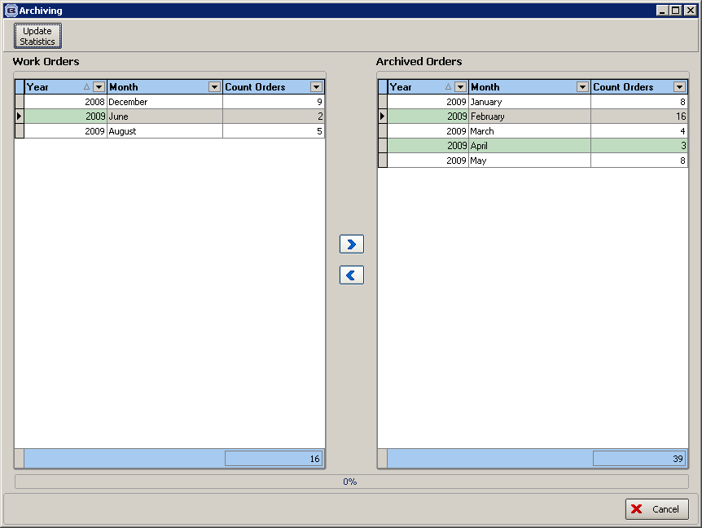

We are currently adjusting all forms and reports to handle accessing of archived orders as well as ‘normal’ orders. This will be completed in the next release, so please do not use this archiving functionality until then.

1064. Applications (PARTLY)

We have a couple of companies that sell mainly to the contract market ie contractors. A contractor is a company that is responsible for (as an example) the entire job of constructing a building and fitting it out, and this may include blinds. The rules are slightly different regarding invoicing, because the jobs may be done in phases and normally involve large orders. These orders may be done in different phases and invoiced for separately. When part of an order is ready for invoicing, an ‘application’ needs to be printed and sent to the customer. This will look like an invoice but will say ‘Application’ instead of invoice, and does not contain any VAT amount. The application is received by the customer and a certificate is sent back authorising all or part of this payment, also giving the invoice date. An invoice is then created and printed by the user for the authorised amount with the relevant invoice date entered. The invoice can then be posted to Sage. The next application is then raised etc.

It is now possible to hold multiple application dates against orders. This is required by companies that are selling blinds to the contract market sector. The application is a list of blinds installed.
The application is then sent off, and if accepted, then a certificate is issued. An invoice is then sent out.

There was existing functionality to deliver individual detail lines in an order. If there are multiple applications per order, and therefore multiple invoices, we have introduced a facility to flag the detail lines in an order as being invoiced. This means that we now hold invoice numbers against order detail lines instead of the header because there will potentially be more than one invoice per order. This feature has been parameterised in the Customer record.

Example

A sales order is entered for 30 blinds, and to keep it simple, the selling price of each blind is £100. The value of the order is therefore £3000 + VAT of £450 = £3450.

The order is going to be delivered in 3 phases of 10 blinds each. The first 10 blinds are manufactured and despatched. An application is then raised for these 10 blinds (they will have to be selected individually from blinds with a status of delivered) and then printed.

The customer then sends back a certificate saying that, for example, 9 of the 10 blinds are ok but there is a problem with the 10th. The tax point date (invoice date will also be stated on this receipt). An invoice is then created for 9 blinds ie £900 + VAT.

When the second application is created, it will be for 11 blinds (the 10 most recently delivered plus the blind from the first application). If the customer accepts this application, an invoice will then be raised for £1100 + VAT. It will have a different invoice number from the previous invoice.

The remaining blinds are then delivered etc.

We should also use this as an opportunity to have partial invoicing for orders ie it will be possible to have more than one invoice per order.

Software Work

We have created a new field in table NextNumber called ‘Application Number’.

We now hold a flag against the customer to say that it is possible to raise applications. This is called ‘Raise Application’ and defaults to false. There is also a new flag in the customer record called ‘Allow Part Invoicing’.

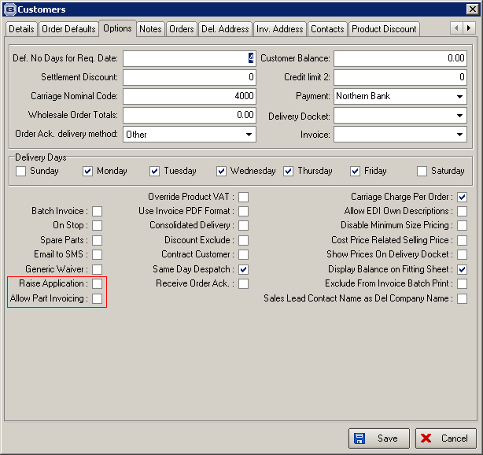

There is a new button on the ‘Order Amend Enquiry’ form called ‘Application’. This is only available if the customer has ‘Raise Application’ = true and the order has a status of ‘Part Delivered’ or ‘Delivered’.

When the ‘Application’ button is selected, a form appears with the blinds that have been delivered. The user is then able to select the blinds to put on the application. It is possible to select them individually or select ‘All’. This will then select those blinds that have been delivered but have not yet had an application raised. Once an application is raised, a new application number is written to these detail lines.

A record is created in Order History called ‘Application Created’.

There is also a button on this form to print an application. The application has the same layout as an invoice print, but has the word ‘Application’ instead of invoice, print application number instead of invoice number and has no mention of VAT.

A record is created in Order History called ‘Application Printed’.

We have also made changes to the ‘Create Invoice’ button on Order Amend Enquiry’.

If a customer is set to ‘Raise Application’ = true and ‘Allow Part Invoicing’ = true, ‘Create Invoices’ also creates an invoice for a part delivered order as well as a fully delivered order. The invoice is only created for relevant detail lines and the invoice number is stored against the detail lines.

If the customer has ‘Raise Application’ = true, then it should only be possible to create the invoice if an application has been raised.

If a customer is set to ‘Raise Application’ = false and ‘Allow Part Invoicing’ = true, ‘Create Invoices’ also creates an invoice for a part delivered order as well as a fully delivered order. The invoice is only created for relevant detail lines and the invoice number is stored against the detail lines.

We have also enabled the ‘Part Manufactured’ status, which was previously inactive.

We have adjusted Financials > Invoice Batch Print to allow for the printing of part invoices.

We have changed the filter form in ‘Order Amend Enquiry’ to allow for the new status options. This now has ‘Part Delivered’ and ‘Part Invoiced’ added to it.

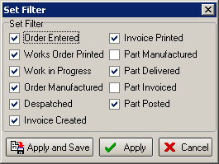

Not yet completed:

We will need a method of printing part invoices.

We will also need to adjust ‘Post Invoices’ to allow for partial invoicing. It should be possible to post more than one invoice per order to Sage. The order status should only change to ‘Invoice Posted’ once all of the invoices in the order have been posted to Sage. Orders where invoices are part posted should have the status ‘Part Posted’.

1247. Order Processing

Results and necessity of the further database optimization. Add menu items Add… (Order, Quotation, Credit).

There should be a new menu option on Order Processing. This should be called ‘Add’ and will have a sub menu for ‘Add Orders’, ‘Add Quotations’ and ‘Add Credit Notes’.

1518. Sales Lead / Fitters Sheet Full

If the appointment is for a fitting, the following child safety information is now included.

Child Safety Cleat Fitted
Fitted (Signed)
Declined (Signed)

