Blindata Release Note 4.6.4 

15 September 2009

Bug Fixes and Enhancements

2780. Quotations > Email Quote

The ‘Email Quote’ button was sometimes greyed out when it should have been enabled. Fixed.

2781. Invoice – Laser Print (Letterhead Logo)

If ‘Hide Detail Line Discount’ is set to true, the unit price and discount % should no longer appear on the invoice.

2782. Purchase Order Enquiry > Send Email

If you try to email a partly bought in PO, nothing happened. Fixed.

2783. Purchase Order Enquiry > Context Menu

When you use ‘View Sales orders’ in the context menu for a partly bought in PO, there are now records displayed.

2784. EDI Enquiry > EDI Import

If an order was entered online that had a minus amount for the option (actually negative uplift percentage) it was not calculated properly when it was imported as an EDI record. Fixed.

2785. Invoice – Bespoke 17a

This invoice stationary has been altered, so the following changes have been made.

- We can now print a fifth detail line on the invoice.
- The totals have been moved down 1.5cm.

2786. Delivery Docket – Bespoke 17b

It is now possible to print a fifth detail line on this report.

2787. Quotations > Create Order

When you convert a quotation to a sales order, the ‘Hide Detail Line Discount’ flag is now brought across properly.

2788. Invoice – Bespoke 17a

If there are 6 detail lines on an invoice and the option description exceeds two lines, the invoice then goes onto a second page and prints the detail line again. It no longer prints the second line.

New Work and Customer Requests

1481. Order Processing > Quotations / Orders

A travel amount can now be added as a field in the Totals tab.

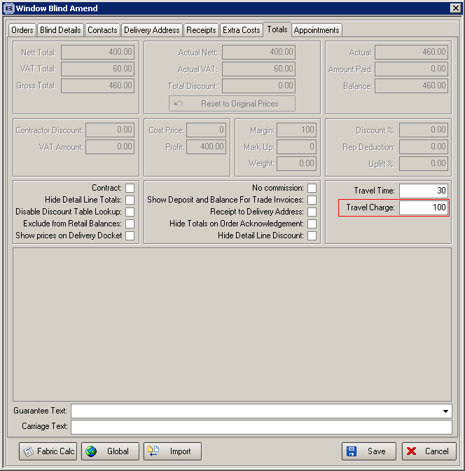

We now hold a separate field for ‘Travel Charge’. If this is entered, then the actual nett is recalculated and the individual detail lines recalculated. The discount % remains as zero.

For example, if the ‘Travel Charge’ in this example was 20.00, then the ‘Actual Nett’ would be 116.38, and the individual detail line nett amount would be multiplied by 116.38 / 96.38, to give the correct amount.

When this is done, a proportionate amount is added to the base price in each detail line and the price overridden button is then set to true for each detail line. If a travel charge is entered, then it is not possible to amend the actual nett, unless the travel charge is changed back to 0.

There is an advanced permission for this called ‘Travel Charge’ in Administration > Parameters.

1482. Order Processing > Quotations > Email Quote

Previously a quotation could only be emailed straight away. If the user wanted to add another attachment to the email, it could not be done. There is now a parameter so that the email sits in Outlook unsent, so the user can then add another attachment to it. (Parameters > Set Connection > Email Straight Away).

1483. Order Processing > Orders > Create PO

When the ‘Create PO’ button is used for bought in blinds, it is now possible to display a window showing the blinds that have to be ordered and select ‘All’ or just some of the blinds for the PO. There is also a parameter for this in Administration > Parameters called ‘Display Blinds in Create Bought In PO’ (Parameters > Defaults).

1484. Order Processing > Orders

If an order is for a bought in blind, then the user may need to amend the supplier before the PO is created. If the selling price is calculated as the cost price plus an uplift %, then the selling price should remain the same but the uplift % should be back calculated. It is now possible to amend multiple blinds at once. This is done by displaying the supplier in the ‘Global’ form, but only if it is for a bought in blind.

1496. Production List Summary By Day

We have included an option here for blind types with zero figures.

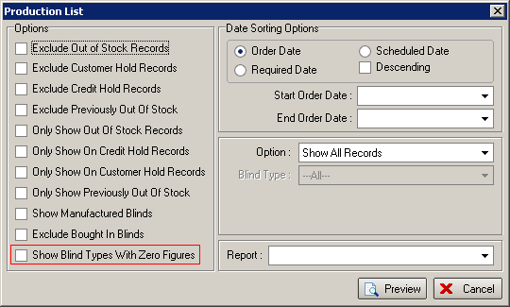

1498. Invoice – Bespoke 29

The delivery address and customer reference now print on this report.

1499. Reports > System Reports > Contact Management by Customer

- The report is now sub grouped by type within customer.
- There is a new column for credit value. Action Date, Type and Action Type have been moved to the left. There is a sub total for credit value against type and customer.

