Blindata Release Note 4.6.3 

4 September 2009

Bug Fixes and Enhancements

2744. EDI Import

When an order is imported for a blind which has a ‘Box Blind’ option, it has an outer code for the box blind, even if it has not been entered on the online order. This is because the XML file has an option for box blind in it, even though it is not flagged to have one. It no longer does this. The box blind option is only created when the order is imported and does not need to be mapped.

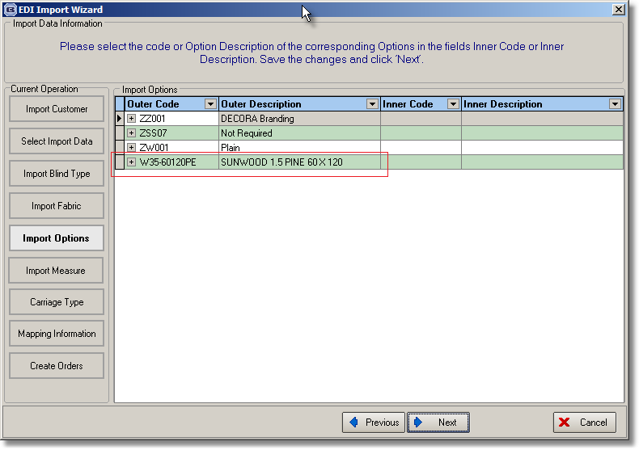

2778. Reports > Stock Valuation Report

- ‘Validation’ now says ‘Valuation’.
- Records where ‘Stock Held In House’ = false are no longer included here.
- There are sub totals and totals for ‘Stock Value’.

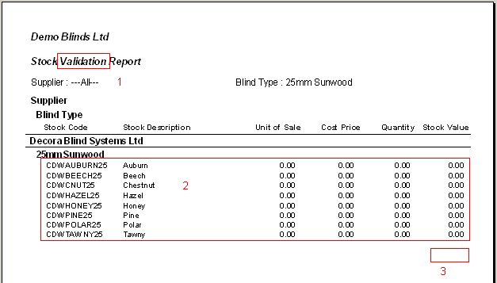

New Work and Customer Requests

1468. Purchase Order Enquiry

A label print has been created for regular purchase orders, but not for bought in purchase orders. There is a new button on the bottom of this form to do this.

Each of these labels is 138mm wide by 79mm deep. They are only printed for orders with fabrics that have ‘Stock Held in House’ = false.

The labels print in the following order: order number, fabric, detail line.

The first label should print once and the second label print once for each blind.

First Label

- Blind type description
- Order No.
- Customer
- Fabric description
- Required date
- Delivery day
- Customer order No

Second Label

- Blind type description
- Required date and delivery day
- Order number
- Customer reference
- Customer
- Fabric description
- Quantity
- Entered width and drop
- Options list
- Number of vanes (if blind identifier = vertical or vanes only)
- Measure To
- Metric entered width and drop
- Special instructions
- Text ‘Proudly Made By:’
- Blind number eg ’12 of 12’.

1491. Order Processing > Paid Proformas

This form has been optimised.

1492. Order Processing > Quotations / Orders

We have created ‘Add Order’ and ‘Add Quotation’ as sub menu options on the ‘Orders’ and ‘Quotations’ menu items. After an order has been entered and saved using ‘Add Orders’, it then defaults to entering another new order.

1494. Sales Files > Customers

The Customer Enquiry form and Customer form have been optimised.

