Blindata Release Note 4.6.1 

14 August 2009

Bug Fixes and Enhancements

2764. Order Processing > Production List

A timeout error appeared when you tried to print this report at one customer site. The report has been optimized.

2765. Sales Analysis Invoice Audit Report

The VAT and Total figures at the bottom of this report are now both correct.

New Work and Customer Requests

1454. Administration > Parameters

We have created a new tab called ‘Internal Email Addresses’ and added two more internal email addresses in here.

Despatch mixed order email

When an order is despatched, a check is made to see if there is more than one manufacturing location for detail lines on the order. If so, an email is sent to this address saying ‘Order nnnn for [customer company name] is a mixed order. Please make sure all blinds get despatched.

EDI/Online OOS email

If an order is flagged as out of stock when it is imported, an email is sent to this address saying ‘There are items on order nnnn, customer order number xxxx, customer reference xxxx for [customer company name] that are out of stock. Please contact the customer.

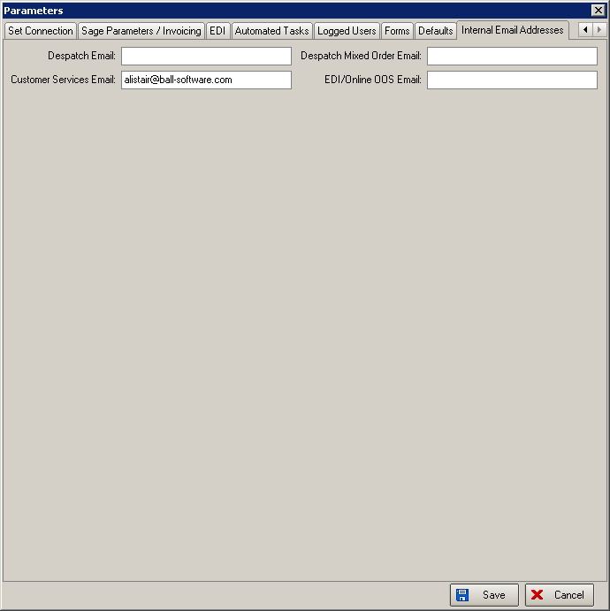

1455. Despatch Method

We now hold two new fields against the despatch method record. These are ‘Cut off time’ and ‘Alternative Despatch Method’. The cut off time defaults to 23:59 and the alternative despatch method defaults to null.

When the order is despatched, the despatch method record is examined to check the cut off time. If the current time is after the cut off time, then the alternative despatch method is used.

1457. Administration > Users

The system no longer allows duplicate user names. If you try to save a record with the same user name, a message appears saying ‘This username has already been used – please use another’.

1458. EDI Import

1. The EDI import now ignore strange characters that the system will not accept eg &.
2. If an order comes in with multiple blinds and some cannot be made (over max) it is put on customer hold.
3. EDI orders are not imported if the quantity in a detail line is 0.

1459. Fabric Optimisation

1. There is a new button to view all the cutting table detail lines for the chosen fabric.
2. It is now possible to choose a fabric without choosing a blind type (because a fabric could be used in more than one blind type and we want to optimise them at the same time).

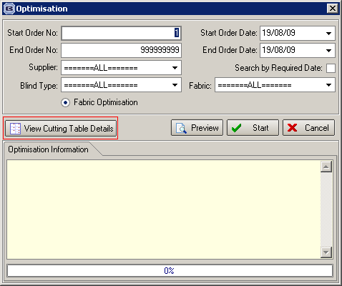

1461. Manufacturing Location

Manufacture Location Dates & Times are now accessible on the Order Processing menu, in ‘Scheduling’, immediately below ‘Production Documentation’. It is not possible to amend the manufacturing location, but it is possible to set ‘Dates and Times’ records.

1463. Works Order – Bespoke 28

This works order is now grouped by manufacturing location and not blind type. There is a new page for each manufacturing location.

1476. Delivery Docket – Laser Print

We have included ‘Location’ on this report. There is a parameter for this in Parameters > Report Parameters (in the Delivery Docket section) called ‘Print Location’.

