Blindata Release Note 4.6.0 

7 August 2009

Bug Fixes and Enhancements

2759. Label print – A4 2 x 11

1. We have included Width and Drop sizes : Imperial (Metric), also number of vanes for blind identifier = Vertical and Headrail Only.

2760. Order Processing > Orders

When adding a contact management record, a timeout error occurred at one site. Fixed.

2761. Order Processing > Order Enquiry

Sometimes when an ‘Order Made Scan’ is done, the scan is not done properly and only the last 5 characters are picked up. This could result in the wrong order being converted to ‘Order Manufactured’. We have an infrequent situation at one customer site where orders that are ‘Invoice Posted’ were reappearing as ‘Order Manufactured’. When the ‘Order Made Scan’ is done on the ‘Order Enquiry’ form, it now checks that the order detail record being scanned is for a detail line that only has a status of ‘Awaiting Manufacture’ or ‘Work in Progress’ and that the order record only has a status of ‘Order Printed’ or ‘Work in Progress’.

2763. Invoice – Bespoke 29

Extra column titles now print on this invoice.

New Work and Customer Requests

1442. Sales Files > Customers

We have added Address Line 3 and Address Line 4 fields to the column choice in Customers.

1443. Google Maps

We have added times as well as distances on the list on the left hand side.

1444. Sage 50 2010

Sage integration now works with Sage 50 2010.

1445. Blind Details > Blind Types

If ‘Online Synchronisation’ is switched on for a blind type, a form now appear that says ’Do you want this to be applied to all online customers?’. If ‘Yes’ is the answer, then a record for this blind type will be added for each customer (appearing in the ‘Blind Type Sync’ tab in the customer record).

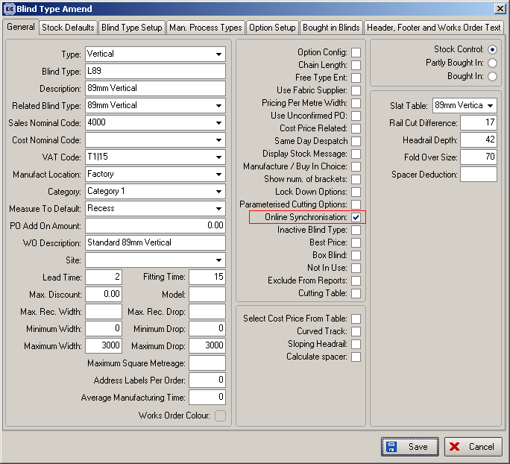

1446. EDI / Online Discounts

We have altered the way that discounts are held for EDI / online orders. Previously, the discount was held by start and end date, customer and blind type. It is now possible to hold the discount by only start and end date, and blind type. This means that this discount will apply to all customers for EDI / online orders.

We have also added an employee field for all discounts (same as employee for normal Discounts).

1447. EDI Mapping

It is now possible to add manually EDI mapping records. This can be done by right clicking on each grid of the EDI Mapping form.

1448. Sales Files > Customers

‘EDI Same Day Despatch’ description has been changed to just ‘Same Day Despatch’ on the customer option form.

1449. Order Processing > Order Enquiry

There are four new scan buttons – one for ‘Un-manufacture Blind Scan’ ‘Un-manufacture Order Scan’, ‘Un-deliver Blind Scan’ and ‘Un-Deliver Order Scan’. There are advanced permissions for all these buttons in Administration > Users.

Un-manufacture Blind Scan

This changes the status of the detail line (and if relevant, serial detail line) to the previous detail line status (depending on whether ‘work in progress’ is being used or not). An order history record is also written. If all the blinds on the order had been manufactured and one was then scanned as ‘un-manufactured’, the order status is set back to the previous status.

Un-manufacture Order Scan

This changes the status of the order back to the previous status, and all of the detail lines back to the previous status. An order history record is also written.

Un-deliver Blind Scan

This changes the status of the detail line (and if relevant, serial detail line) back to ‘Blind Manufactured’. An order history record is also written. If all the blinds on the order had been delivered and one was then scanned as ‘un-delivered’, the order status is also set back to the previous status.

Un-deliver Order Scan

This changes the status of the order back to the previous status, and all of the detail lines back to the previous status. An order history record is also written.

1450. Pricing > Discounts / EDI Online Discounts

There is now a ‘Copy to Clipboard’ option on the context menu (right click) of this form so discounts can be copied to spreadsheets.

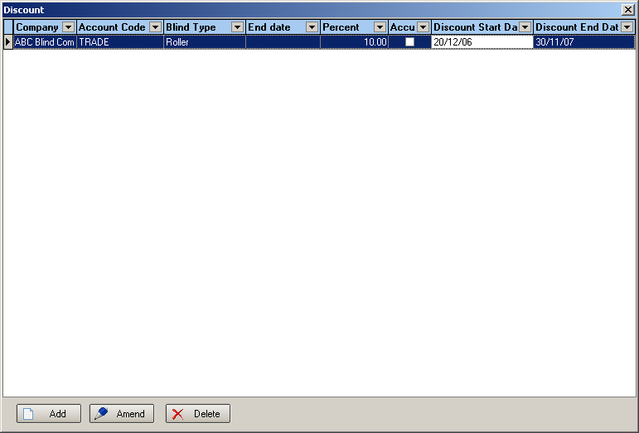

1451. Order Processing > Quotations > Create Order

If you try to create an order for a quotation that contains a detail line for a blind type that is an ‘Inactive Blind Type’, then it no longer allows the quotation to be converted. It brings up a message saying ‘This quotation contains a detail line for [blind type description], which has been flagged as inactive, so an order cannot be created’.

1452. Order Processing > Orders

When an order is un-flagged as same day despatch, the must go flag is now switched off as well.

1453. Order Processing > Production List

Authorisation on hold orders is now also selected if ‘On Show On Credit Hold Records’ is ticked for these reports.

