Blindata Release Note 4.5.9 

31 July 2009

Bug Fixes and Enhancements

2754. Administration > Sage Utilities

When you update customers from Blindata to Sage, the VAT number is now updated.

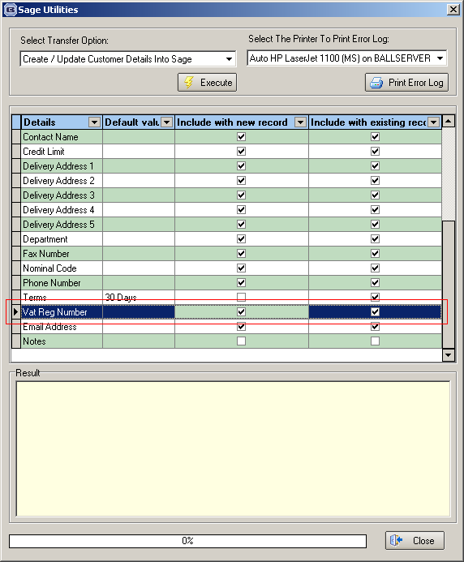

2757. Order Processing > Orders

The required date on the cutting table detail table is now updated when an order is amended and the required date in the order is changed.

New Work and Customer Requests

1430. Production List Summary by Day

There was an omission in the original specification for this report. If the report is generated by start and end required date, we need to know the numbers of blinds with a required date before the start date that have not yet been manufactured.

There is also an argument that this report date should only be by required date and should only have the following criteria.

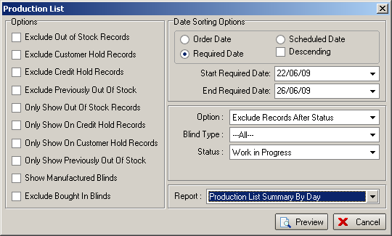

The blinds that have not been manufactured and are before the start date are now included in brackets after the day amount. A total is then shown for the blinds that have to be manufactured for that day plus those that need to be manufactured that day. As the required date is already in the past for these blinds, we have worked out the next required date according to the lead time and despatch date algorithm we use when the orders are entered.

1439. Stock Setup > Stock Items

There is now a facility to uplift a lot of unit cost prices and selling prices at once. There is a new button at the bottom of this form called ‘Uplift Prices’. This button is used to display another form that allows you to choose either ‘Unit Cost Price’ or ‘Unit Selling Price’, and also a field to enter the ‘Percentage Uplift’.

Once these fields have been selected, two warning messages will appear. The first says ‘You have chosen to uplift cost/selling prices by x%. Are you sure?’

If the answer is yes, then a further message appears saying ‘Are you absolutely sure you want to do this?’. If the answer is yes, then the records that have been selected (by filtering in the ‘Stock Enquiry’ form, will be updated.

1440. Stock Setup > Stock Items

When you are adding records in the ‘Additional Options’, the ‘Quantity’ now defaults to 0 and the ‘Default Code’ defaults to A.

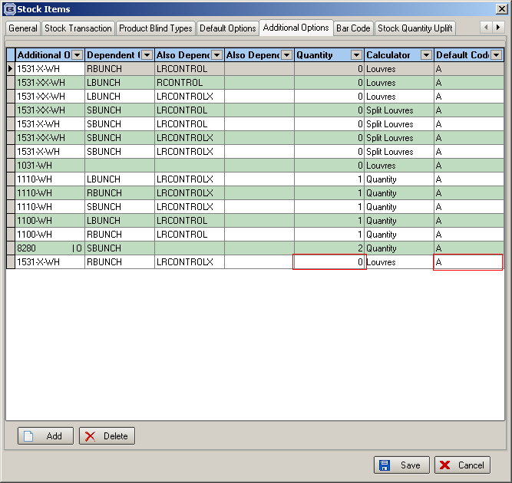

1441. Order Processing > Orders

There is a new button on the ‘Bill of Materials’ form so that the parent code stock item can be accessed and then edited. There is also a button for accessing the ‘Dimension Calculations’ form from here.

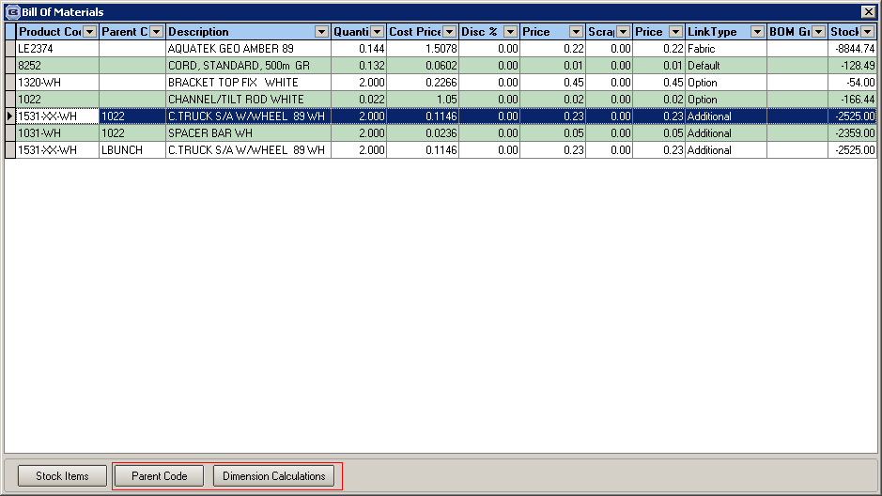

1460. Invoice – Bespoke 29

There is a new invoice layout called ‘Invoice – Bespoke 29’, similar to the Sage tractor feed layout.

