Blindata Release Note 4.5.7 

17 July 2009

Bug Fixes and Enhancements

New Work and Customer Requests

1398. Google Maps

When a number of sales leads are entered, it is now possible to pass the postcodes (or zip codes in Blindata.net) into Google Maps to see the distances between the appointment locations.

We have added ‘Maps’ button to the ‘Fitter Sheet \ Sales Leads’ form:

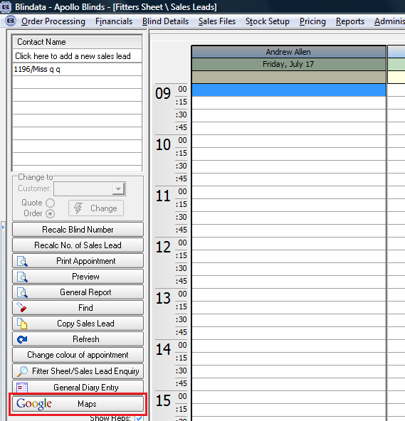

After clicking ‘Maps’ button the following form will appear:
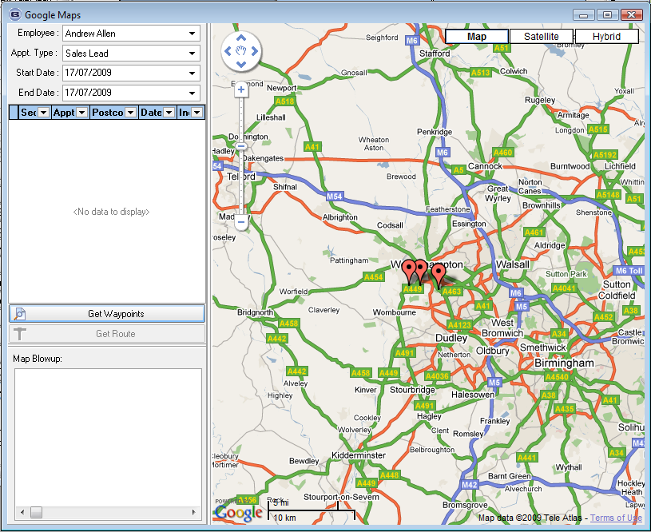

Employee, Appt. Type, Start and End Date are automatically selected. Also at this moment postcode and zip are taken from Company address and map automatically shows it location (if postcode cannot be found – then the map locates to the centre of ‘Belfast, UK’). If there is more than one location, the map shows all of them.

After selecting Start and End Dates we can get all the appointments for selected Employee by clicking ‘Get Waypoints’ button. All the waypoints information is stored in the temporary Google Point table.
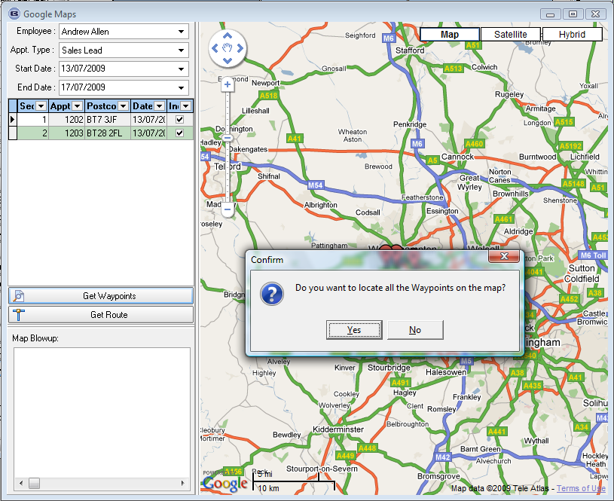

The program will ask if you want to locate all the Waypoints on the map. If you select ‘Yes’ – you will see the following:
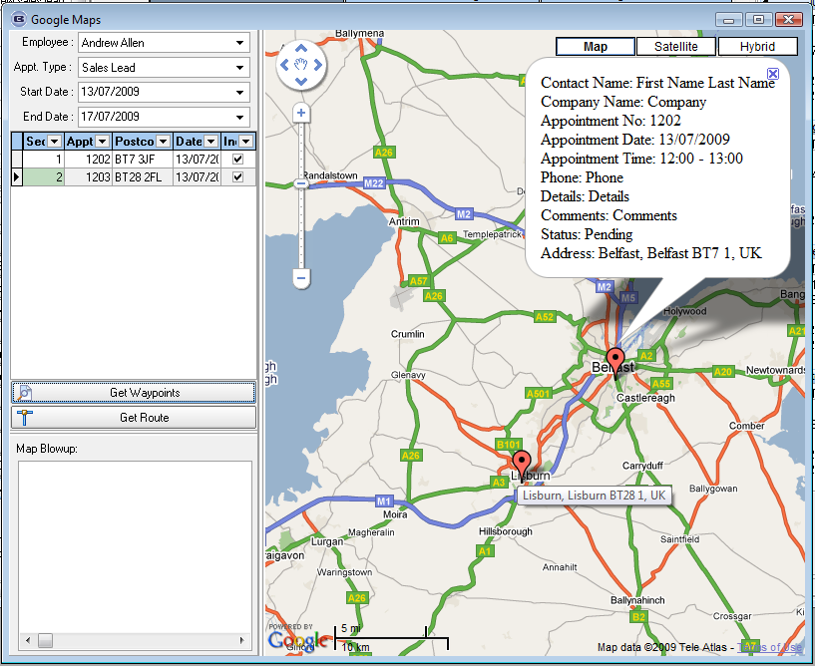

We have two appointments in this example and see two waypoints on the map. If you point on the marker you will see address of this point (bottom marker) and if you double click on it – you will see appointment information (top marker).

Then you will be able to get route between included waypoints by pressing ‘Get route’ button. Only records which have ‘Include’ (right column in the grid) = true will be included into the displaying and route getting routines:
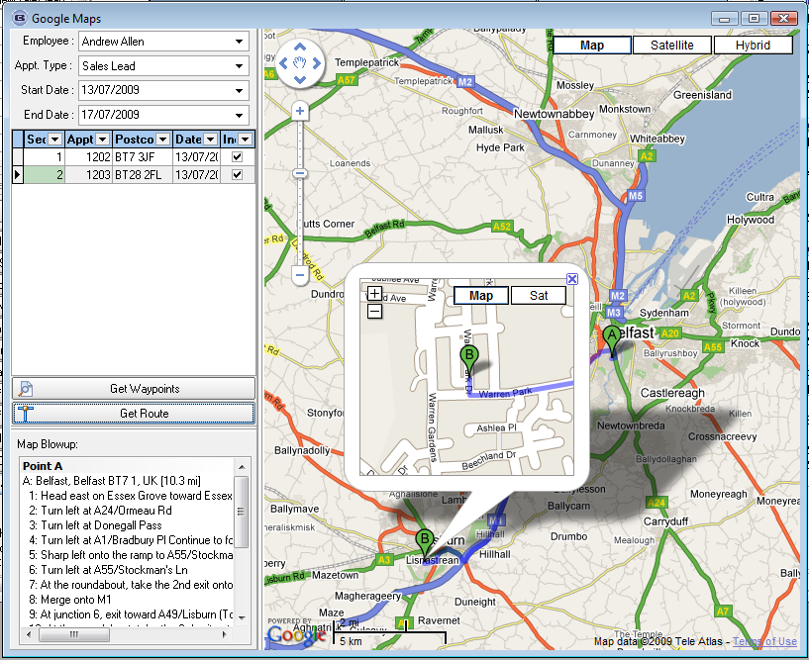
In the left bottom you will see ‘Map Blowup’. You are able to click on each step to see where it is located on the map. If you click on the waypoint once you will see the detailed placement map (see screenshot above). When you double click on the marker you will see the appointment information:
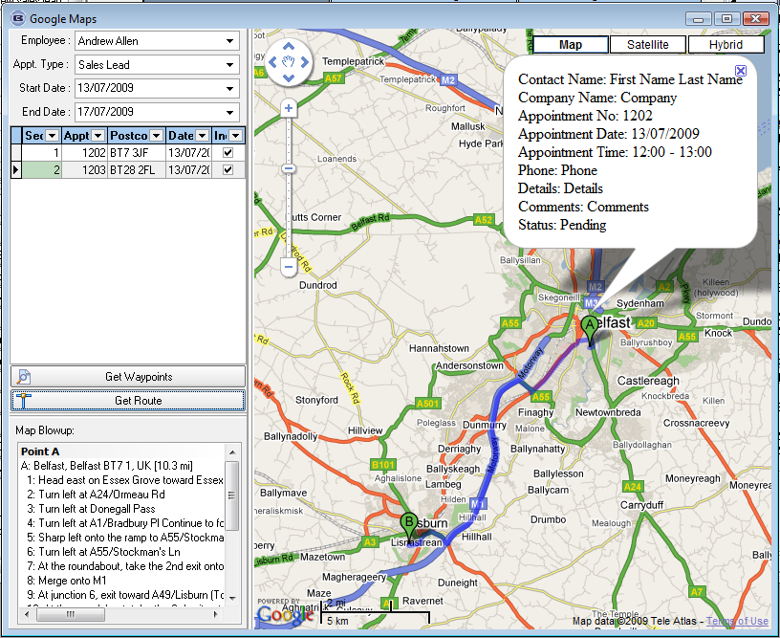

We have created right-click popup menu for the grid maintenance:
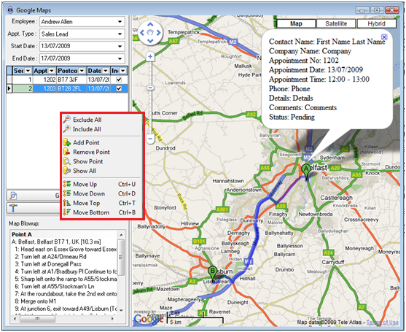

Here you can Include/Exclude all points, add new points, remove points, show points on the map, show all the included points, move selected point up, down, top or bottom. The last four operations are needed for route getting (at the moment routine gets the route by waypoints arranged in grid, not the optimal one – this is a separate complicated task). In addition we have assigned shortcuts to the last four operations (‘Ctrl + U’, ‘Ctrl + D’, ‘Ctrl + T’, ‘Ctrl + B’ accordingly). Separate record can be excluded\included by editing ‘Include’ field value in the grid.

You can also copy Map Blowup to the Clipboard using another right-click popup menu (in the left bottom list):
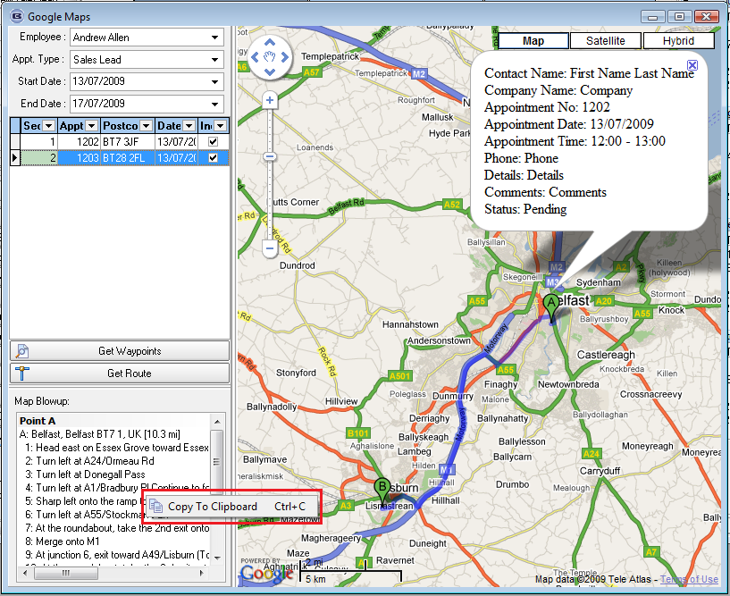

If you select Add Point from the grid right-click popup menu you will see the following form:

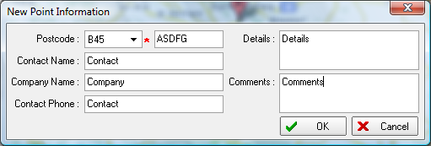

The postcode is mandatory here. The other fields are not mandatory. After saving a new point it will be automatically added to the grid:
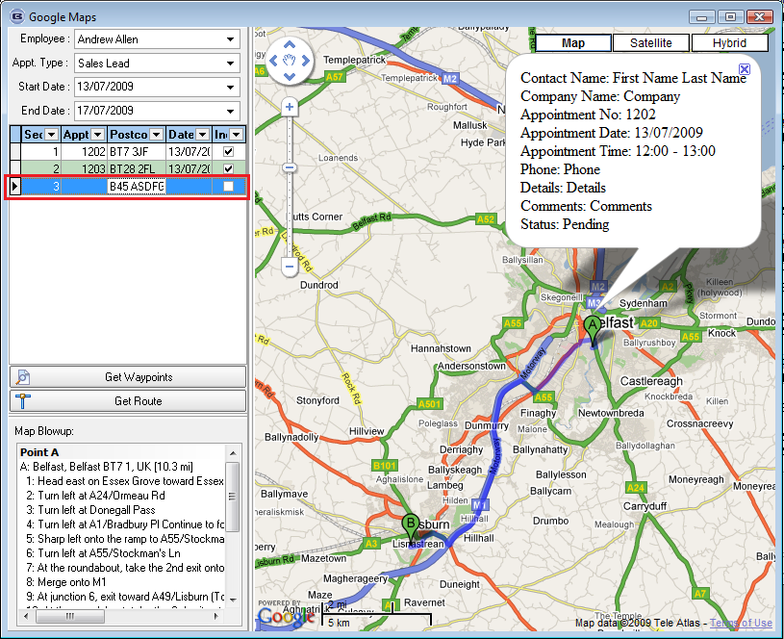

Also we have designed an error processing engine. During the route getting routine errors are displayed as warning messages, in all other cases – in left bottom list. Let’s consider some error cases. The last point we have added manually (see above) has an incorrect postcode (‘ASDFG’), so we getting the following error when trying to show this point:
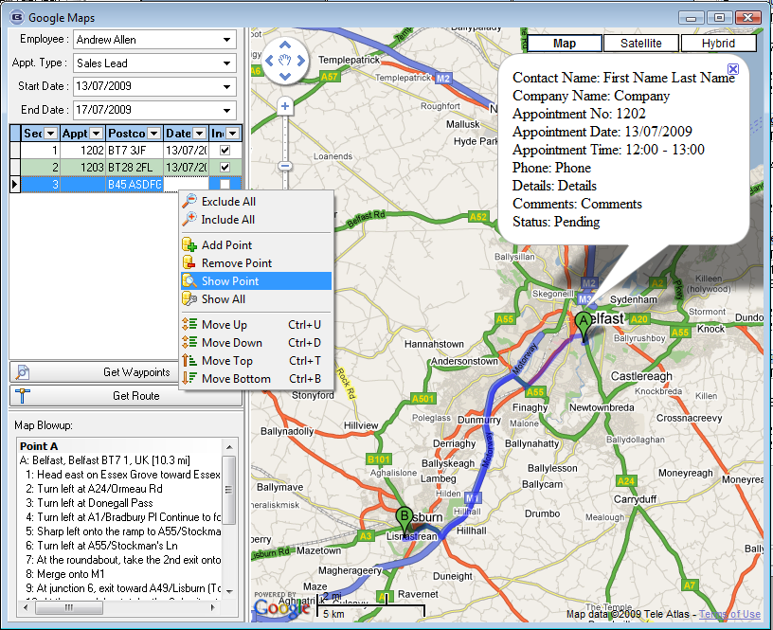

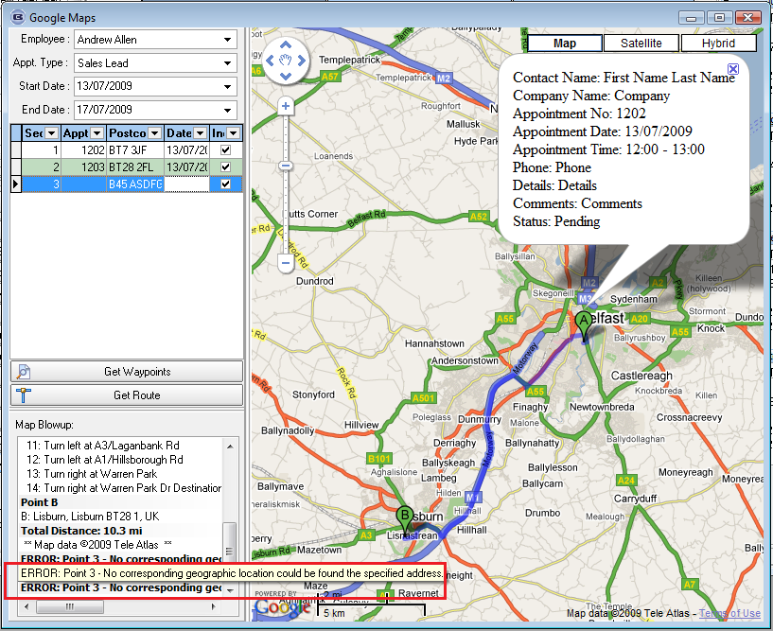

If we try to get a route with incorrect point we will get the following message:
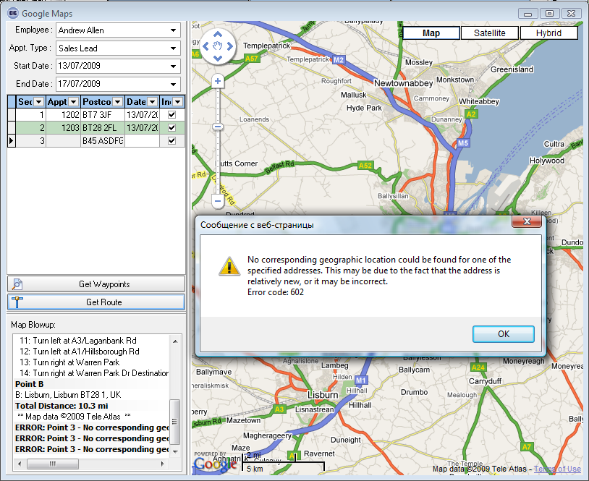

As usual you are able to zoom in, zoom out map; select map type (map, satellite, hybrid):
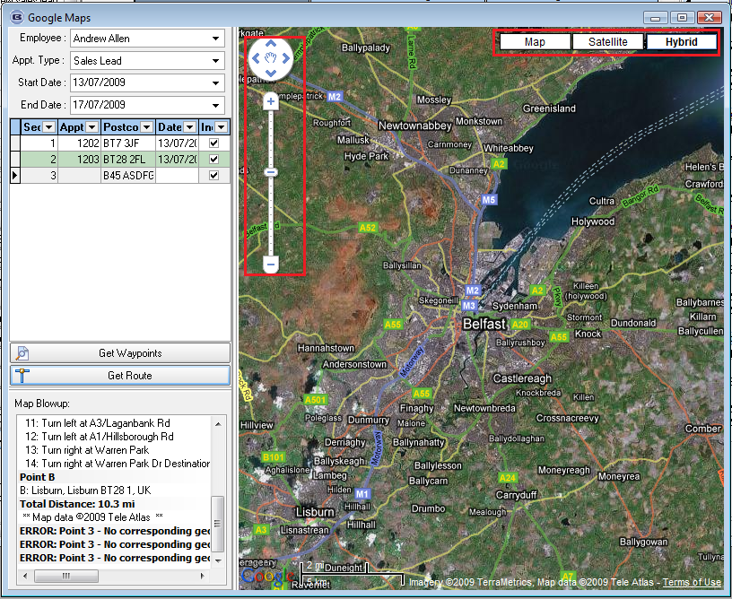

In addition we have realized controls sizing using separators marked with red. I.e. you are able to chage left panel and grid sizes. This information will be stored in the INI-file.

